UNITED STATES

SECURITIES AND EXCHANGE COMMISSION

Washington, D.C. 20549

FORM 10-Q

(Mark One)

- QUARTERLY REPORT PURSUANT TO SECTION 13 OR 15(d) OF THE SECURITIES EXCHANGE ACT OF 1934

For the quarterly period ended December 28, 2024

OR

- TRANSITION REPORT PURSUANT TO SECTION 13 OR 15(d) OF THE SECURITIES EXCHANGE ACT OF 1934 For the transition period from ______ to

 | Commission file number 001-40175
 | SYMBOTIC INC.
 | (Exact name of registrant as specified in its charter)
Delaware | 98-1572401
(State or other jurisdiction of incorporation or | (I.R.S. Employer Identification No.)
organization)
 | 200 Research Drive
 | Wilmington, MA 01887
 | (978) 284-2800
 | (Address, Including Zip Code, and Telephone Number, Including Area Code, of
 | Registrant’s Principal Executive Offices)
 | Not Applicable
 | (Former name, former address and former fiscal year, if changed since last report)

Securities registered pursuant to Section 12(b) of the Act:
Title of each class |  | Trading Symbol(s) |  | Name of each exchange on which registered
Class A common stock, par value $0.0001 per share |  | SYM |  | The Nasdaq Stock Market LLC

Indicate by check mark whether the registrant: (1) has filed all reports required to be filed by Section 13 or 15(d) of the Securities Exchange Act of 1934 during the preceding 12 months (or for such shorter period that the registrant was required to file such reports); and (2) has been subject to such filing requirements for the past 90 days. Yes ☒ No o

Indicate by check mark whether the registrant has submitted electronically and posted on its corporate web site, if any, every Interactive Data File required to be submitted and posted pursuant to Rule 405 of Regulation S-T (§232.405 of this chapter) during the preceding 12 months (or for such shorter period that the registrant was required to submit and post such files). Yes ☒ No o

Indicate by check mark whether the registrant is a large accelerated filer, an accelerated filer, a non-accelerated filer, or a smaller reporting company. See the definitions of “large accelerated filer,” “accelerated filer” and “smaller reporting company” in Rule 12b-2 of the Exchange Act. (Check one):

Large accelerated filer | ☒ | Accelerated filer | ☐
Non-accelerated filer | ☐ | Smaller reporting company | ☐
 |  | Emerging growth company | ☐

If an emerging growth company, indicate by check mark if the registrant has elected not to use the extended transition period for complying with any new or revised financial accounting standards provided pursuant to Section 13(a) of the Exchange Act. o

Indicate by check mark whether the registrant is a shell company (as defined in Rule 12b-2 of the Exchange Act). Yes o No ☒

As of February 3, 2025, the following shares of common stock were outstanding:

107,704,510 shares of Class A common stock, par value $0.0001 per share

76,378,094 shares of Class V-1 common stock, par value $0.0001 per share

404,309,196 shares of Class V-3 common stock, par value $0.0001 per share

 |  |  |  |  |  |  |  |  |  |  |  | TABLE OF CONTENTS
 |  |  |  |  |  |  |  |  |  |  |  |  |  |  |  |  |  |  |  |  |  | Page
 |  |  |  |  |  |  |  |  |  | Part I - Financial Information
Item 1. | Financial Statements |  |  |  |  |  |  |  |  |  |  |  |  |  |  |  |  |  |  |  |  | 1
 | Unaudited Condensed Consolidated Financial Statements |  |  |  |  |  |  |  |  |  |  |  |  |  |  |  |  |  |  |  |  | 1
 | Unaudited Condensed Consolidated Balance Sheets as of December 28, 2024 and September 28, 2024 |  |  |  |  |  |  |  |  |  |  |  |  |  |  |  |  |  |  |  |  | 1
 | Unaudited Condensed Consolidated Statements of Operations for the Three Months Ended December 28, 2024 and December 30, 2023 |  |  |  |  |  |  |  |  |  |  |  |  |  |  |  |  |  |  |  |  | 3
 | Unaudited Condensed Consolidated Statements of Comprehensive Loss for the Three Months Ended December 28, 2024 and December 30, 2023 |  |  |  |  |  |  |  |  |  |  |  |  |  |  |  |  |  |  |  |  | 4
 | Unaudited Condensed Consolidated Statements of Changes in Equity (Deficit) for the Three Months Ended December 28, 2024 and December 30, 2023 |  |  |  |  |  |  |  |  |  |  |  |  |  |  |  |  |  |  |  |  | 5
 | Unaudited Condensed Consolidated Statements of Cash Flows for the Three Months Ended December 28, 2024 and December 30, 2023 |  |  |  |  |  |  |  |  |  |  |  |  |  |  |  |  |  |  |  |  | 6
 | Notes to Unaudited Condensed Consolidated Financial Statements |  |  |  |  |  |  |  |  |  |  |  |  |  |  |  |  |  |  |  |  | 8
Item 2. | Management’s Discussion and Analysis of Financial Condition and Results of Operations |  |  |  |  |  |  |  |  |  |  |  |  |  |  |  |  |  |  |  |  | 24
Item 3. | Quantitative and Qualitative Disclosures About Market Risk |  |  |  |  |  |  |  |  |  |  |  |  |  |  |  |  |  |  |  |  | 33
Item 4. | Controls and Procedures |  |  |  |  |  |  |  |  |  |  |  |  |  |  |  |  |  |  |  |  | 34
 |  |  |  |  |  |  |  |  |  |  | Part II - Other Information
Item 1. | Legal Proceedings |  |  |  |  |  |  |  |  |  |  |  |  |  |  |  |  |  |  |  |  | 35
Item 1A. | Risk Factors |  |  |  |  |  |  |  |  |  |  |  |  |  |  |  |  |  |  |  |  | 36
Item 2. | Unregistered Sales of Equity Securities and Use of Proceeds |  |  |  |  |  |  |  |  |  |  |  |  |  |  |  |  |  |  |  |  | 36
Item 3. | Defaults Upon Senior Securities |  |  |  |  |  |  |  |  |  |  |  |  |  |  |  |  |  |  |  |  | 36
Item 4. | Mine Safety Disclosures |  |  |  |  |  |  |  |  |  |  |  |  |  |  |  |  |  |  |  |  | 36
Item 5. | Other Information |  |  |  |  |  |  |  |  |  |  |  |  |  |  |  |  |  |  |  |  | 36
Item 6. | Exhibits |  |  |  |  |  |  |  |  |  |  |  |  |  |  |  |  |  |  |  |  | 37
 | Signatures |  |  |  |  |  |  |  |  |  |  |  |  |  |  |  |  |  |  |  |  | 38

i

CAUTIONARY NOTE ON FORWARD-LOOKING STATEMENTS

This Quarterly Report on Form 10-Q contains forward-looking statements within the meaning of the Private Securities Litigation Reform Act of 1995, Section 27A of the Securities Act of 1933, as amended (the “Securities Act”), and Section 21E of the Securities Exchange Act of 1934, as amended (the “Exchange Act”). These statements include, but are not limited to, our expectations or predictions of future financial or business performance or conditions. Forward-looking statements are inherently subject to risks, uncertainties and assumptions. Generally, statements that are not historical facts, including statements concerning our possible or assumed future actions, business strategies, events or results of operations, are forward-looking statements. These statements may be preceded by, followed by or include the words “believes,” “estimates,” “expects,” “projects,” “forecasts,” “may,” “will,” “should,” “seeks,” “plans,” “scheduled,” “anticipates,” or “intends” or similar expressions.

Forward-looking statements contained in this Quarterly Report on Form 10-Q include, but are not limited to, statements about our ability to, or expectations that Symbotic will:

- meet the technical requirements of existing or future supply agreements with its customers, including with respect to existing backlog;

- expand its target customer base and maintain its existing customer base;

- realize the benefits expected from the acquisition of Walmart’s Advanced Systems and Robotics business, the GreenBox joint venture, the Commercial Agreement with GreenBox, Symbotic’s acquisitions of developed technology intangible assets, and the commercial agreement with Walmart de México y Centroamérica;
- realize its outlook, including its system gross margin;

- anticipate industry trends;

- maintain and enhance its system;

- maintain the listing of the Symbotic Class A Common Stock on Nasdaq;

- execute its growth strategy;

- develop, design and sell systems that are differentiated from those of competitors;

- execute its research and development strategy;

- acquire, maintain, protect and enforce intellectual property;

- attract, train and retain effective officers, key employees or directors;

- comply with laws and regulations applicable to its business;

- stay abreast of modified or new laws and regulations applying to its business;

- successfully defend litigation;

- issue equity securities in connection with future transactions;

- meet future liquidity requirements and, if applicable, comply with restrictive covenants related to long-term indebtedness;

- timely and effectively remediate any material weaknesses in its internal control over financial reporting;

- anticipate rapid technological changes; and

- effectively respond to general economic and business conditions.

Forward-looking statements made in this Quarterly Report on Form 10-Q also include, but are not limited to, statements with respect to:

- the future performance of Symbotic’s business and operations;

- expectations regarding revenues, expenses, adjusted EBITDA and anticipated cash needs;

- expectations regarding cash flow, liquidity and sources of funding;

- expectations regarding capital expenditures;

- the anticipated benefits of Symbotic’s leadership structure;

- the effects of pending and future legislation;

- business disruption;

- disruption to the business due to Symbotic’s dependency on certain customers;

ii

- increasing competition in the warehouse automation industry;

- any delays in the design, production or launch of Symbotic’s systems and products;

- the failure to meet customers’ requirements under existing or future contracts or customer’s expectations as to price or pricing structure;

- any defects in new products or enhancements to existing products;

- the fluctuation of operating results from period to period due to a number of factors, including the pace of customer adoption of Symbotic’s new products and services and any changes in its product mix that shift too far into lower gross margin products; and
- any consequences associated with joint ventures and legislative and regulatory actions and reforms.

Such forward-looking statements involve risks and uncertainties that may cause actual events, results or performance to differ materially from those indicated by such statements. Certain of these risks are identified and discussed in other sections of this Quarterly Report on Form 10-Q and in our Annual Report on Form 10-K filed with the U.S. Securities and Exchange Commission (“SEC”) on December 4, 2024. These risk factors will be important to consider in determining future results and should be reviewed in their entirety. These forward-looking statements are expressed in good faith, and we believe there is a reasonable basis for them. However, there can be no assurance that the events, results or trends identified in these forward-looking statements will occur or be achieved. Forward-looking statements are provided for the purposes of assisting the reader in understanding our financial performance, financial position and cash flows as of and for periods ended on certain dates and to present information about management’s current expectations and plans relating to the future, and the reader is cautioned not to place undue reliance on these forward-looking statements because of their inherent uncertainty and to appreciate the limited purposes for which they are being used by management. While we believe that the assumptions and expectations reflected in the forward-looking statements are reasonable based on information currently available to management, there is no assurance that such assumptions and expectations will prove to have been correct.

The forward-looking statements made in this Quarterly Report on Form 10-Q relate only to events as of the date on which the statements are made and are based on the beliefs, estimates, expectations and opinions of management on that date. We are not under any obligation, and expressly disclaim any obligation, to update, alter or otherwise revise any forward-looking statements made in this Quarterly Report on Form 10-Q, whether as a result of new information, future events or otherwise, except as required by law.

In addition to factors previously disclosed in our Annual Report on Form 10-K filed with the SEC on December 4, 2024, and those identified elsewhere in this Quarterly Report on Form 10-Q, the following factors, among others, could cause actual results to differ materially from forward-looking statements or historical performance: failure to realize the benefits expected from adding to Symbotic’s base of outsourcing partners and the effects of pending and future legislation.

Annualized and estimated numbers are not forecasts and may not reflect actual results.

In this Quarterly Report on Form 10-Q, the terms “Symbotic,” “we,” “us,” and “our” refer to Symbotic Inc. and its subsidiaries, unless the context indicates otherwise.

iii

Table of Contents

PART I - FINANCIAL INFORMATION

Item 1. Unaudited Condensed Consolidated Financial Statements

Symbotic Inc.

Unaudited Condensed Consolidated Balance Sheets

(in thousands, except share data)

 |  |  | December 28, 2024 |  |  | September 28, 2024
 | ASSETS
Current assets:
Cash and cash equivalents | $ |  | 903,034 |  | $ | 727,310
Accounts receivable |  |  | 134,391 |  |  | 201,548
Unbilled accounts receivable |  |  | 223,349 |  |  | 218,233
Inventories |  |  | 108,691 |  |  | 106,136
Deferred expenses |  |  | 3,221 |  |  | 1,058
Prepaid expenses and other current assets |  |  | 85,740 |  |  | 101,252
Total current assets |  |  | 1,458,426 |  |  | 1,355,537
Property and equipment, net |  |  | 105,079 |  |  | 97,109
Intangible assets, net |  |  | 14,949 |  |  | 3,664
Equity method investment |  |  | 85,946 |  |  | 81,289
Other assets |  |  | 51,222 |  |  | 40,953
Total assets | $ |  | 1,715,622 |  | $ | 1,578,552
 | LIABILITIES AND EQUITY
Current liabilities:
Accounts payable | $ |  | 206,324 |  | $ | 175,188
Accrued expenses |  |  | 203,353 |  |  | 165,644
Deferred revenue |  |  | 787,174 |  |  | 676,314
Total current liabilities |  |  | 1,196,851 |  |  | 1,017,146
Deferred revenue |  |  | 76,712 |  |  | 129,233
Other liabilities |  |  | 48,134 |  |  | 42,043
Total liabilities |  |  | 1,321,697 |  |  | 1,188,422
Commitments and contingencies (Note 13) |  |  | — |  |  | —

Equity:

Class A Common Stock, 3,000,000,000 shares authorized, 106,521,915 and 104,689,377 shares issued and outstanding at December 28, 2024 and September 28, 2024, respectively

Class V-1 Common Stock, 1,000,000,000 shares authorized, 76,588,618 and 76,965,386 shares issued and outstanding at December 28, 2024 and September 28, 2024, respectively

13 13

7 7

1

Table of Contents

Class V-3 Common Stock, 450,000,000 shares authorized, 404,309,196 and 404,309,196 shares issued and outstanding at December |  | 40 |  |  | 40
28, 2024 and September 28, 2024, respectively |  | 40 |  |  | 40
Additional paid-in capital |  | 1,526,573 |  |  | 1,523,692
Accumulated deficit |  | (1,327,401) |  |  | (1,323,925)
Accumulated other comprehensive loss |  | (2,696) |  |  | (2,594)
Total stockholders' equity |  | 196,536 |  |  | 197,233
Noncontrolling interest |  | 197,389 |  |  | 192,897
Total equity |  | 393,925 |  |  | 390,130
Total liabilities and equity | $ | 1,715,622 |  | $ | 1,578,552

The accompanying notes are an integral part of these unaudited condensed consolidated financial statements.

2

Table of Contents

Symbotic Inc.

Unaudited Condensed Consolidated Statements of Operations

(in thousands, except share and per share information)

 |  | For the Three Months Ended
 |  | December 28, 2024 |  |  | December 30, 2023
Revenue:
Systems | $ | 464,059 |  | $ | 347,705
Software maintenance and support |  | 5,525 |  |  | 2,169
Operation services |  | 17,109 |  |  | 10,069
Total revenue |  | 486,693 |  |  | 359,943
Cost of revenue:
Systems |  | 381,819 |  |  | 283,946
Software maintenance and support |  | 1,884 |  |  | 1,726
Operation services |  | 22,951 |  |  | 10,214
Total cost of revenue |  | 406,654 |  |  | 295,886
Gross profit |  | 80,039 |  |  | 64,057
Operating expenses:
Research and development expenses |  | 43,592 |  |  | 42,144
Selling, general, and administrative expenses |  | 61,076 |  |  | 47,012
Total operating expenses |  | 104,668 |  |  | 89,156
Operating loss |  | (24,629) |  |  | (25,099)
Other income, net |  | 7,823 |  |  | 6,199
Loss before income tax and equity method investment |  | (16,806) |  |  | (18,900)
Income tax expense |  | (150) |  |  | (172)
Loss from equity method investment |  | (1,564) |  |  | —
Net loss |  | (18,520) |  |  | (19,072)
Net loss attributable to noncontrolling interests |  | (15,044) |  |  | (16,236)
Net loss attributable to common stockholders | $ | (3,476) |  | $ | (2,836)
Loss per share of Class A Common Stock:
Basic and Diluted | $ | (0.03) |  | $ | (0.03)
Weighted-average shares of Class A Common Stock outstanding:
Basic and Diluted |  | 106,098,566 |  |  | 83,320,943

The accompanying notes are an integral part of these unaudited condensed consolidated financial statements.

3

Table of Contents

Symbotic Inc.

Unaudited Condensed Consolidated Statements of Comprehensive Loss

(in thousands)

 |  | For the Three Months Ended
 |  | December 28, 2024 |  |  | December 30, 2023
Net loss | $ | (18,520) |  | $ | (19,072)
Less: Net loss attributable to noncontrolling interests |  | (15,044) |  |  | (16,236)
Net loss attributable to common stockholders | $ | (3,476) |  | $ | (2,836)
Other comprehensive income (loss):
Foreign currency translation adjustments |  | (563) |  |  | 360
Changes in unrealized gain on investments, net of income taxes of $— for the three months ended December 28, 2024 and December 30, 2023 |  | — |  |  | (911)
Total other comprehensive loss |  | (563) |  |  | (551)
Less: other comprehensive loss attributable to noncontrolling interests |  | (461) |  |  | (468)
Other comprehensive loss attributable to common stockholders | $ | (102) |  | $ | (83)
Comprehensive loss |  | (19,083) |  |  | (19,623)
Less: Comprehensive loss attributable to noncontrolling interests |  | (15,505) |  |  | (16,704)
Total comprehensive loss attributable to common stockholders | $ | (3,578) |  | $ | (2,919)

The accompanying notes are an integral part of these unaudited condensed consolidated financial statements.

4

Table of Contents

Symbotic Inc.

Unaudited Condensed Consolidated Statements of Changes in Equity (Deficit)

(in thousands, except share information)

 |  |  |  |  |  |  |  |  |  |  |  |  |  |  |  |  |  |  |  |  |  |  |  | Three Months Ended December 28, 2024
 |  |  |  | Class A Common |  |  |  |  |  |  |  |  |  | Class V-1 Common |  |  |  |  |  |  |  |  | Class V-3 Common |  |  |  |  |  |  |  |  |  |  |  |  |  |  | Accumulated
 |  |  |  |  | Stock |  |  |  |  |  |  |  |  |  |  | Stock |  |  |  |  |  |  |  |  | Stock |  |  |  |  |  |  |  |  |  | Additional |  |  | Other
 |  |  |  |  |  |  |  |  |  |  |  |  |  |  |  |  |  |  |  |  |  |  |  |  |  |  |  |  |  |  |  |  |  |  | Paid-in |  | Comprehensive |  |  | Accumulated |  |  | Noncontrolling |  |  | Total Equity
 |  |  |  | Shares |  |  |  | Amount |  |  |  |  |  | Shares |  |  |  | Amount |  |  |  |  | Shares |  |  |  |  |  | Amount |  |  |  |  |  | Capital |  |  | Loss |  |  | Deficit |  |  | Interest |  |  | (Deficit)
Balance at September 28, 2024 |  |  |  | 104,689,377 |  |  |  | $ | 13 |  |  |  |  | 76,965,386 |  |  |  | $ | 7 |  |  |  | 404,309,196 |  |  |  | $ |  |  | 40 |  |  | $ |  | 1,523,692 |  | $ | (2,594) |  | $ | (1,323,925) |  | $ | 192,897 |  | $ | 390,130
Net loss |  |  |  |  |  | — |  |  | — |  |  |  |  |  |  | — |  |  | — |  |  |  |  |  |  | — |  |  |  | — |  |  |  |  | — |  |  | — |  |  | (3,476) |  |  | (15,044) |  |  | (18,520)
Issuance of common stock under stock plans, net of shares
withheld for employee taxes |  |  |  | 1,652,671 |  |  |  |  | — |  |  |  |  |  |  | — |  |  | — |  |  |  |  |  |  | — |  |  |  | — |  |  |  |  | (3,012) |  |  | — |  |  | — |  |  | — |  |  | (3,012)
Exchange of Class V-1 common stock |  |  |  | 179,867 |  |  |  |  | — |  |  |  |  | (179,867) |  |  |  |  | — |  |  |  |  |  |  | — |  |  |  | — |  |  |  |  | 1,044 |  |  | — |  |  | — |  |  | (1,044) |  |  | —
Cancellation of Class V-1 common stock |  |  |  |  |  | — |  |  | — |  |  |  |  | (196,901) |  |  |  |  | — |  |  |  |  |  |  | — |  |  |  | — |  |  |  |  | — |  |  | — |  |  | — |  |  | — |  |  | —
Stock-based compensation |  |  |  |  |  | — |  |  | — |  |  |  |  |  |  | — |  |  | — |  |  |  |  |  |  | — |  |  |  | — |  |  |  |  | 4,849 |  |  | — |  |  | — |  |  | 21,891 |  |  | 26,740
Other comprehensive loss |  |  |  |  |  | — |  |  | — |  |  |  |  |  |  | — |  |  | — |  |  |  |  |  |  | — |  |  |  | — |  |  |  |  | — |  |  | (102) |  |  | — |  |  | (461) |  |  | (563)
Distribution to Symbotic Holdings LLC partners |  |  |  |  |  | — |  |  | — |  |  |  |  |  |  | — |  |  | — |  |  |  |  |  |  | — |  |  |  | — |  |  |  |  | — |  |  | — |  |  | — |  |  | (850) |  |  | (850)
Balance at December 28, 2024 |  |  |  | 106,521,915 |  |  |  | $ | 13 |  |  |  |  | 76,588,618 |  |  |  | $ | 7 |  |  |  | 404,309,196 |  |  |  |  |  | $ | 40 |  |  | $ |  | 1,526,573 |  | $ | (2,696) |  | $ | (1,327,401) |  | $ | 197,389 |  | $ | 393,925
 |  |  |  |  |  |  |  |  |  |  |  |  |  |  |  |  |  |  |  |  |  |  | Three Months Ended December 30, 2023
 | Class A Common |  |  |  |  | Class V-1 Common |  |  |  |  |  |  |  |  |  | Class V-3 Common |  |  |  |  |  |  |  |  |  | Additional |  |  |  |  |  |  |  |  |  |  |  | Accumulated
 |  |  |  |  |  |  |  |  |  |  |  |  |  |  |  |  |  |  |  |  |  |  |  |  |  |  | Paid-in |  |  |  |  |  |  |  | Additional |  |  | Other
 | Stock |  |  |  |  |  |  |  | Stock |  |  |  |  |  |  |  |  |  | Stock
 |  |  |  |  |  |  |  |  |  |  |  |  |  |  |  |  |  |  |  |  |  |  |  |  |  | Capital - |  |  |  |  |  |  |  |  | Paid-in |  | Comprehensive |  |  | Accumulated |  |  | Noncontrolling |  |  | Total Equity
 | Shares |  | Amount |  |  | Shares |  |  |  |  |  | Amount |  |  |  | Shares |  |  |  |  |  | Amount |  |  |  | Warrants |  |  |  |  |  |  |  |  | Capital |  |  | Loss |  |  | Deficit |  |  | Interest |  |  | (Deficit)
Balance at September 30, 2023 | 82,112,881 |  | $ | 8 | 66,931,097 |  |  |  |  |  |  | $ |  | 7 |  | 407,528,941 |  |  |  |  |  | $ | 41 | $ |  |  |  |  |  | 58,126 |  |  | $ |  | 1,254,022 |  | $ | (1,687) |  | $ | (1,310,435) |  | $ | (2,798) |  | $ | (2,716)
Net loss | — |  |  | — |  |  |  |  | — |  |  |  |  | — |  |  |  |  | — |  |  |  | — |  |  |  |  |  |  | — |  |  |  |  | — |  |  | — |  |  | (2,836) |  |  | (16,236) |  |  | (19,072)
Issuance of common stock under stock plans, | 665,842 |  |  | — |  |  |  |  | — |  |  |  |  | — |  |  |  |  | — |  |  |  | — |  |  |  |  |  |  | — |  |  |  |  | (8)
net of shares withheld for employee taxes |  |  |  |  |  |  |  |  |  |  |  |  |  |  |  |  |  |  |  |  |  |  |  |  |  |  |  |  |  |  |  |  |  |  |  |  |  | — |  |  | — |  |  | (50) |  |  | (58)
Exchange of Class V-1 and V-3 common stock | 2,327,865 |  |  | 2 | (1,311,865) |  |  |  |  |  |  |  |  | (2) |  | (1,016,000) |  |  |  |  |  |  | — |  |  |  |  |  |  | — |  |  |  |  | (536) |  |  | — |  |  | — |  |  | 536 |  |  | —
Stock-based compensation | — |  |  | — |  |  |  |  | — |  |  |  |  | — |  |  |  |  | — |  |  |  | — |  |  |  |  |  |  | — |  |  |  |  | 4,375 |  |  | — |  |  | — |  |  | 25,087 |  |  | 29,462
Other comprehensive loss | — |  |  | — |  |  |  |  | — |  |  |  |  | — |  |  |  |  | — |  |  |  | — |  |  |  |  |  |  | — |  |  |  |  | — |  |  | (83) |  |  | — |  |  | (468) |  |  | (551)
Exercise of warrants | — |  |  | — | 15,870,411 |  |  |  |  |  |  |  |  | 3 |  |  |  |  | — |  |  |  | — |  |  |  | (58,126) |  |  |  |  |  |  |  | — |  |  | — |  |  | — |  |  | 216,828 |  |  | 158,705
Balance at December 30, 2023 | 85,106,588 |  | $ | 10 |  | 81,489,643 |  |  |  |  |  | $ |  | 8 |  | 406,512,941 |  |  |  |  |  | $ | 41 |  |  | $ |  |  |  | — |  |  |  | $ | 1,257,853 |  | $ | (1,770) |  | $ | (1,313,271) |  | $ | 222,899 |  | $ | 165,770

The accompanying notes are an integral part of these unaudited condensed consolidated financial statements.

5

Table of Contents

Symbotic Inc.

Unaudited Condensed Consolidated Statements of Cash Flows

(in thousands)

 |  | For the Three Months Ended
 |  | December 28, 2024 |  |  | December 30, 2023
Cash flows from operating activities:
Net loss | $ | (18,520) |  | $ | (19,072)
Adjustments to reconcile net loss to net cash provided by (used in) operating activities:
Depreciation and amortization |  | 7,645 |  |  | 3,197
Foreign currency (gains) losses |  | (32) |  |  | 22
Loss on disposal of assets |  | 201 |  |  | —
Provision for excess and obsolete inventory |  | 688 |  |  | 70
Stock-based compensation |  | 26,773 |  |  | 29,462
Changes in operating assets and liabilities:
Accounts receivable |  | 67,376 |  |  | (83,789)
Inventories |  | (10,425) |  |  | (1,567)
Prepaid expenses and other current assets |  | 10,317 |  |  | (32,653)
Deferred expenses |  | (2,164) |  |  | (7,152)
Other assets |  | (1,079) |  |  | (5,906)
Accounts payable |  | 31,145 |  |  | (7,261)
Accrued expenses and other current liabilities |  | 45,540 |  |  | 15,716
Deferred revenue |  | 58,336 |  |  | 69,966
Other liabilities |  | (10,774) |  |  | 8,817
Net cash provided by (used in) operating activities |  | 205,027 |  |  | (30,150)
Cash flows from investing activities:
Purchases of property and equipment |  | (7,357) |  |  | (2,173)
Capitalization of internal use software development costs |  | — |  |  | (820)
Proceeds from maturities of marketable securities |  | — |  |  | 150,000
Purchases of marketable securities |  | — |  |  | (48,317)
Acquisitions of strategic investments |  | (17,992) |  |  | —
Net cash provided by (used in) investing activities |  | (25,349) |  |  | 98,690
Cash flows from financing activities:
Payment for taxes related to net share settlement of stock-based compensation awards |  | (3,012) |  |  | (56)
Proceeds from exercise of warrants |  | — |  |  | 158,702
Distributions to or on behalf of Symbotic Holdings LLC partners |  | (850) |  |  | —
Net cash provided by (used in) financing activities |  | (3,862) |  |  | 158,646
Effect of exchange rate changes on cash, cash equivalents, and restricted cash |  | (84) |  |  | (2)
Net increase in cash, cash equivalents, and restricted cash |  | 175,732 |  |  | 227,184
Cash, cash equivalents, and restricted cash — beginning of period |  | 730,354 |  |  | 260,918
Cash, cash equivalents, and restricted cash — end of period | $ | 906,086 |  | $ | 488,102

6

Table of Contents

Non-cash activities:
Operating lease right-of-use assets obtained in exchange for operating lease liabilities | $ | 7,988 | $ | 5,818
Transfer of equipment from inventories to property and equipment | $ | 7,982 | $ | —

The accompanying notes are an integral part of these unaudited condensed consolidated financial statements.

7

Table of Contents

Symbotic Inc.
Notes to Unaudited Condensed Consolidated Financial Statements

1. Organization and Operations

SVF Investment Corp. 3, formerly known as SVF Investment III Corp., (“SVF 3” and, after the transactions described below, “Symbotic” or the “Company”) was a blank check company incorporated as a Cayman Islands exempted company on December 11, 2020. Warehouse Technologies LLC (“Legacy Warehouse”) was formed in December 2006 to make investments in companies that develop new technologies to improve operating efficiencies in modern warehouses. Symbotic LLC, a technology company that develops and commercializes innovative technologies for use within warehouse operations, and Symbotic Group Holdings, ULC were wholly owned subsidiaries of Legacy Warehouse. On December 12, 2021, (i) SVF 3 entered into an Agreement and Plan of Merger (the “Merger Agreement”) with Legacy Warehouse, Symbotic Holdings LLC (“Symbotic Holdings”), and Saturn Acquisition (DE) Corp., a wholly owned subsidiary of SVF 3 (“Merger Sub”) and (ii) Legacy Warehouse entered into an Agreement and Plan of Merger (the “Company Merger Agreement”) with Symbotic Holdings.

On June 7, 2022, as contemplated by the Company Merger Agreement, Legacy Warehouse merged with and into Symbotic Holdings (the “Company Reorganization”), with Symbotic Holdings surviving the merger (“Interim Symbotic”). Immediately following such merger, on June 7, 2022, as contemplated by the Merger Agreement, SVF 3 transferred by way of continuation from the Cayman Islands and domesticated as a Delaware corporation, changing its name to “Symbotic Inc.” Immediately following the domestication of SVF 3, on June 7, 2022, as contemplated by the Merger Agreement, Merger Sub merged with and into Interim Symbotic (the “Merger” and, together with the Company Reorganization, the “Business Combination”), with Interim Symbotic surviving the merger as a subsidiary of Symbotic (“New Symbotic Holdings”).

Symbotic is an automation technology company established to develop technologies to improve operating efficiencies in modern warehouses. The Company’s vision is to make the supply chain work better for everyone. The Company does this by developing innovative, comprehensive technology solutions that dramatically improve supply chain operations. The Company currently automates the processing of pallets and cases in large warehouses for some of the largest retail companies in the world. Its systems enhance operations at the front end of the supply chain, and therefore benefit all supply partners further down the chain, irrespective of fulfillment strategy.

The Company’s headquarters are located in Wilmington, Massachusetts, and its Canadian headquarters are located in Montreal, Quebec.

2. Summary of Significant Accounting Policies

Basis of Presentation and Consolidation

The accompanying unaudited condensed consolidated financial statements have been prepared in U.S. dollars, in accordance with accounting principles generally accepted in the United States of America (“GAAP”). Certain information and note disclosures normally included in the Company’s annual audited consolidated financial statements and accompanying notes prepared in accordance with GAAP have been condensed in, or omitted from, these interim financial statements. Accordingly, these unaudited condensed consolidated financial statements included herein should be read in conjunction with the audited consolidated financial statements and accompanying notes thereto as of and for the year ended September 28, 2024, which are included within the Company’s Annual Report on Form 10-K filed with the SEC on December 4, 2024. The September 28, 2024 consolidated balance sheet included herein is derived from the Company’s audited consolidated financial statements.

The accompanying unaudited condensed consolidated financial statements include the accounts of the Company and its wholly owned subsidiaries and majority-owned subsidiaries and reflect all adjustments (consisting solely of normal, recurring adjustments) which are, in the opinion of management, necessary for a fair statement of results for the interim periods presented. All intercompany balances and transactions have been eliminated in consolidation. The consolidated financial statements include 100% of the accounts of wholly owned and majority-owned subsidiaries and the ownership interest of the minority investor is recorded as a non-controlling interest in a subsidiary. The results of operations for the interim periods presented are not necessarily indicative of the results to be expected for any future period or the entire fiscal year.

The Company operates and reports using a 52-53 week fiscal year ending on the last Saturday of September of each calendar year. Each of the Company’s fiscal quarters end on the last Saturday of the third month of each quarter.

8

Table of Contents

Use of Estimates

The preparation of unaudited condensed consolidated financial statements in conformity with GAAP requires management to make estimates, judgments, and assumptions that affect the reported amounts of assets, liabilities, revenue, and expenses, and the amounts disclosed in the related notes to the consolidated financial statements. Actual results and outcomes may differ materially from management’s estimates, judgments, and assumptions. Significant estimates, judgments, and assumptions used in these financial statements include, but are not limited to, those related to revenue, useful lives and realizability of long-lived assets, accounting for income taxes and related valuation allowances, and stock-based compensation. Estimates are periodically reviewed in light of changes in circumstances, facts, and experience.

Significant Accounting Policies

The Company’s significant accounting policies are described in Note 2, Summary of Significant Accounting Policies, to the audited consolidated financial statements and related notes thereto as of and for the year ended September 28, 2024. There have been no material changes to the significant accounting policies during the three month period ended December 28, 2024.

Presentation of Restricted Cash

Restricted cash primarily consists of collateral required for a credit card processing program and a U.S. customs bond. The short-term or long-term classification is determined in accordance with the required amount of time the cash is to be held as collateral, which is short-term for less than 12 months, and long-term for greater than 12 months from the balance sheet date. The following table summarizes the end-of-period cash and cash equivalents from the Company’s Consolidated Balance Sheets and the total cash, cash equivalents, and restricted cash as presented on the accompanying Consolidated Statements of Cash Flows (in thousands):

 |  | Three Months Ended
 |  | December 28, 2024 |  |  | December 30, 2023
Cash and cash equivalents | $ | 903,034 |  | $ | 485,952
Restricted cash classified in:
Prepaid expenses and other current assets |  | 870 |  |  | —
Other assets |  | 2,182 |  |  | 2,150
Cash, cash equivalents, and restricted cash shown in the statement of cash flows | $ | 906,086 |  | $ | 488,102

Volume of Business

The Company has concentration in the volume of purchases it conducts with its suppliers. For the three months ended December 28, 2024, there were two suppliers that accounted for greater than 10% of total purchases, and the aggregate purchases amounted to $87.1 million. For the three months ended December 30, 2023, there was one supplier that accounted for greater than 10% of total purchases, and the aggregate purchases amounted to $40.0 million.

Recent Accounting Pronouncements

In November 2023, the Financial Accounting Standards Board (“FASB”) issued Accounting Standards Update (“ASU”) 2023-07, “Segment Reporting (Topic 280): Improvements to Reportable Segment Disclosures” (“ASU 2023-07”). ASU 2023-07 enhances segment reporting under Topic 280 by expanding the breadth and frequency of segment disclosures. ASU 2023-07 requires disclosure of significant expenses that are regularly provided to an entity’s chief operating decision maker (“CODM”) and included in the reported measure(s) of a segment’s profit or loss. When applying this disclosure requirement, an entity identifies the segment expenses that are regularly provided to the CODM or easily computable from information that is regularly provided to the CODM. Entities are also required to disclose other segment items, i.e., the difference between reported segment revenue less the significant segment expenses and the reported measure(s) of a segment’s profit or loss. ASU 2023-07 also clarifies that single reportable segment entities are subject to Topic 280 in its entirety. ASU 2023-07 is effective for public entities for fiscal years beginning after December 15, 2023, and interim periods in fiscal years beginning after December 15, 2024. The amendments in ASU 2023-07 should be adopted retrospectively unless impracticable. Early adoption is permitted. The disclosures required by ASU 2023-07 are not expected to have a material effect on the Company’s consolidated financial statements.

9

Table of Contents

In December 2023, the FASB issued ASU 2023-09, “Income Taxes (Topic 740): Improvements to Income Tax Disclosures” (“ASU 2023-09”). ASU 2023-09 requires public entities, on an annual basis, to provide: a tabular rate reconciliation (using both percentages and reporting currency amounts) of (1) the reported income tax expense (or benefit) from continuing operations, to (2) the product of the income (or loss) from continuing operations before income taxes and the applicable statutory federal (national) income tax rate of the jurisdiction (country) of domicile using specific categories, and separate disclosure for any reconciling items within certain categories that are equal to or greater than a specified quantitative threshold. For each annual period presented, ASU 2023-09 also requires all reporting entities to disclose the year-to-date amount of income taxes paid (net of refunds received) disaggregated by federal (national), state, and foreign. It also requires additional disaggregated information on income taxes paid (net of refunds received) to an individual jurisdiction equal to or greater than 5% of total income taxes paid (net of refunds received). ASU 2023-09 is effective for public entities for fiscal years beginning after December 15, 2024. ASU 2023-09 is to be applied on a prospective basis with the option to apply the standard retrospectively. Early adoption is permitted. The Company is currently evaluating the impact that ASU 2023-09 will have on its consolidated financial statements.

In November 2024, the FASB issued ASU 2024-03, “Income Statement-Reporting Comprehensive Income-Expense Disaggregation Disclosures (Subtopic 220-40) - Disaggregation of Income Statement Expenses,” (“ASU 2024-03”), which requires additional disclosure about specified categories of expenses included in relevant expense captions presented on the income statement. The amendments are effective for annual periods beginning after December 15, 2026, and for interim periods within fiscal years beginning after December 15, 2027. Early adoption is permitted. The amendments may be applied either prospectively or retrospectively. The Company is currently evaluating the impact that ASU 2024-03 will have on its disclosures.

The Company considers the applicability and impact of all ASUs issued by the FASB. There are no other accounting pronouncements which have been issued but are not yet effective that would have a material impact on the consolidated financial statements when adopted.

3. Noncontrolling Interests

Noncontrolling interests represent the portion of net assets in consolidated entities that are not owned by the Company.

The following table summarizes the ownership of Symbotic stock for the three months ended December 28, 2024.

 |  |  | Class V-1 and Class V-3 |  |  |  |  |  | Class V-1 and Class V-3
 | Class A Common Stock |  | Common Stock |  | Total |  | Class A Common Stock |  | Common Stock |  | Total
Balance at September 28, 2024 | 104,689,377 |  | 481,274,582 |  | 585,963,959
Issuances | 1,652,671 |  | — |  | 1,652,671
Exchanges | 179,867 |  | (179,867) |  | —
Cancellations | — |  | (196,901) |  | (196,901)
Balance at December 28, 2024 | 106,521,915 |  | 480,897,814 |  | 587,419,729 |  | 18.1 % |  | 81.9 % |  | 100 %

4. Revenue

The Company generates revenue through its design and installation of supply chain automation systems (the “System”) to automate customers’ depalletizing, storage, selection, and palletization warehousing processes. The System has both a hardware component and an essential software component that enables the System to be programmed to operate within specific customer environments. The Company enters into contracts with customers that can include various combinations of services to design and install the System. These services are generally distinct and accounted for as separate performance obligations. As a result, each customer contract may contain multiple performance obligations. The Company determines whether performance obligations are distinct based on whether the customer can benefit from the product or service on its own or together with other resources that are readily available and whether the Company’s commitment to provide the services to the customer is separately identifiable from other obligations in the contract.

10

Table of Contents

The Company recognizes revenue upon transfer of control of promised goods or services in a contract with a customer, generally as title and risk of loss pass to the customer, in an amount that reflects the consideration the Company expects to receive in exchange for those products or services. Revenue is recognized only to the extent that it is probable that a significant reversal of revenue will not occur and when collection is considered probable. In instances where the timing of revenue recognition differs from the timing of invoicing, the Company has determined its contracts do not include a significant financing component. Taxes collected from customers, which are subsequently remitted to governmental authorities, are excluded from revenue. Shipping and handling costs billed to customers are included in revenue and the related costs are included in cost of revenue when incurred. The Company presents amounts collected from customers for sales and other taxes net of the related amounts remitted.

The design, assembly, and installation of a System includes substantive customer-specified acceptance criteria that allow the customer to accept or reject Systems that do not meet the customer’s specifications. When the Company cannot objectively determine that acceptance criteria will be met upon contract inception, revenue relating to Systems is deferred and recognized at a point in time upon final acceptance from the customer. If acceptance can be reasonably certain upon contract inception, revenue is recognized over time based on an input method, using a cost-to-cost measure of progress. Under this method, revenue is recorded based on the ratio of costs incurred over total estimated contract costs. This method provides a faithful depiction of the transfer of the System to the customer because the costs incurred represent the Company’s inputs towards satisfying the performance obligation.

Disaggregation of Revenue

The Company provides disaggregation of revenue based on product and service type on the consolidated statements of operations as it believes these categories best depict how the nature, amount, timing, and uncertainty of revenue and cash flows are affected by economic factors.

Contract Balances

The following table provides information about accounts receivable, unbilled accounts receivable, and contract liabilities from contracts with customers (in thousands):

 |  | December 28, 2024 |  |  | September 28, 2024
Accounts receivable | $ | 134,391 |  | $ | 201,548
Unbilled accounts receivable | $ | 223,349 |  | $ | 218,233
Contract liabilities | $ | 863,886 |  | $ | 805,547

The change in the opening and closing balances of the Company’s accounts receivable primarily results from the increase in customer System implementations in the current fiscal year as well as the timing of when customer payments are due. The change in the opening and closing balances of the Company’s contract liabilities primarily results from the timing difference between the Company’s performance and customer payments. The Company’s performance obligations are typically satisfied over time as work is performed. Payment from customers can vary, and is often received in advance of satisfaction of the performance obligations, resulting in a contract liability balance. During the three months ended December 28, 2024, the Company recognized $101.1 million of the contract liability balance at September 28, 2024, as revenue upon transfer of the products or services to customers. During the three months ended December 30, 2023, the Company recognized $249.7 million of the contract liability balance at September 30, 2023, as revenue upon transfer of the products or services to customers.

11

Table of Contents

Remaining Performance Obligations

Remaining performance obligations represent the aggregate amount of the transaction price allocated to performance obligations not delivered, or partially undelivered, at the end of the reporting period. Remaining performance obligations include deferred revenue plus unbilled amounts not yet recorded in deferred revenue. Remaining performance obligation estimates are subject to change and are affected by several factors, including terminations, changes in scope of contracts, periodic revalidation, adjustments for revenue that have not materialized, adjustments for inflation, and adjustments for currency. The definition of remaining performance obligations excludes those contracts that provide the customer with the right to cancel or terminate the contract without incurring a substantial penalty as well as operation services contracts. For contracts with a duration of greater than one year, the transaction price allocated to performance obligations that are unsatisfied as of December 28, 2024 was $22.4 billion, which is primarily comprised of undelivered or partially undelivered Systems under contract, and which a substantial majority relates to undelivered or partially undelivered Systems in connection with the Master Automation Agreement (“MAA”) with Walmart Inc. (“Walmart”) to implement Systems in all of Walmart’s 42 regional distribution centers, and in connection with the Commercial Agreement with GreenBox (as defined below) under which Symbotic will implement its System into GreenBox distribution center locations. As the Company accounts for GreenBox as an equity method investment, the remaining performance obligation includes the Company’s proportionate share of unconsolidated variable interest entity contracts. The Company expects to recognize approximately 11% of its remaining performance obligations as revenue in the next 12 months, approximately 57% of its remaining performance obligations as revenue within the next 13 to 60 months, and the remaining thereafter, which is dependent on the timing of System installation timelines. The Company does not disclose the value of remaining performance obligations for contracts with an original expected duration of one year or less.

Significant Customers

For the three months ended December 28, 2024 and December 30, 2023, there was one customer, including all affiliates, subsidiaries, and consolidated entities, that individually accounted for 10% or more of total revenue. The following table represents this customer’s aggregate percent of total revenue.

Three Months Ended

 | December 28, 2024 |  |  | December 30, 2023
Customer A |  | 86.1 % |  | 82.0 %

At December 28, 2024 and September 28, 2024, there was one customer that accounted for over 10% of the Company’s accounts receivable balance. The following table represents this customer’s aggregate percent of total accounts receivable.

 | December 28, 2024 |  |  | September 28, 2024
Customer A |  | 89.5 % |  | 92.8 %

The concentration in the volume of business transacted with this customer may lead to a material impact on the Company’s results from operations if a total or partial loss of the business relationship were to occur. As of the date of the issuance of these financial statements, the Company is not aware of any specific event or circumstance which would result in a material adverse impact to its results of operations or liquidity and financial condition.

5. Leases

The Company leases office space in Wilmington, MA, Montreal, QC, Plant City, FL, and Milpitas, CA through operating lease arrangements. The Company has no finance lease agreements. The operating lease arrangements expire at various dates through December 2030.

12

Table of Contents

The following table presents the balance sheet location of the Company’s operating leases for each of the periods presented (in thousands):

 | December 28, 2024 |  |  |  | September 28, 2024
ROU assets:
Other long-term assets | $ | 21,925 |  | $ | 15,257
Lease Liabilities:
Accrued expenses and other current liabilities | $ | 2,244 |  | $ | 1,647
Other long-term liabilities |  | 22,515 |  |  | 16,076
Total lease liabilities | $ | 24,759 |  | $ | 17,723

The following table presents maturities of the Company’s operating lease liabilities as of December 28, 2024, presented under ASC Topic 842 (in thousands):

 |  | December 28, 2024
Remaining fiscal year 2025 | $ | 2,849
Fiscal year 2026 |  | 5,293
Fiscal year 2027 |  | 5,130
Fiscal year 2028 |  | 5,299
Fiscal year 2029 |  | 5,473
Thereafter |  | 7,099
Total future minimum payments | $ | 31,143
Less: Implied interest |  | (6,384)
Total lease liabilities | $ | 24,759

The Company uses its estimated incremental borrowing rate, which is derived from information available at the lease commencement date, in determining the present value of operating lease payments. To determine the estimated incremental borrowing rate, the Company uses publicly available credit ratings for peer companies. The Company estimates the incremental borrowing rate using yields for maturities that are in line with the duration of the lease payments. The weighted average discount rate for operating leases as of December 28, 2024 was 7.6%.

As of December 28, 2024, the weighted-average remaining lease term of the Company’s operating leases was approximately 5.7 years. Operating cash flows for amounts included in the measurement of the Company’s operating lease liabilities were $0.4 for the three months ended December 28, 2024.

6. Inventories

Inventories at December 28, 2024 and September 28, 2024 consist of the following (in thousands):

 |  | December 28, 2024 |  |  | September 28, 2024
Raw materials and components | $ | 82,022 |  | $ | 72,279
Work in process |  | 4,435 |  |  | 4,538
Finished goods |  | 22,234 |  |  | 29,319
Total inventories | $ | 108,691 |  | $ | 106,136

13

Table of Contents

7. Property and Equipment

Property and equipment at December 28, 2024 and September 28, 2024 consists of the following (in thousands):

 |  | December 28, 2024 |  |  | September 28, 2024
Computer equipment and software, furniture and fixtures, and test and other equipment | $ | 128,072 |  | $ | 114,515
Internal use software |  | 6,753 |  |  | 7,141
Leasehold improvements |  | 10,129 |  |  | 9,576
Total property and equipment |  | 144,954 |  |  | 131,232
Less accumulated depreciation |  | (39,875) |  |  | (34,123)
Property and equipment, net | $ | 105,079 |  | $ | 97,109

For the three months ended December 28, 2024 and December 30, 2023, depreciation expense was $6.2 million and $2.3 million, respectively.

8. Intangible Assets

In connection with asset acquisitions in July and December 2024, the Company acquired developed technology intangible assets of $15.9 million. The developed technology intangible assets will be amortized over a useful life of 3 years on a straight-line basis. The estimated weighted average useful life of the developed technology intangible asset is 3 years.

The following table presents the developed technology intangible assets that are subject to amortization as of December 28, 2024 (in thousands). There were no acquired intangible assets that are subject to amortization as of December 30, 2023.

 |  | Developed Technology
Balance at December 28, 2024, gross | $ | 15,861
Accumulated amortization |  | (912)
Balance at December 28, 2024, net | $ | 14,949

Amortization expense was $0.7 million for the three months ended December 28, 2024.

The following table presents the estimated future annual pre-tax amortization expense of definite-lived intangible assets as of the date indicated (in thousands):

 |  | Total
Fiscal year 2025 | $ | 3,963
Fiscal year 2026 |  | 5,285
Fiscal year 2027 |  | 5,037
Fiscal year 2028 |  | 664
Total | $ | 14,949

9. Income Taxes

The Company is subject to U.S. federal income taxes, in addition to state and local income taxes, with respect to its allocable share of any taxable income or loss of Symbotic Holdings, LLC. The remaining share of Symbotic Holdings income or loss is non-taxable to the Company and is not reflected in current or deferred income taxes. The Company’s foreign subsidiaries are subject to income tax in their local jurisdictions.

For the three months ended December 28, 2024, the Company recorded a current income tax expense of $0.2 million, and for the three months ended December 30, 2023, the Company recorded a current income tax expense of $0.2 million. The Company incurred a pre-tax loss for the three month period and recorded a full valuation allowance against its domestic deferred tax assets and a partial valuation allowance against its foreign deferred tax assets. The Company incurs state tax expense by Symbotic at the flow-through entity level and foreign tax expense at its foreign subsidiaries. The effective tax rate for the three months ended December 28, 2024 is (0.8)% and differs from the federal statutory income tax rate primarily due

14

Table of Contents

to the flow-through entity level taxes and the effect of the valuation allowance against its net federal, state, and foreign deferred income taxes.

As of December 28, 2024, the Company continues to conclude that the negative evidence regarding its ability to realize its deferred tax assets outweighs the positive evidence, and the Company has a full valuation allowance against its domestic federal and state net deferred tax assets and a partial valuation allowance against its foreign net deferred tax assets. The Company has a history of cumulative pre-tax losses for the three previous fiscal years which it believes represents significant negative evidence in evaluating whether its deferred tax assets are realizable. Given these cumulative losses, lack of forecast history, the competitive environment, and uncertainty of general economic conditions, the Company does not believe it can rely on projections of future taxable income exclusive of reversing taxable temporary differences to support the realization of its deferred tax assets. In upcoming quarters, the Company will continue to evaluate both the positive and negative evidence surrounding its ability to realize its deferred tax assets.

Tax Receivable Agreement

As of December 28, 2024 future payments under the Tax Receivable Agreement (“TRA”) with respect to the purchase of Symbotic Holdings units which occurred as part of or subsequent to the Business Combination are expected to be $409.1 million. Payments made under the TRA represent payments that otherwise would have been made to taxing authorities in the absence of attributes obtained by the Company as a result of exchanges by its pre-IPO members. Such amounts will be paid only when a cash tax savings is realized as a result of attributes subject to the TRA. That is, payments under the TRA are only expected to be made in periods following the filing of a tax return in which the Company is able to utilize certain tax benefits to reduce its cash taxes paid to a taxing authority. The impact of any changes in the projected obligations under the TRA as a result of changes in the geographic mix of the Company’s earnings, changes in tax legislation and tax rates or other factors that may impact the Company’s tax savings will be reflected in income or loss before taxes on the consolidated statement of operations in the period in which the change occurs. As of December 28, 2024, no TRA liability was recorded based on current projections of future taxable income taking into consideration the Company’s full valuation allowance against its net deferred tax asset.

10. Fair Value Measures

The Company measures certain financial assets at fair value. Fair value is determined based upon the exit price that would be received to sell an asset or paid to transfer a liability in an orderly transaction between market participants, as determined by either the principal market or the most advantageous market. Inputs used in the valuation techniques to derive fair values are classified based on a three-level hierarchy, as follows:

Level 1 – inputs to the valuation methodology are quoted prices (unadjusted) for an identical asset or liability in an active market

Level 2 – inputs to the valuation methodology include quoted prices for a similar asset or liability in an active market or model-derived valuations in which all significant inputs are observable for substantially the full term of the asset or liability

Level 3 – inputs to the valuation methodology are unobservable and significant to the fair value measurement of the asset or liability

The following table presents the Company’s financial assets measured and recorded at fair value on a recurring basis using the above input categories as of December 28, 2024 and September 28,

2024 (in thousands):

 |  |  |  |  | December 28, 2024 |  |  |  |  |  |  |  |  |  |  |  | September 28, 2024
 |  | Level 1 |  |  | Level 2 |  | Level 3 |  |  |  | Total |  |  | Level 1 |  |  | Level 2 |  | Level 3 |  |  |  | Total
Assets:
Money market funds | $ | 787,697 |  | $ | — |  | $ | — |  | $ | 787,697 |  | $ | 712,958 |  | $ | — |  | $ | — |  | $ | 712,958
Warrant fair value |  | — |  |  | 12,308 |  |  | — |  |  | 12,308 |  |  | — |  |  | 12,308 |  |  | — |  |  | 12,308
Total assets | $ | 787,697 |  | $ | 12,308 |  | $ | — |  | $ | 800,005 |  | $ | 712,958 |  | $ | 12,308 |  | $ | — |  | $ | 725,266

15

Table of Contents

The Company had no liabilities measured and recorded at fair value on a recurring basis as of December 28, 2024 and September 28, 2024.

The Company considers all highly liquid investments purchased with an original maturity of three months or less to be cash equivalents. The fair value of the Company’s investments in certain money market funds is their face value and such instruments are classified as Level 1 and are included in cash and cash equivalents on the consolidated balance sheets. At December 28, 2024, the fair value of the warrant issued as described in Note 11, Derivative Instruments, is classified as Level 2. Level 2 securities are priced by pricing vendors. These pricing vendors utilize the most recent observable market information in pricing these securities or, if specific prices are not available for these securities, use other observable inputs like market transactions involving identical or comparable securities.

11. Derivative Instruments

During fiscal year 2024, the Company entered into warrant agreements and a development and supply agreement with a supplier which, subject to meeting certain conditions, will entitle the Company to acquire a fixed number of shares of the supplier during the period of time set forth in the warrant agreements. The warrants vest in a series of tranches, at a specified price per share, upon meeting certain development and production-based milestones. If, and when, the relevant milestone is reached, the corresponding tranche of warrant will become exercisable up until the expiration date of the warrants in May 2044.

The warrants are accounted for as a derivative under ASC 815, Derivatives and Hedging, as a result of certain net settlement provisions in the warrant agreements. The Company reports the warrants at their fair values within “other assets” in its condensed consolidated balance sheets and changes in the fair value of the warrants are recognized in “other income, net” on its condensed consolidated statements of operations. The day-one value attributable to the other side of the warrants is reported within “other liabilities” in the Company’s condensed consolidated balance sheets and will be amortized over the life of the applicable development and production milestones as determined in the development and supply agreement. The fair value of the warrants recognized within “other assets” on the Company’s condensed consolidated balance sheets at December 28, 2024 is $12.3 million. There is no impact recorded to “other income, net” on the Company’s condensed consolidated statements of operations for the period ended December 28, 2024, as there has been no change to the fair value of the warrants since the Company entered into these warrant agreements in the third quarter of fiscal year 2024.

12. Related Party Transactions

ASC 850, Related Party Disclosures (“ASC 850”), provides guidance for the identification of related parties and the disclosure of related party transactions. Related parties are generally defined as (i) affiliates of the Company; (ii) owners of more than 10% of the voting interests of the Company and members of their immediate families; (iii) management of the Company and members of their immediate families; (iv) other parties which directly or indirectly control, are controlled by, or are under common control with the Company; or (v) other parties who can significantly influence the financial and operating decisions of the Company. A transaction is considered to be a related party transaction when there is a transfer of resources or obligations between related parties. The Company assesses related parties each reporting period. For the period ending December 28, 2024, the Company determined that C&S Wholesale Grocers, Inc. (“C&S”), GreenBox, and certain current holders of Symbotic Holdings were each a related party under ASC 850. The following transactions were related party transactions under ASC 850.

Aircraft Time Sharing Agreement

In December 2021 and May 2022, the Company entered into aircraft time-sharing agreements with C&S with respect to private aircraft owned by them, whereby the Company’s executives may utilize two C&S aircraft on an as-needed and as-available basis, with no minimum usage being required. As there is no defined period of time stated within these aircraft time-sharing agreements, the Company does not consider these to meet the definition of a lease, and as such, records payments in the period in which the obligation for the payment is incurred. For the three months ended December 28, 2024 and December 30, 2023, the Company incurred expense of $0.4 million and $0.2 million, respectively, related to these aircraft time-sharing agreements.

Usage of Facility and Employee Services

The Company has a license arrangement with C&S whereby C&S is providing receiving and logistics services for the Company within a C&S distribution facility. The arrangement also provides for C&S employees assisting with certain of the Company’s operations. For the three months ended December 28, 2024 and December 30, 2023, the Company incurred expense of $0.4 million and $0.7 million, respectively, related to this arrangement.

16

Table of Contents

Customer Contracts

The Company has customer contracts with C&S relating to systems implementation, software maintenance services and the operations of Systems. Revenue of $2.2 million and $12.8 million was recognized for the three months ended December 28, 2024 and December 30, 2023, respectively, relating to these customer contracts. There was $5.2 million unbilled accounts receivable and accounts receivable due from C&S at December 28, 2024, and $18.4 million unbilled accounts receivable and accounts receivable due from C&S at September 28, 2024. There was $2.5 million and $1.8 million of deferred revenue related to contracts with C&S at December 28, 2024 and September 28, 2024, respectively. The transaction price allocated to performance obligations that are unsatisfied as of December 28, 2024 was $4.6 million.

GreenBox

The Company has a customer contract relating to systems implementation and shared services with GreenBox. Revenue of $2.7 million was recognized for the three months ended December 28, 2024 related to this customer contract. There was no unbilled accounts receivable and accounts receivable due from the customer contract and $2.0 million accounts receivable due from the shared service agreement at December 28, 2024. There was $77.1 million and $69.1 million of deferred revenue related to contracts with GreenBox at December 28, 2024 and September 28, 2024, respectively. The transaction price allocated to performance obligations that are unsatisfied as of December 28, 2024 was $11.5 billion. There was no revenue, accounts receivable, or deferred revenue for GreenBox at and for the three months ended December 30, 2023. Funding of $6.8 million was made by the Company to GreenBox in relation to the VIE (as further described in Note 14, Variable Interest Entities) for the three months ended December 28, 2024. No funding was made for the three months ended December 30, 2023.

Tax Distribution to Symbotic Holdings LLC partners

Pursuant to the Second Amended and Restated Limited Liability Company Agreement of Symbotic Holdings, Symbotic LLC makes pro rata tax distributions to the holders of Symbotic Holdings’ units in an amount sufficient to fund all or part of their tax obligations with respect to the taxable income of Symbotic Holdings that is allocated to them. For the three months ended December 28, 2024, the Company distributed a total of $0.9 million of tax distributions to or on behalf of its members, of which $0.8 million was distributed to or on behalf of those who met the definition of a related party in accordance with ASC 850.

13. Commitments and Contingencies

Purchase Obligations

The Company has contractual obligations to purchase goods or services, which specify significant terms, including fixed or minimum quantities to be purchased and fixed minimum, or variable price provisions. The majority of the purchase commitments covered by these arrangements are for periods of less than one year and aggregate to approximately $1.3 billion as of December 28, 2024.

Lease Commitments

The Company leases certain of its facilities under operating leases expiring in various years through 2030. Refer to Note 5, Leases for a schedule of future lease payments under non-cancellable leases as of December 28, 2024.

17

Table of Contents

Warranty

The Company provides a limited warranty on its System and has established a reserve for warranty obligations based on estimated warranty costs. The reserve is included as part of “accrued expenses and other current liabilities” and “other liabilities” in the accompanying consolidated balance sheets.

Activity related to the warranty accrual is as follows (in thousands):

 |  | Three Months Ended
 |  | December 28, 2024 |  |  | December 30, 2023
Balance at beginning of period | $ | 31,935 |  | $ | 18,948
Provision |  | 7,320 |  |  | 6,195
Warranty usage |  | (2,392) |  |  | (2,820)
Balance at end of period | $ | 36,863 |  | $ | 22,323

Legal Matters

The Company is subject from time to time to various claims, lawsuits and other legal and administrative proceedings. Some of these claims, lawsuits and other proceedings may involve highly complex issues that are subject to substantial uncertainties, and could result in damages, fines and penalties, non-monetary sanctions or relief.

The Company recognizes provisions for claims or pending litigation when it is determined that an unfavorable outcome is probable, and the amount of loss can be reasonably estimated. Due to the inherent uncertain nature of litigation, the ultimate outcome or actual cost of settlement may materially vary from estimates.

SEC Matters

The Company has been responding to requests for information from the SEC relating to an investigation by the SEC of alleged violations by the Company of Rule 21F-17, which prohibits actions to impede communications directly with the SEC staff about a possible securities law violation. The Company intends to continue to defend this matter vigorously and cannot predict the outcome of this investigation.

The Company has received a subpoena from the SEC relating to its November 2024 restatement of revenues for the year ended September 28, 2024 and certain other matters. The Company is cooperating with the SEC with respect to this matter.

Securities Class Actions

On August 14, 2024, a putative class action captioned Fox v. Symbotic Inc. et al., Case No. 24-cv-12090 was filed in the United States District Court for the District of Massachusetts by an alleged holder of the Company’s common stock. The complaint asserts claims for violations of federal securities laws against the Company and two of its officers on the grounds that, among other things, the Company made false and/or misleading statements related to its expected earnings for the third quarter of fiscal year 2024. Based on these allegations, the plaintiff brings claims seeking unspecified damages, attorneys’ fees, expert fees, and other costs and relief on behalf of herself and a putative class of persons who purchased the Company’s stock between May 6, 2024 and July 29, 2024. On September 11, 2024, the court entered a stipulation staying the Company’s deadline to respond to the complaint until after a lead plaintiff has been appointed pursuant to the Private Securities Litigation Reform Act. As of February 3, 2025, a lead plaintiff has not been appointed. On December 20, 2024, the plaintiff filed a motion to consolidate this matter with another putative class action captioned Decker v. Symbotic Inc. et al. (further described below). As of February 3, 2025, the court has not yet ruled on the pending motion to consolidate.

On December 3, 2024, a putative class action captioned Decker v. Symbotic Inc. et al., Case No. 24-cv-12976 was filed in the United States District Court for the District of Massachusetts by an alleged purchaser of the Company’s common stock. The complaint asserts claims for violations of federal securities laws against the Company and three of its officers on the grounds that the Company made false and/or misleading statements related to its revenue recognition and the effectiveness of its disclosure controls and procedures. Based on these allegations, the plaintiff brings claims seeking unspecified damages, attorneys’ fees, expert fees, and other costs and relief on behalf of himself and a putative class of persons who purchased the Company’s stock between February 8, 2024 and November 26, 2024. The parties have filed a stipulation staying the Company’s deadline to respond to the complaint until after a pending motion to consolidate is resolved and a lead plaintiff has been appointed pursuant to the Private Securities Litigation Reform Act.

The Company intends to vigorously defend these cases. If a court ultimately determines that the Company is liable in either or both of these cases, the Company may be subject to substantial damages. The Company cannot predict with any

18

Table of Contents

degree of certainty the outcome of these matters or determine the extent of any potential liabilities. The Company also cannot provide an estimate of the possible loss or range of loss. Any adverse outcome in these matters could expose the Company to substantial damages that may have a material adverse impact on its operations and cash flows. Despite the potential for significant damages, the Company does not believe, based on currently available information, that the outcome of these proceedings will have a material adverse effect on its financial condition, although the outcome could be material to its operating results for any particular period, depending, in part, upon the operating results for such period.

Shareholder Derivative Actions

On October 2, 2024, two putative shareholder derivative actions captioned Austen v. Cohen et al., 24-cv-12522 and Kukreja v. Cohen et al., 24-cv-12523 were filed in the United States District Court for the District of Massachusetts by the Company’s alleged shareholders. The actions assert claims on behalf of the Company against certain senior officers and members of its board of directors for, among others, breach of fiduciary duty, unjust enrichment, and violations of federal securities laws based primarily on allegations that the defendants caused or allowed the Company to disseminate misleading and inaccurate information to shareholders in connection with the Company’s expected earnings for the third quarter of fiscal year 2024. The actions also contend that the defendants wasted corporate assets by exposing the Company to the securities class action lawsuit filed on August 14, 2024. The actions seek compensatory damages, changes to corporate governance and internal procedures, restitution, costs and attorneys’ fees, and other unspecified relief. Motions to consolidate the two actions into a single matter, appoint lead plaintiffs’ counsel, and stay any obligation of the defendants to respond to the complaint based on the pendency of the related Fox v. Symbotic securities class action lawsuit remain pending.

The Company intends to vigorously defend these cases. If a court ultimately determines that the Company is liable, the Company may be subject to substantial damages. The Company cannot predict with any degree of certainty the outcome of this matter or determine the extent of any potential liabilities. The Company also cannot provide an estimate of the possible loss or range of loss. Any adverse outcome in this matter could expose the Company to substantial damages that may have a material adverse impact on its operations and cash flows. Despite the potential for significant damages, the Company does not believe, based on currently available information, that the outcome of this proceeding will have a material adverse effect on its financial condition, although the outcome could be material to its operating results for any particular period, depending, in part, upon the operating results for such period.

Contingencies

Liabilities for any loss contingencies arising from claims, assessments, litigation, fines, penalties, and other matters are recorded when it is probable that the liability has been incurred and the amount of the liability can be reasonably estimated. Legal costs associated with loss contingencies are expensed as incurred. As of December 28, 2024, the Company had made appropriate provisions related to such matters and does not believe that such matters will have a material adverse effect on the Company’s consolidated operations, financial position, or liquidity.

Indemnifications

In the ordinary course of business, the Company enters into various contracts under which it may agree to indemnify other parties for losses incurred from certain events as defined in the relevant contract, such as litigation, regulatory penalties, or claims relating to past performance. Such indemnification obligations may not be subject to maximum loss clauses. The Company has never incurred costs to defend lawsuits or settle claims related to these indemnification obligations. As a result, the Company believes the estimated fair value of these obligations is not material. Accordingly, the Company has no liabilities recorded for these obligations as of December 28, 2024 and September 28, 2024.

14. Variable Interest Entities (“VIE”)

VIEs are entities with any of the following characteristics: (i) the entity does not have enough equity to finance its activities without additional financial support; (ii) the equity holders, as a group, lack the characteristics of a controlling financial interest; or (iii) the entity is structured with non-substantive voting rights.

Consolidation of a VIE is required for the party deemed to be the primary beneficiary, if any. The primary beneficiary is the party who has both (a) the power to direct the activities of a VIE that most significantly impact the entity’s economic performance and (b) an obligation to absorb losses of the entity or a right to receive benefits from the entity that could potentially be significant to the entity.

On July 23, 2023, the Company, New Symbotic Holdings, and Symbotic LLC (collectively, the “Symbotic Group”), entered into a Framework Agreement (the “Framework Agreement”) with Sunlight Investment Corp., a Delaware corporation (“Sunlight”), SVF II Strategic Investments AIV LLC, a Delaware limited liability company (“SVF” and, together with

19

Table of Contents

Sunlight, “SoftBank”), and GreenBox Systems LLC, a Delaware limited liability company (“GreenBox”), related to, among other things, the formation of GreenBox as a venture between the Symbotic Group and SoftBank and a warrant to purchase Class A Common Stock of Symbotic (the “GreenBox Warrant”). On July 23, 2023, GreenBox also entered into a Master Services, License and Equipment Agreement with Symbotic LLC with respect to the purchase of Systems (“GreenBox Commercial Agreement”).

GreenBox was established on July 21, 2023, to build and automate supply chain networks globally by operating and financing the Company’s advanced artificial intelligence and automation technology for the warehouse. Symbotic Holdings and Sunlight own 35% and 65% of GreenBox, respectively. The Company evaluated for VIEs upon the formation of GreenBox in accordance with ASC 810, Consolidation. The Company holds a variable interest in GreenBox through its equity interest in GreenBox. GreenBox is a VIE resulting from GreenBox’s lack of sufficient equity to finance its operations without additional subordinated financial support from both the Company and SoftBank. The consolidation of GreenBox is not required as the Company is not the primary beneficiary of this VIE as it does not have the power to direct the activities that most significantly impact GreenBox’s economic performance. Such power is conveyed through GreenBox’s board of directors and the Company does not have control over GreenBox’s board of directors.

The Company’s recorded investments in the unconsolidated VIE and related estimated maximum exposure to loss are as follows (in thousands):

 |  | December 28, 2024
 |  |  |  | Symbotic's Maximum Exposure to
 | Investments in Unconsolidated VIE |  |  |  | Loss
GreenBox Systems LLC | $ | 85,946 |  | $ | 1,635,200

The Company calculated its maximum exposure to loss while considering its equity investment in the VIE, any amounts owed to the Company for services which may have been provided, and future funding commitments of $1,633.2 million. As of December 28, 2024, there is a $85.9 million carrying value of the VIE which represents the amount which the Company has invested in the VIE, net of the Company’s proportionate share of the VIE’s net loss. The Company’s maximum exposure to loss as displayed above does not take into consideration the VIE’s commitment under the GreenBox Commercial Agreement to reimburse the Company in the event of a termination. If the VIE’s commitment under the GreenBox Commercial Agreement was taken into consideration, there would be no maximum exposure to loss presented as the VIE’s commitment under the GreenBox Commercial Agreement exceeds the Company’s future funding commitments.

15. Net Loss per Share

Basic earnings per share of Class A common stock is computed by dividing net loss attributable to common shareholders by the weighted-average number of shares of Class A common stock outstanding during the period. Diluted earnings per share of Class A common stock is computed by dividing net loss attributable to common shareholders adjusted for the assumed exchange of all potentially dilutive securities, by the weighted-average number of shares of Class A common stock outstanding adjusted to give effect to potentially dilutive elements. Since the Company incurred net losses for each of the periods presented, diluted net loss per share is the same as basic net loss per share.

20

Table of Contents

The following table sets forth reconciliations of the numerators and denominators used to compute basic and diluted earnings per share of Class A common stock (in thousands, except per share information):

 |  | Three Months Ended
 |  | December 28, 2024 |  |  | December 30, 2023
Numerator - basic and diluted
Net loss | $ | (18,520) |  | $ | (19,072)
Less: Net loss attributable to the noncontrolling interest |  | (15,044) |  |  | (16,236)
Net loss attributable to common stockholders | $ | (3,476) |  | $ | (2,836)
Denominator - basic and diluted
Weighted-average shares of Class A common shares outstanding |  | 106,098,566 |  |  | 83,320,943
Loss per share of Class A common stock - basic and diluted | $ | (0.03) |  | $ | (0.03)

The Company’s Class V-1 Common Stock and Class V-3 Common Stock do not participate in the earnings or losses of the Company and are therefore not participating securities. As such, separate presentation of basic and diluted earnings per share of Class V-1 Common Stock and Class V-3 Common Stock under the two-class method has not been presented.

The Company uses the treasury stock method and the average market price per share during the period for calculating any potential dilutive effect of its equity instruments. The average stock price for the three months ended December 28, 2024 was $28.49. For the three months ended December 28, 2024, there were 4.0 million potentially dilutive common stock equivalents related to the RSUs which would have been included in the diluted EPS calculation, and 5.4 million anti-dilutive common stock equivalents related to the unvested GreenBox Warrant that could potentially dilute EPS in the future.

16. Stock-Based Compensation and Warrants

The following two tables show stock-based compensation expense by award type and where the stock-based compensation expense is recorded in the Company’s consolidated statements of operations (in thousands):

 |  | Three Months Ended
 |  | December 28, 2024 |  |  | December 30, 2023
RSUs (service-based and performance-based) | $ | 25,823 |  | $ | 28,987
Employee stock purchase plan |  | 950 |  |  | 475
Total stock-based compensation expense | $ | 26,773 |  | $ | 29,462
Effect of stock-based compensation expense on income by line item (in thousands):
 |  | Three Months Ended
 |  | December 28, 2024 |  |  | December 30, 2023
Cost of revenue, Systems | $ | 3,148 |  | $ | 2,715
Cost of revenue, Software maintenance and support |  | 97 |  |  | 175
Cost of revenue, Operation services |  | 464 |  |  | 541
Research and development |  | 10,554 |  |  | 12,297
Selling, general, and administrative |  | 12,510 |  |  | 13,734
Total stock-based compensation expense | $ | 26,773 |  | $ | 29,462

Warrants

GreenBox Warrant

On July 23, 2023, the Company issued the GreenBox Warrant, which allows Sunlight to acquire up to an aggregate of 11,434,360 shares of the Company’s Class A Common Stock, subject to certain vesting conditions. The GreenBox Warrant had a grant date fair value of $19.90 per share. The GreenBox Warrant may vest in connection with conditions defined by the terms of the GreenBox Warrant, as GreenBox makes additional expenditures to the Company in connection with the Framework Agreement. There are up to eight tranches in the GreenBox Warrant based on increments of expenditures where

21

Table of Contents

approximately 1,429,295 additional shares may vest per tranche, subject to certain conditions defined by the terms of the GreenBox Warrant. Upon vesting, warrant shares may be acquired at an exercise price of $41.9719. The warrant contains customary anti-dilution, down-round, and change-in-control provisions. The right to purchase shares in connection with the GreenBox Warrant expires 36 months following the end of the initial term of the Framework Agreement which is July 23, 2027, or if applicable, the extension term of the Framework Agreement, which is July 23, 2029. As of December 28, 2024, none of the GreenBox Warrant shares had vested.

Walmart Warrant

On May 20, 2022, in connection with its entry into the 2nd Amended and Restated MAA, the Company issued Walmart a warrant to acquire up to an aggregate of 258,972 Legacy Warehouse Class A Units (“May 2022 Warrant”), subject to certain vesting conditions. The May 2022 Warrant had a grant date fair value of $224.45. In connection with the closing of the Company’s initial public offering in June 2022, the May 2022 Warrant was converted into a new warrant to acquire up to an aggregate of 15,870,411 common units of Symbotic Holdings (“June 2022 Warrant” and, the common units of Symbotic Holdings issuable thereunder, the “Warrant Units”). The June 2022 Warrant vested in the second quarter of fiscal year 2023, as the installation commencement date for certain Systems which the Company is installing in Walmart’s 42 regional distribution centers had occurred. In December 2023, Walmart elected to gross exercise the vested warrants for $158.7 million. As a result of this gross exercise, 15,870,411 shares of Class V-1 Common Stock were issued to Walmart.

17. Segment and Geographic Information

The Company operates as one operating segment. Revenue and property and equipment, net by geographic region, based on physical location of the operations recording the sale or the assets are as follows:

Revenue by geographical region for the three months ended December 28, 2024 and December 30, 2023 are as follows (in thousands):

 |  | Three Months Ended
 |  | December 28, 2024 |  |  | December 30, 2023
United States | $ | 486,184 |  | $ | 358,886
International |  | 509 |  |  | 1,057
Total revenue | $ | 486,693 |  | $ | 359,943
Percentage of revenue generated outside of the United States
Percentage of revenue generated outside of the United States |  | nil |  |  | nil

Total property and equipment, net by geographical region at December 28, 2024 and at September 28, 2024 are as follows (in thousands):

 |  | December 28, 2024 |  |  | September 28, 2024
United States | $ | 104,850 |  | $ | 96,802
International |  | 229 |  |  | 307
Total property and equipment, net | $ | 105,079 |  | $ | 97,109
Percentage of property and equipment, net held outside of the United States
 |  | nil |  |  | nil

18. Subsequent Events

The Company evaluated subsequent events and transactions that occurred after the balance sheet date up to the date that the unaudited condensed consolidated financial statements were issued. Other than as described in these unaudited condensed consolidated financial statements and below, the Company did not identify any subsequent events that would have required adjustment or disclosure in the unaudited condensed consolidated financial statements.

On January 15, 2025, the Company entered into a Purchase and Sale Agreement (the “Purchase Agreement”) with Walmart, pursuant to which, among other things, the Company agreed to acquire from Walmart all of the issued and outstanding equity interests in Walmart Advanced Systems & Robotics Inc. (“WASR”), a Delaware corporation and wholly owned subsidiary of Walmart.

The Purchase Agreement provides that, subject to the terms and conditions set forth therein, Symbotic will pay to Walmart, (a) upon the closing (the “Closing”) of the transactions contemplated by the Purchase Agreement, $200 million in cash, subject to customary adjustments for cash, indebtedness and transaction expenses (the “Base Consideration”), and (b)

22

Table of Contents

deferred cash consideration following the Closing of (i) $175 million, payable only upon acceptance of the first APD (as defined below) under the terms of the Walmart Commercial Agreement (as defined below) by Walmart, and (ii) $175 million, payable only upon Walmart’s exercise of the Additional APD Option (as defined below). As stated below, the acquisition closed on January 27, 2025, and the Company paid Walmart $200 million in cash.

The Purchase Agreement also contemplates that, immediately prior to or at the Closing, the Company and Walmart (or their respective affiliates) will enter into a number of ancillary agreements, including (a) a transition services agreement, pursuant to which Walmart and its affiliates will provide certain transition services to Symbotic LLC and affiliates thereof for a period following the Closing, subject to the terms and conditions set forth therein, and (b) an intellectual property agreement, pursuant to which Walmart and its affiliates will grant to the Company and its affiliates certain licenses concerning intellectual property assets relating to the operation of the Business (as defined in the Purchase Agreement), subject to the terms and conditions set forth therein.

Contemporaneously with the Closing, Symbotic LLC and Walmart entered into a Master Automation Agreement (the “Walmart Commercial Agreement”), which sets forth the terms and conditions governing the development, manufacture and installation of accelerated pickup and delivery systems (“APDs”) by Symbotic LLC for Walmart. The Walmart Commercial Agreement provides for a commitment, subject to the satisfaction of defined system performance metrics of the APDs, from Walmart to purchase 400 APDs, with an option for Walmart to purchase an additional 200 APDs (the “Additional APD Option”), exercisable by Walmart within 30 days following acceptance of the 220th APD under the terms of the Walmart Commercial Agreement. For each APD, Walmart will pay Symbotic LLC: (a) the cost of implementation, including the cost of material and labor, plus a specified net profit amount; (b) for software maintenance and support; and (c) for spare parts and other miscellaneous expenses. Pursuant to the terms and conditions of the Walmart Commercial Agreement, Walmart will also pay Symbotic LLC a total of $520 million of research and development fees relating to the generation of prototypes and other research and development, with $230 million payable at Closing, $165 million payable one year after Closing and $125 million payable two years after Closing, and under certain specified circumstances if Symbotic LLC commercializes substantially similar APDs (or the software used within such APDs) with third parties, Walmart may be entitled to a royalty fee paid by Symbotic LLC.

The Company completed the acquisition of WASR on January 27, 2025, with a preliminary purchase price of up to $200 million.

23

Table of Contents

Item 2. Management’s Discussion and Analysis of Financial Condition and Results of Operations

The following discussion and analysis of our financial condition and results of operations should be read in conjunction with our unaudited condensed consolidated financial statements and related notes thereto appearing elsewhere in this Quarterly Report on Form 10-Q and our audited consolidated financial statements and related notes thereto as of and for the year ended September 28, 2024, as included within our Annual Report on Form 10-K, as filed with the Securities and Exchange Commission on December 4, 2024. As discussed in the section titled “Cautionary Note on Forward-Looking Statements,” the following discussion and analysis contains forward-looking statements that involve risks and uncertainties, as well as assumptions that, if they never materialize or prove incorrect, could cause our results to differ materially from those expressed or implied by such forward-looking statements. Factors that could cause or contribute to such differences include, but are not limited to, those identified below, and those discussed in the section titled “Risk Factors” included under Part II, Item 1A below.

Company Overview

Our vision is to make the supply chain work better for everyone. We do this by developing, commercializing, and deploying innovative, comprehensive technology solutions that dramatically improve supply chain operations. We currently automate the processing of pallets and cases in large warehouses for some of the largest retail companies in the world. Our System enhances operations at the front end of the supply chain, and therefore benefit all supply partners further down the chain, irrespective of fulfillment strategy.

Our System is based on a unique approach to connecting producers of goods to end users, in a way that resolves the mismatches of quantity, timing and location that arise between the two, while reducing costs. The underlying architecture of our System is what differentiates our solution from anything else in the marketplace. It utilizes fully autonomous robots, collectively controlled by our artificial intelligence enabled system software to achieve at scale, real world supply chain improvements that are so compelling that we believe our approach can become the de facto standard approach for how warehouses operate.

Key Components of Consolidated Statements of Operations

Revenue

We generate revenue through our design and installation of supply chain automation systems to automate customers’ depalletizing, storage, selection, and palletization warehousing processes (“System”). The Systems have both a hardware component and an essential software component that enables the Systems to be programmed to operate within specific customer environments. We enter into contracts with customers that can include various combinations of services to design and install the Systems. These services are generally distinct and accounted for as separate performance obligations. As a result, each customer contract may contain multiple performance obligations. We determine whether performance obligations are distinct based on whether the customer can benefit from the product or service on its own or together with other resources that are readily available and whether our commitment to provide the services to the customer is separately identifiable from other promises in the contract.

We have identified the following distinct performance obligations in our contracts with customers:

Systems: We design, assemble, and install Systems and perform configuration of essential software. Systems include the delivery of hardware and an essential software component, sold as either a perpetual or term-based on-premise license, that automate our customers’ depalletizing, storage, selection, and palletization warehousing processes. The hardware and essential software are each not capable of being distinct because our customers cannot benefit from the hardware or software on their own. Accordingly, they are treated as a single performance obligation. Fees for Systems are typically either fixed or cost-plus fixed fee amounts that are due based on the achievement of a variety of milestones beginning at contract inception through final acceptance. The substantial majority of our software is sold as a perpetual on-premise license, however, we do sell an immaterial amount of term-based on-premise licenses.

The key metrics which describe our System from commencement to completion are as follows: (1) “Start” is defined as when we sign a Statement of Work (“SOW”) with a customer; (2) “Deployment” is defined as the period of time following the signed SOW until the acceptance of the System; and (3) “Operational” is defined as achieving acceptance of a System. The majority of Systems revenue occurs during Deployment, and once a System is Operational, software maintenance and support begins.

24

Table of Contents

Software Maintenance and Support: “Software Maintenance and Support” is defined as support services that provide our customers with technical support, updates, and upgrades to the software license. Fees for Software Maintenance and Support are typically payable in advance on a quarterly, or annual basis over the term of the Software Maintenance and Support contract, which term can range from one to 15 years but, for a substantial majority of our Software Maintenance and Support contracts, is 15 years.

Operation Services: “Operation Services” is defined as assistance services we provide our customers operating the System and ensuring user experience is optimized for efficiency and effectiveness. Fees for Operation Services are typically invoiced to our customers on a time and materials basis monthly in arrears or using a fixed fee structure. Also included in Operation Services is revenue generated from the sales of spare parts to our customers as needed to service their System.

Cost of Revenue

Our cost of revenue is composed of the following for each of our distinct performance obligations:

Systems: Systems cost of revenue consists primarily of material and labor consumed in the production and installation of Systems, as well as depreciation expense. The design, assembly, and installation of a System includes substantive customer-specified acceptance criteria that allow the customer to accept or reject Systems that do not meet the customer’s specifications. When we cannot objectively determine that acceptance criteria will be met upon contract inception, cost of revenue relating to Systems is deferred and expensed at a point in time upon final acceptance from the customer. If acceptance criteria can be reasonably certain upon contract inception, Systems cost of revenue is expensed as incurred.

Software Maintenance and Support: Cost of revenue attributable to Software Maintenance and Support primarily relates to labor cost for our maintenance team providing routine technical support, and maintenance updates and upgrades to our customers. Software Maintenance and Support cost of revenue is expensed as incurred.

Operation Services: Operation Services cost of revenue consists primarily of labor cost for our operations team who is providing services to our customers to run their System within their warehouse. Operation Services cost of revenue also includes the cost of spare parts sold to our customers as needed to service their System. Operation Services cost of revenue is expensed as incurred.

Research and Development

Costs incurred in the research and development of our products are expensed as incurred. Research and development costs include personnel, contracted services, materials, and indirect costs involved in the design and development of new products and services, as well as depreciation expense.

Selling, General, and Administrative

Selling, general, and administrative expenses include all costs that are not directly related to satisfaction of customer contracts or research and development. Selling, general, and administrative expenses include items for our selling and administrative functions, such as sales, finance, legal, human resources, and information technology support. These functions include costs for items such as salaries and benefits and other personnel-related costs, maintenance and supplies, professional fees for external legal, accounting, and other consulting services, intangible asset amortization, and depreciation expense.

Other Income (Expense), Net

Other income (expense), net primarily consists of dividend and interest income earned on our money market accounts and the impact of foreign currency transaction gains and losses associated with monetary assets and liabilities.

Income Taxes

We are subject to U.S. federal income taxes, in addition to state and local income taxes, with respect to our allocable share of any taxable income or loss of Symbotic Holdings. We also have foreign subsidiaries which are subject to income tax in their local jurisdictions.

Results of Operations for the Three Months Ended December 28, 2024 and December 30, 2023

The following tables set forth our results of operations for the periods presented and as a percentage of our total revenue for those periods. The data has been derived from the unaudited condensed consolidated financial statements contained in this Quarterly Report on Form 10-Q which include, in our opinion, all adjustments, consisting only of normal recurring adjustments, that we consider necessary for a fair statement of the financial position and results of operations for the interim periods presented. The period-to-period comparison of financial results is not necessarily indicative of financial results to be achieved in future periods.

25

Table of Contents

 |  | For the Three Months Ended
 |  | December 28, 2024 |  |  | December 30, 2023
 |  | (in thousands)
Revenue:
Systems | $ | 464,059 |  | $ | 347,705
Software maintenance and support |  | 5,525 |  |  | 2,169
Operation services |  | 17,109 |  |  | 10,069
Total revenue |  | 486,693 |  |  | 359,943
Cost of revenue:
Systems |  | 381,819 |  |  | 283,946
Software maintenance and support |  | 1,884 |  |  | 1,726
Operation services |  | 22,951 |  |  | 10,214
Total cost of revenue |  | 406,654 |  |  | 295,886
Gross profit |  | 80,039 |  |  | 64,057
Operating expenses:
Research and development expenses |  | 43,592 |  |  | 42,144
Selling, general, and administrative expenses |  | 61,076 |  |  | 47,012
Total operating expenses |  | 104,668 |  |  | 89,156
Operating loss |  | (24,629) |  |  | (25,099)
Other income, net |  | 7,823 |  |  | 6,199
Loss before income tax and equity method investment |  | (16,806) |  |  | (18,900)
Income tax expense |  | (150) |  |  | (172)
Loss from equity method investment |  | (1,564) |  |  | —
Net loss | $ | (18,520) |  | $ | (19,072)

26

Table of Contents

 | For the Three Months Ended
 | December 28, 2024 |  | December 30, 2023
Revenue:
Systems | 95 % |  | 97 %
Software maintenance and support | 1 |  | 1
Operation services | 4 |  | 3
Total revenue | 100 |  | 100
Cost of revenue:
Systems | 78 |  | 79
Software maintenance and support | — |  | —
Operation services | 5 |  | 3
Total cost of revenue | 84 |  | 82
Gross profit | 16 |  | 18
Operating expenses:
Research and development expenses | 9 |  | 12
Selling, general, and administrative expenses | 13 |  | 13
Total operating expenses | 22 |  | 25
Operating loss | (5) |  | (7)
Other income, net | 2 |  | 2
Loss before income tax and equity method investment | (3) |  | (5)
Income tax expense | — |  | —
Loss from equity method investment | — |  | —
Net loss | (4)% |  | (5)%

*Percentages are based on actual values. Totals may not sum due to rounding.

Three Months Ended December 28, 2024 Compared to the Three Months Ended December 30, 2023 Revenue

 |  | For the Three Months Ended |  |  |  |  |  | Change
 |  | December 28, 2024 |  |  | December 30, 2023 |  |  | Amount |  | %
 |  |  |  |  | (dollars in thousands)
Systems | $ | 464,059 |  | $ | 347,705 |  | $ | 116,354 |  | 33 %
Software maintenance and support |  | 5,525 |  |  | 2,169 |  |  | 3,356 |  | 155 %
Operation services |  | 17,109 |  |  | 10,069 |  |  | 7,040 |  | 70 %
Total revenue | $ | 486,693 |  | $ | 359,943 |  | $ | 126,750 |  | 35 %

Systems revenue increased during the three months ended December 28, 2024 as compared to the three months ended December 30, 2023 due to there being 44 Systems in Deployment during the fiscal quarter ending December 28, 2024 as compared to 37 Systems in Deployment during the same quarter of fiscal 2024. The increase in Deployments is primarily due to the continued build out of our Systems included in the Walmart MAA. Pursuant to the MAA, we are installing and implementing our System within all of Walmart’s 42 regional distribution centers. We expect the MAA to continue to generate Systems revenue as we install and implement the Systems at the remaining regional distribution centers through fiscal year 2029.

The increase in Software Maintenance and Support revenue is due to 29 Operational Systems which are under Software Maintenance and Support contracts for the three months ended December 28, 2024, as compared to 15 Operational Systems which are under Software Maintenance and Support contracts for the three months ended December 30, 2023.

27

Table of Contents

The increase in Operation Services revenue is attributable to an increase in Operational Systems where we are performing Operations Services for the three months ended December 28, 2024, as compared to the three months ended December 30, 2023. As we continue to increase the number of Operational Systems, an increase in the number of Operation Services contracts is expected.

Gross Profit

The following table sets forth our gross profit for the three months ended December 28, 2024 and December 30, 2023:

 |  | For the Three Months Ended |  |  |  |  |  | Change
 |  | December 28, 2024 |  |  | December 30, 2023 |  |  | Amount
 |  |  |  |  | (in thousands)
Systems | $ | 82,240 |  | $ | 63,759 |  | $ | 18,481
Software maintenance and support |  | 3,641 |  |  | 443 |  |  | 3,198
Operation services |  | (5,842) |  |  | (145) |  |  | (5,697)
Total gross profit | $ | 80,039 |  | $ | 64,057 |  | $ | 15,982

Systems gross profit increased $18.5 million for the three months ended December 28, 2024, as compared to the three months ended December 30, 2023. The increase in Systems gross profit is primarily driven by 44 Systems in Deployment during the fiscal quarter ended December 28, 2024, as compared to 37 Systems in Deployment during the fiscal quarter ended December 30, 2023.

The increase in Software Maintenance and Support gross profit is driven by the revenue from the additional Operational Systems which are under Software Maintenance and Support contracts for the three months ended December 28, 2024, as compared to the three months ended December 30, 2023, while costs to perform our maintenance and support services remained relatively flat.

The decrease in Operation Services gross profit for the three months ended December 28, 2024, as compared to the three months ended December 30, 2023, is driven by increased cost due to additional Operation Services costs needed at certain of our customer sites.

Research and Development Expenses

 |  | For the Three Months Ended |  |  |  |  | Change
 |  | December 28, 2024 |  | December 30, 2023 |  | Amount |  | %
 |  |  |  | (dollars in thousands)
Research and development | $ | 43,592 | $ | 42,144 |  | $ | 1,448 | 3 %
Percentage of total revenue |  | 9 % |  | 12 %

The increase in research and development expenses for the three months ended December 28, 2024, as compared to the three months ended December 30, 2023, is due to the following:

 |  | Change
 |  | (in thousands)
Employee-related costs | $ | (2,616)
Prototype-related costs, allocated overhead expenses, and other |  | 4,064
 | $ | 1,448

Employee-related costs decreased primarily as a result of a decrease in our stock-based compensation expense for the three months ended December 28, 2024, as compared to the three months ended December 30, 2023.

The increase in prototype-related costs, allocated overhead expenses, and other during the three months ended December 28, 2024, as compared to the three months ended December 30, 2023, is primarily due to an increase in prototype expenses as we implement efforts to expand on our current product offerings.

28

Table of Contents

Selling, General, and Administrative Expenses

 |  | For the Three Months Ended |  |  |  |  | Change
 |  | December 28, 2024 |  | December 30, 2023 |  | Amount |  | %
 |  |  |  | (dollars in thousands)
Selling, general, and administrative | $ | 61,076 | $ | 47,012 |  | $ | 14,064 | 30 %
Percentage of total revenue |  | 13 % |  | 13 %

The increase in selling, general, and administrative expenses for the three months ended December 28, 2024, as compared to the three months ended December 30, 2023, is due to the following:

 |  | Change
 |  | (in thousands)
Employee-related costs | $ | 5,469
Allocated overhead expenses and other |  | 8,595
 | $ | 14,064

Employee-related costs increased primarily as a result of our full-time and contracted employee headcount growth within our selling, general, and administrative functions. We increased our headcount primarily to support our rapid acceleration of System Deployments and business transformation. We incurred incremental costs related to building both shorter-term as well as permanent processes and infrastructure to ramp partnerships and operations.

Allocated overhead and other expenses increased primarily due to an increase in information technology related costs to support growth within our employee base and infrastructure, as well as an increase in audit, tax, and legal expenses as compared to the prior year. The increase in audit, tax, and legal expenses for the three months ended December 28, 2024, as compared to the three months ended December 30, 2023, is primarily attributable to increased professional services fees related to strategic acquisitions as well as increased professional services fees related to our internal controls remediation.

Other income, net

 |  | For the Three Months Ended |  |  |  |  | Change
 |  | December 28, 2024 |  | December 30, 2023 |  | Amount |  | %
 |  |  |  | (dollars in thousands)
Other income, net | $ | 7,823 | $ | 6,199 |  | $ | 1,624 | 26 %
Percentage of total revenue |  | 2 % |  | 2 %

The increase in other income, net for the three months ended December 28, 2024, as compared to the three months ended December 30, 2023, is due to higher interest earned on invested cash balances as a result of increased interest rates.

Income Taxes

 |  | For the Three Months Ended |  |  |  |  | Change
 |  | December 28, 2024 |  | December 30, 2023 |  | Amount |  | %
 |  |  |  | (dollars in thousands)
Income tax expense | $ | (150) | $ | (172) |  | $ | (22) | (13)%
Percentage of total revenue |  | nil |  | nil

The decrease in income tax expense for the three months ended December 28, 2024, as compared to the three months ended December 30, 2023, is attributable to a decrease in our international tax pretax book profit and corresponding impacts on our international tax expense.

29

Table of Contents

Non-GAAP Financial Measures

In addition to providing financial measurements based on GAAP, we provide additional financial metrics that are not prepared in accordance with GAAP, or non-GAAP financial measures. We use these non-GAAP financial measures, in addition to GAAP financial measures, to understand and compare operating results across accounting periods, for financial and operational decision making, for planning and forecasting purposes, to measure executive compensation, and to evaluate our financial performance. These non-GAAP financial measures are Adjusted EBITDA, Adjusted gross profit, Adjusted gross profit margin, and free cash flow, as discussed below.

We believe that these non-GAAP financial measures reflect our ongoing business in a manner that allows for meaningful comparisons and analysis of trends in the business, as it facilitates comparing financial results across accounting periods and to those of peer companies. We also believe that these non-GAAP financial measures enable investors to evaluate our operating results and future prospects in the same manner as we do. These non-GAAP financial measures may exclude expenses and gains that may be unusual in nature, infrequent, or not reflective of our ongoing operating results.

The non-GAAP financial measures do not replace the presentation of our GAAP financial measures and should only be used as a supplement to, not as a substitute for, our financial results presented in accordance with GAAP.

We consider Adjusted EBITDA to be an important indicator of the operational strength and performance of our business and a good measure of our historical operating trends. Adjusted EBITDA eliminates items that we do not consider to be part of our core operations. We define Adjusted EBITDA as GAAP net loss excluding the following items: interest income; income taxes; depreciation and amortization of tangible and intangible assets; stock-based compensation; joint venture formation fees; business combination transaction expenses; internal control remediation; equity method investment; and other infrequent items that may arise from time to time.

The non-GAAP adjustments, and our basis for excluding them from our non-GAAP financial measures, are outlined below:

- Stock-based compensation – Although stock-based compensation is an important aspect of the compensation paid to our employees, the grant date fair value varies based on the derived stock price at the time of grant, varying valuation methodologies, subjective assumptions, and the variety of award types. This makes the comparison of our current financial results to previous and future periods difficult to interpret; therefore, we believe it is useful to exclude stock-based compensation from our non-GAAP financial measures in order to highlight the performance of our business and to be consistent with the way many investors evaluate our performance and compare our operating results to peer companies.

- Business combination transaction expenses – Business combination transaction expenses represent the expenses incurred related to strategic acquisition opportunities. It primarily includes investment banker fees, legal fees, professional fees for accountants, transaction fees, advisory fees, due diligence costs, certain other professional fees, and other direct costs associated with strategic activities. These amounts are impacted by the timing of the strategic acquisition opportunities which we may pursue. We exclude business combination transaction expenses from our non-GAAP financial measures to provide a useful comparison of our operating results to prior periods and to peer companies because such amounts vary significantly based on the magnitude of the transaction and do not reflect our core operations.

- Equity method investment – Equity method investment represents our proportionate share of income or loss of unconsolidated variable interest entities. We exclude this from our non-GAAP financial measures to provide a useful comparison of our operating results to prior periods and to our peer companies because such amounts are not representative of our normal operating activities.

- Internal control remediation – Internal control remediation costs represent professional services fees related to the Company’s efforts to remediate internal control material weaknesses. We excluded these fees from our non-GAAP financial measures to provide a useful comparison of our operating results to prior periods and to our peer companies because such amounts are not representative of our normal operating activities.

- Joint venture formation fees – Joint venture formation fees represent the charges incurred associated with the formation of GreenBox, which was established on July 21, 2023. It primarily includes investment banker fees, legal fees, transaction fees, advisory fees, and certain other professional fees. We exclude joint venture formation fees from our non-GAAP financial measures to provide a useful comparison of our operating results to prior periods and peer companies because such amounts vary significantly based on the magnitude of the joint venture and do not reflect our core operations.

30

Table of Contents

The following table reconciles GAAP net loss to Adjusted EBITDA for the three months ended December 28, 2024 and December 30, 2023 (in thousands):

 |  | Three Months Ended
 |  | December 28, 2024 |  |  | December 30, 2023
Net loss | $ | (18,520) |  | $ | (19,072)
Interest income |  | (7,769) |  |  | (6,149)
Income tax expense |  | 150 |  |  | 172
Depreciation and amortization |  | 6,860 |  |  | 2,565
Stock-based compensation |  | 28,741 |  |  | 29,462
Business combination transaction expenses |  | 3,802 |  |  | —
Equity method investment |  | 1,564 |  |  | —
Internal control remediation |  | 3,076 |  |  | —
Joint venture formation fees |  | — |  |  | 1,089
Adjusted EBITDA | $ | 17,904 |  | $ | 8,067

We consider Adjusted gross profit and Adjusted gross profit margin to be important indicators of profitability which we use in our financial and operational decision-making and evaluation of our overall operating performance. We define Adjusted gross profit, a non-GAAP financial measure, as GAAP gross profit excluding the following items: depreciation and stock-based compensation expense. We define Adjusted gross profit margin, a non-GAAP financial measure, as non-GAAP Adjusted gross profit divided by total revenue. The following table reconciles GAAP gross profit to Adjusted gross profit and gross profit margin to Adjusted gross profit margin during the periods presented (dollars in thousands):

 |  | Three Months Ended
 |  | December 28, 2024 |  |  | December 30, 2023
Gross profit | $ | 80,039 |  | $ | 64,057
Depreciation |  | 2,469 |  |  | 93
Stock-based compensation |  | 3,709 |  |  | 3,431
Adjusted gross profit | $ | 86,217 |  | $ | 67,581
Gross profit margin |  | 16.4 % |  |  | 17.8 %
Adjusted gross profit margin |  | 17.7 % |  |  | 18.8 %

We consider free cash flow to be an important indicator of financial liquidity, which we use in our financial and operational decision-making and evaluation of our overall operating performance. We define free cash flow as net cash provided by, or used in, operating activities less purchases of property and equipment and capitalization of internal use software development costs. The following table reconciles GAAP net cash provided by, or used in, operating activities to free cash flow during the periods presented (in thousands):

 |  | Three Months Ended
 |  | December 28, 2024 |  |  | December 30, 2023
Net cash provided by (used in) operating activities | $ | 205,027 |  | $ | (30,150)
Purchases of property and equipment |  | (7,357) |  |  | (2,173)
Capitalization of internal use software development costs |  | — |  |  | (820)
Free cash flow | $ | 197,670 |  | $ | (33,143)

Liquidity and Capital Resources

As of December 28, 2024, our principal sources of liquidity were cash received from customers upon the inception and continuation of contracts to install Systems.

31

Table of Contents

The following table shows net cash provided by (used in) operating activities, net cash provided by (used in) investing activities, and net cash provided by (used in) financing activities for the three months ended December 28, 2024 and December 30, 2023:

 |  | Three Months Ended
 |  | December 28, 2024 |  | December 30, 2023
 |  | (in thousands)
Net cash provided by (used in):
Operating activities | $ | 205,027 | $ | (30,150)
Investing activities | $ | (25,349) | $ | 98,690
Financing activities | $ | (3,862) | $ | 158,646

Operating Activities

Our net cash provided by (used in) operating activities consists of net loss adjusted for certain non-cash items, including depreciation and amortization, foreign currency gains and losses, loss on disposal of assets, provision for excess and obsolete inventory, and stock-based compensation, as well as changes in operating assets and liabilities. The primary changes in working capital items, such as the changes in accounts receivable and deferred revenue, result from the difference in timing of payments from our customers related to system installations and the associated costs incurred by us to fulfill the System performance obligation. This may result in an operating cash flow source or use for the period, depending on the timing of payments received as compared to the fulfillment of the System performance obligation.

Net cash provided by operating activities was $205.0 million during the three months ended December 28, 2024. Net cash provided by operating activities was primarily due to our net loss of

$18.5 million adjusted for non-cash items of $35.3 million, primarily consisting of $7.6 million depreciation and amortization and $26.8 million stock-based compensation, offset by cash provided by

operating assets and liabilities of $188.3 million. Cash provided by operating assets and liabilities of $188.3 million was primarily driven by net working capital changes, including timing of cash

payments to vendors and cash receipts from customers, an increase in inventory purchases to meet our installation timeline for our customers’ upcoming System installations in connection with the

Walmart MAA and other customer contracts, as well as an increase in deferred revenue resulting from an increase in the number of active System Deployments.

Net cash used in operating activities was $30.2 million during the three months ended December 30, 2023. Net cash used in operating activities was primarily due to our net loss of $19.1 million adjusted for non-cash items of $32.8 million, primarily consisting of $3.2 million depreciation and amortization and $29.5 million stock-based compensation, in addition to cash used in operating assets and liabilities of $43.8 million. Cash used in operating assets and liabilities of $43.8 million was primarily driven by net working capital changes, including the timing of cash payments to vendors and cash receipts from customers.

Investing Activities

Our investing activities have consisted primarily of property and equipment purchases, capitalization of internal use software development costs, purchases of marketable securities, and proceeds from maturities of marketable securities.

Net cash and cash equivalents used in investing activities during the three months ended December 28, 2024 consisted of $7.4 million of purchased property and equipment and $18.0 million related to acquisitions of strategic investments, which includes our investment in GreenBox.

Net cash and cash equivalents provided by investing activities during the three months ended December 30, 2023 is primarily driven by $150.0 million in proceeds upon the maturity of certain U.S. Treasury securities, offset by purchases of U.S. Treasury securities of $48.3 million and purchases of property and equipment of $2.2 million.

Financing Activities

Our financing activities typically consist of payments and proceeds related to our equity incentive plans for both RSUs and ESPP, and also include proceeds from the exercise of the vested warrants issued to Walmart.

During the three months ended December 28, 2024, we paid taxes of $3.0 million related to net share settlement of RSUs and we also paid $0.9 million in distributions to or on behalf of Symbotic Holdings partners to fund all or part of their tax obligations with respect to the taxable income of Symbotic Holdings that is allocated to them.

32

Table of Contents

During the three months ended December 30, 2023, we received cash of $158.7 million upon the gross exercise of Walmart’s vested warrant, which occurred in December 2023. No other significant financing activities occurred during the three months ended December 30, 2023.

Contractual Obligations and Commitments and Liquidity Outlook

Our cash flows from operations along with equity infusions have historically been sufficient to fund our operating activities and other cash requirements. As of December 28, 2024, we have a cash and cash equivalents balance of $903.0 million. Our cash requirements for the three months ended December 28, 2024 were primarily related to inventory purchases in order to deliver our Systems to our customers in an orderly manner in line with our installation timeline, and acquisitions of strategic investments to expand our investment profile.

Based on our present business plan, we expect our current cash and cash equivalents, working capital, and our forecasted cash flows from operations to be sufficient to meet our foreseeable cash needs for at least the next 12 months. Our foreseeable cash needs, in addition to our recurring operating expenses, include our expected capital expenditures to support expansion of our infrastructure and workforce, potential strategic acquisitions, and minimum contractual obligations. Contractual obligations are cash that we are obligated to pay as part of certain contracts that we have entered into during our course of business. Our contractual obligations consist of operating lease liabilities that are included in our consolidated balance sheet and vendor commitments associated with agreements that are legally binding. Our operating lease cash requirements have not changed materially since September 28, 2024, and are disclosed within Note 5, Leases, included elsewhere in this Quarterly Report on Form 10-Q.

The following table summarizes our current and long-term material cash requirements as of December 28, 2024 for our vendor commitments:

 |  |  |  |  |  | Payments due in:
 |  | Total |  | Less than 1 Year |  | 1-3 Years |  | 3-5 Years | More than 5 Years
 |  |  |  |  |  | (in thousands)
Vendor commitments | $ | 1,265,047 | $ | 1,255,380 | $ | 9,667 | $ | — $ | —

Our future capital requirements will depend on many factors, including our growth rate, the timing and extent of spending to support research and development efforts, the expansion of sales and marketing activities, the introduction of new and enhanced product and service offerings, and the cost of any future acquisitions of technology or businesses. In the event that additional financing is required from outside sources, we may be unable to raise the funds on acceptable terms, if at all.

Critical Accounting Policies and Estimates

There have been no significant changes in our critical accounting policies and estimates during the three months ended December 28, 2024 as compared to the critical accounting policies and estimates disclosed in the audited consolidated financial statements and related notes thereto as of and for the year ended September 28, 2024, which are included within the Annual Report on Form 10-K filed with the SEC on December 4, 2024.

Off-Balance Sheet Arrangements

As of December 28, 2024, we had no off-balance sheet arrangements as defined in Instruction 8 to Item 303(b) of Regulation S-K.

Recent Accounting Pronouncements

For information on recent accounting pronouncements, see Recently Issued Accounting Pronouncements and Recently Adopted Accounting Pronouncements in the notes to the unaudited condensed consolidated financial statements appearing elsewhere in this Quarterly Report on Form 10-Q.
Item 3. Quantitative and Qualitative Disclosures About Market Risk

There have been no material changes in our assessment of our sensitivity to market risk since our presentation set forth in Item 7A, “Quantitative and Qualitative Disclosures About Market Risk” in the Annual Report on Form 10-K filed with the SEC on December 4, 2024.

33

Table of Contents

Item 4. Controls and Procedures

Evaluation of Disclosure Controls and Procedures

Our management, with the participation of our Chief Executive Officer and Chief Financial Officer (our principal executive officer and principal financial officer, respectively), has evaluated the effectiveness of our disclosure controls and procedures as defined in Rules 13a-15(e) and 15d-15(e) under the Securities Exchange Act of 1934, as amended (the “Exchange Act”), as of the end of the period covered by this Quarterly Report on Form 10-Q. The term “disclosure controls and procedures,” as defined in the Exchange Act, means controls and other procedures of a company that are designed to ensure that information required to be disclosed by a company in the reports that it files or submits under the Exchange Act is recorded, processed, summarized, and reported, within the time periods specified in the Securities and Exchange Commission’s rules and forms. Disclosure controls and procedures include, without limitation, controls and procedures designed to ensure that information required to be disclosed by a company in the reports that it files or submits under the Exchange Act is accumulated and communicated to the company’s management, including its principal executive and principal financial officers, or persons performing similar functions, as appropriate to allow timely decisions regarding required disclosures. Management recognizes that any controls and procedures, no matter how well designed and operated, can provide only reasonable assurance of achieving their objectives, and management necessarily applies its judgment in evaluating the cost-benefit relationship of possible controls and procedures.

Based on such evaluation, our Chief Executive Officer and Chief Financial Officer have concluded that as of December 28, 2024, our disclosure controls and procedures were not effective at the reasonable assurance level because of the existence of the material weaknesses described below. A material weakness is a deficiency, or a combination of deficiencies, in internal control over financial reporting, such that there is a reasonable possibility that a material misstatement of a company's annual or interim consolidated financial statements will not be prevented or detected on a timely basis.

As of December 28, 2024, the Company did not effectively design procedures and controls over the timing of cost of revenue recognition. This resulted in the acceleration of the recognition of cost of revenue. Given that we recognize revenue on a percentage of completion basis, this resulted in the acceleration of recognition of revenue. Additionally, the Company did not effectively design and execute controls over revenue recognition related to cost overruns on certain deployments that will not be billable. These deficiencies in internal control over financial reporting constituted material weaknesses as of December 28, 2024.

Notwithstanding the material weaknesses in internal control over financial reporting, our management, including our Chief Executive Officer and Chief Financial Officer, have concluded that our consolidated financial statements present fairly, in all material respects, our financial position, results of our operations and our cash flows for the periods presented in this Quarterly Report on Form 10-Q, in conformity with U.S. GAAP. There can be no assurance that these material weaknesses will not result in a misstatement to the annual or interim consolidated financial statements for future periods that would not be prevented or detected.

Changes in Internal Control Over Financial Reporting

Subject to the steps taken in connection with the remediation plan noted below, there have been no changes in our internal control over financial reporting for the three months ended December 28, 2024 that have materially affected, or are reasonably likely to materially affect, our internal control over financial reporting.

Material Weakness Remediation Plan

Management has developed a remediation plan, which it began implementing as of the end of fiscal year 2024, that includes the following elements:

- Augmented compensating controls over the receipt of goods and services, with a focus on milestone related expenses;

- Implemented ERP system enhancements for goods and services receipts and enhanced documentation requirements for milestone related expenses;

- Training of the employees and redesign of the structure of the organization receiving goods and services; and

- Implemented compensating controls over revenue recognition for non-billable cost overruns.

Management is committed to the completion of the remediation of these material weaknesses, and, as of February 5, 2025, had implemented all of the controls described above. These controls were tested in connection with management’s evaluation of the effectiveness of our disclosure controls and procedures as of December 28, 2024. No deficiencies were

34

Table of Contents

noted as part of that testing. We will continue to test these controls, including in connection with management’s evaluation of the effectiveness of our internal control over financial reporting as of the end of our current fiscal year. As management continues to evaluate and work to improve its internal control over financial reporting, it may determine that additional measures to address control deficiencies or modifications to the remediation plan are necessary. Therefore, management cannot assure you when these material weaknesses will be remediated, that additional actions will not be required to remediate these material weaknesses, or the costs of any such additional actions. These material weaknesses will not be determined to be remediated until the remediated controls operate for a sufficient period of time and management has concluded, through further testing, that these controls are operating effectively.

PART II - OTHER INFORMATION

Item 1. Legal Proceedings

We are subject from time to time to various claims, lawsuits, and other legal and administrative proceedings (including those described below). Some of these claims, lawsuits, and other proceedings may involve highly complex issues that are subject to substantial uncertainties, and could result in damages, fines, and penalties, non-monetary sanctions, or relief. We intend to recognize provisions for claims or pending litigation when we determine that an unfavorable outcome is probable, and the amount of loss can be reasonably estimated. Due to the inherent uncertain nature of litigation, the ultimate outcome or actual cost of settlement may materially vary from estimates. For additional information, see “Risk Factors – Risks Related to Our Common Stock - We are party to pending litigation, and we may be subject to future litigation in the operation of our business. An adverse outcome in one or more proceedings could adversely affect our business.”

SEC Matters

We have been responding to requests for information from the SEC relating to an investigation by the SEC of alleged violations by us of Rule 21F-17, which prohibits actions to impede communications directly with the SEC staff about a possible securities law violation. We intend to continue to defend this matter vigorously and cannot predict the outcome of this investigation.

We have received a subpoena from the SEC relating to our November 2024 restatement of revenues for the year ended September 28, 2024 and certain other matters. We are cooperating with the SEC with respect to this matter.

Securities Class Actions

On August 14, 2024, a putative class action captioned Fox v. Symbotic Inc. et al., Case No. 24-cv-12090 was filed in the United States District Court for the District of Massachusetts by an alleged holder of our common stock. The complaint asserts claims for violations of federal securities laws against us and two of our officers on the grounds that, among other things, we made false and/or misleading statements related to our expected earnings for the third quarter of fiscal year 2024. Based on these allegations, the plaintiff brings claims seeking unspecified damages, attorneys’ fees, expert fees, and other costs and relief on behalf of herself and a putative class of persons who purchased our stock between May 6, 2024 and July 29, 2024. On September 11, 2024, the court entered a stipulation staying the Company’s deadline to respond to the complaint until after a lead plaintiff has been appointed pursuant to the Private Securities Litigation Reform Act. As of February 3, 2025, a lead plaintiff has not been appointed. On December 20, 2024, the plaintiff filed a motion to consolidate this matter with another putative class action captioned Decker v. Symbotic Inc. et al. (further described below). As of February 3, 2025, the court has not yet ruled on the pending motion to consolidate.

On December 3, 2024, a putative class action captioned Decker v. Symbotic Inc. et al., Case No. 24-cv-12976 was filed in the United States District Court for the District of Massachusetts by an alleged purchaser of our common stock. The complaint asserts claims for violations of federal securities laws against us and three of our officers on the grounds that we made false and/or misleading statements related to our revenue recognition and the effectiveness of our disclosure controls and procedures. Based on these allegations, the plaintiff brings claims seeking unspecified damages, attorneys’ fees, expert fees, and other costs and relief on behalf of himself and a putative class of persons who purchased our stock between February 8, 2024 and November 26, 2024. The parties have filed a stipulation staying the Company’s deadline to respond to the complaint until after the pending motion to consolidate is resolved and a lead plaintiff has been appointed pursuant to the Private Securities Litigation Reform Act.

We intend to vigorously defend these cases. If a court ultimately determines that we are liable in either or both of these cases, we may be subject to substantial damages. We cannot predict with any degree of certainty the outcome of these matters or determine the extent of any potential liabilities. We also cannot provide an estimate of the possible loss or range of loss. Any adverse outcome in these matters could expose us to substantial damages that may have a material adverse impact on our

35

Table of Contents

operations and cash flows. Despite the potential for significant damages, we do not believe, based on currently available information, that the outcome of these proceedings will have a material adverse effect on our financial condition, although the outcome could be material to our operating results for any particular period, depending, in part, upon the operating results for such period.

Shareholder Derivative Actions

On October 2, 2024, two putative shareholder derivative actions captioned Austen v. Cohen et al., 24-cv-12522 and Kukreja v. Cohen et al., 24-cv-12523 were filed in the United States District Court for the District of Massachusetts by our alleged shareholders. The actions assert claims on behalf of us against certain senior officers and members of our board of directors for, among others, breach of fiduciary duty, unjust enrichment, and violations of federal securities laws based primarily on allegations that the defendants caused or allowed us to disseminate misleading and inaccurate information to shareholders in connection with our expected earnings for the third quarter of fiscal year 2024. The actions also contend that the defendants wasted corporate assets by exposing us to the securities class action lawsuit filed on August 14, 2024. The actions seek compensatory damages, changes to corporate governance and internal procedures, restitution, costs and attorneys’ fees, and other unspecified relief. Motions to consolidate the two actions into a single matter, appoint lead plaintiffs’ counsel, and stay any obligation of the defendants to respond to the complaint based on the pendency of the related Fox v. Symbotic securities class action lawsuit remain pending.

We intend to vigorously defend these cases. If a court ultimately determines that we are liable, we may be subject to substantial damages. We cannot predict with any degree of certainty the outcome of this matter or determine the extent of any potential liabilities. We also cannot provide an estimate of the possible loss or range of loss. Any adverse outcome in this matter could expose us to substantial damages that may have a material adverse impact on our operations and cash flows. Despite the potential for significant damages, we do not believe, based on currently available information, that the outcome of this proceeding will have a material adverse effect on our financial condition, although the outcome could be material to our operating results for any particular period, depending, in part, upon the operating results for such period.

Item 1A. Risk Factors

We are subject to various risks and uncertainties in the course of our business. For a detailed discussion of these risks, please see the section in our Annual Report on Form 10-K filed with the SEC on December 4, 2024 titled “Risk Factors”. Any of the matters highlighted in those risk factors could adversely affect our business, results of operation and financial condition.
Item 2. Unregistered Sales of Equity Securities and Use of Proceeds

None.

Item 3. Defaults Upon Senior Securities

None.

Item 4. Mine Safety Disclosures

Not Applicable.

Item 5. Other Information

During the fiscal quarter ended December 28, 2024, no director or officer, as defined in Rule 16a-1(f) under the Exchange Act, adopted or terminated a “Rule 10b5-1 trading arrangement” or a “non-Rule 10b5-1 trading arrangement,” as defined in Regulation S-K Item 408:

Certain of our directors or officers have made elections to participate in, and are participating in, our Incentive Compensation Plan, ESPP or our defined-contribution benefit plan under the provisions of Section 401(k) of the Internal Revenue Code and have may, and may from time to time make, elections to have shares withheld to cover withholding taxes or pay the exercise price of options, which may be designed to satisfy the affirmative defense conditions of Rule 10b5-1 under the Exchange Act or may constitute non-Rule 10b5–1 trading arrangements (as defined in Item 408(c) of Regulation S-K).

36

Table of Contents

Item 6. Exhibits
 | The exhibits listed below are filed or incorporated by reference into this Report.
 |  |  |  |  |  |  |  |  |  |  |  |  |  |  |  |  |  | Incorporated by Reference
 | Exhibit |  |  |  |  | Description |  |  |  |  |  |  |  |  |  |  | Form |  |  | Exhibit |  | Filing Date
2.1*++ |  |  | Purchase and Sale Agreement, by and between Walmart Inc. and Symbotic Inc., dated as of January 15, 2025 |  |  |  |  |  |  |  |  |  |  |  |  |  | 8-K | 2.1 |  |  |  | 1/16/2025
10.1*++ |  |  | Master Automation Agreement, by and between Walmart Inc. and Symbotic LLC, dated as of January 27, 2025. |  |  |  |  |  |  |  |  |  |  |  |  |  | 8-K | 10.1 |  |  |  | 1/28/2025
10.2# |  |  | Consulting Agreement, dated October 31, 2024, between George Dramalis and Symbotic LLC
10.3# |  |  | Form of Restricted Stock Unit Award Agreement under the Symbotic Inc. 2022 Omnibus Incentive Compensation Plan
10.4# |  |  | Form of Performance-Based Restricted Stock Unit Award Agreement under the Symbotic Inc. 2022 Omnibus
 |  |  | Incentive Compensation Plan
31.1 |  |  | Certification of Chief Executive Officer Pursuant to Rule 13a-14(a)/ Rule 15d-14(a) of the Securities Exchange Act of
 |  |  | 1934, as amended
31.2 |  |  | Certification of Chief Financial Officer pursuant to Rule 13a-14(a)/ Rule 15d-14(a) of the Securities Exchange Act of
 |  |  | 1934, as amended
32.1 |  |  | Certification of Chief Executive Officer pursuant to 18 U.S.C. Section 1350, as adopted pursuant to Section 906 of the
 |  |  | Sarbanes-Oxley Act of 2002
32.2 |  |  | Certification of Chief Financial Officer pursuant to 18 U.S.C. Section 1350, as adopted pursuant to Section 906 of the
 |  |  | Sarbanes-Oxley Act of 2002
 | 101.SCH |  | Inline XBRL Taxonomy Extension Schema Document
 | 101.CAL |  | Inline XBRL Taxonomy Extension Calculation Linkbase Document
 | 101.DEF |  | Inline XBRL Taxonomy Extension Definition Linkbase Document
 | 101.LAB |  | Inline XBRL Taxonomy Extension Label Linkbase Document
 | 101.PRE |  | Inline XBRL Taxonomy Extension Presentation Linkbase Document

  - Cover Page Interactive Data File (formatted as Inline XBRL with applicable taxonomy extension information contained in Exhibits 101.*)

- Indicates management contract or compensatory plan

- Certain of the exhibits and schedules to this Exhibit have been omitted in accordance with Item 1.01 of Form 8-K and Item 601(a)(5) of Regulation S-K. The Registrant agrees to furnish a copy of all omitted exhibits and schedules to the SEC upon its request.

  - Certain confidential information contained in this document, marked by brackets and asterisks, has been omitted pursuant to Item 1.01 of Form 8-K and Item 601(b)(10)(iv) of Regulation S-K, because Symbotic customarily and actually treats such information as private or confidential and the omitted information is not material.

37

Table of Contents

SIGNATURES

Pursuant to the requirements of the Securities Exchange Act of 1934, the registrant has duly caused this report to be signed on its behalf by the undersigned thereunto duly authorized.

Date: February 5, 2025

Symbotic Inc.
By: | /s/ Maria G. Freve
Name: | Maria G. Freve
Title: | Vice President, Controller and Chief Accounting Officer
 | (Principal Accounting Officer)

38

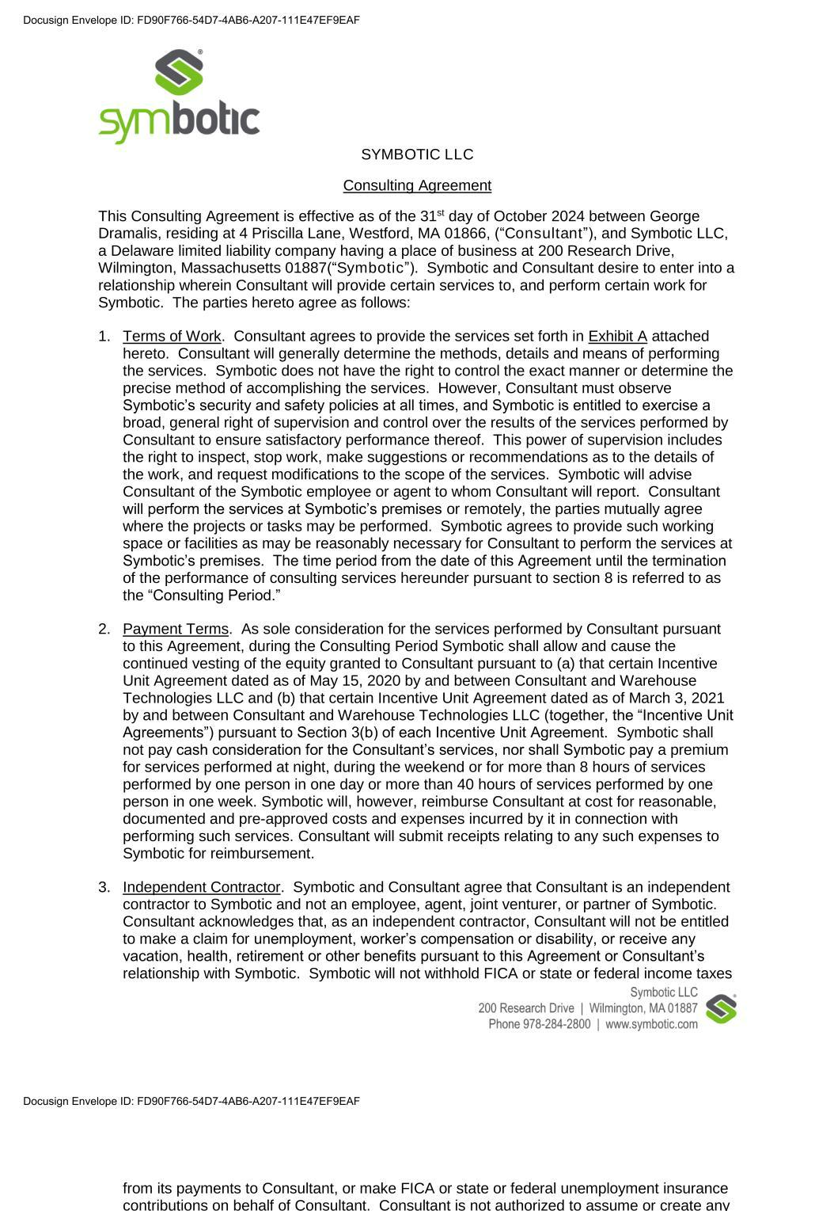

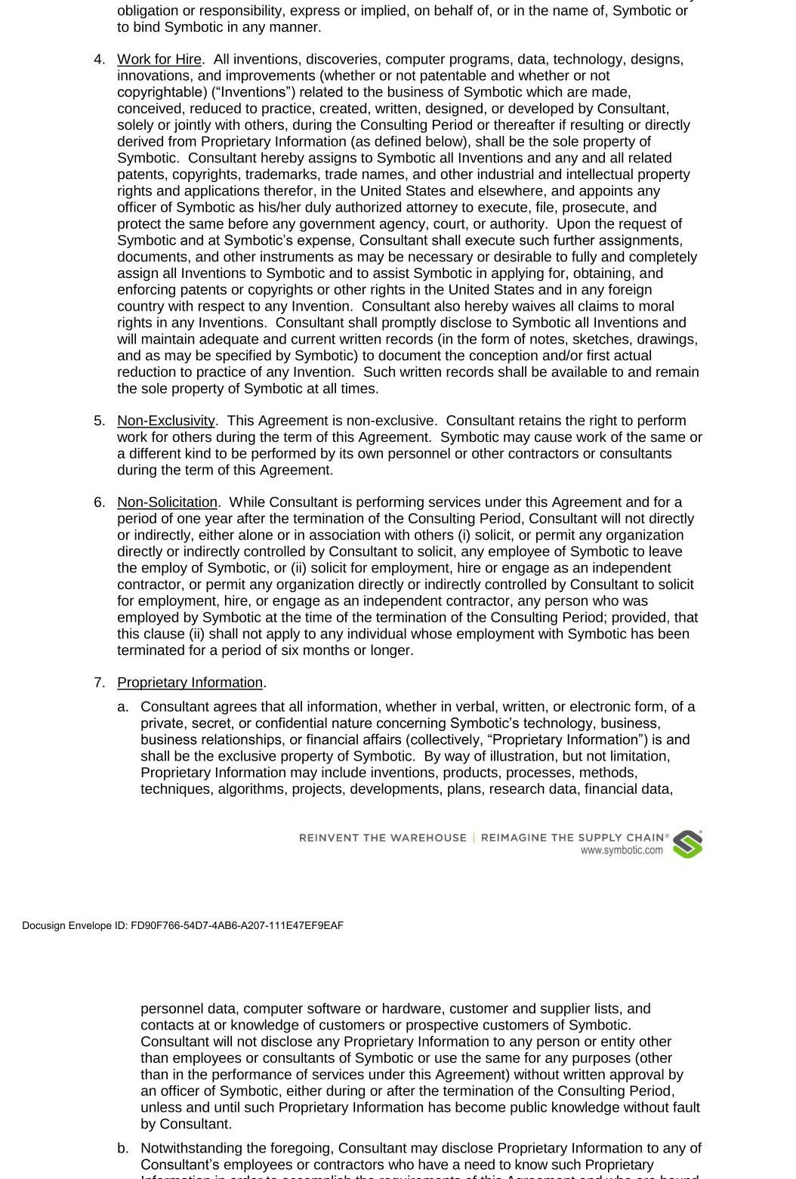

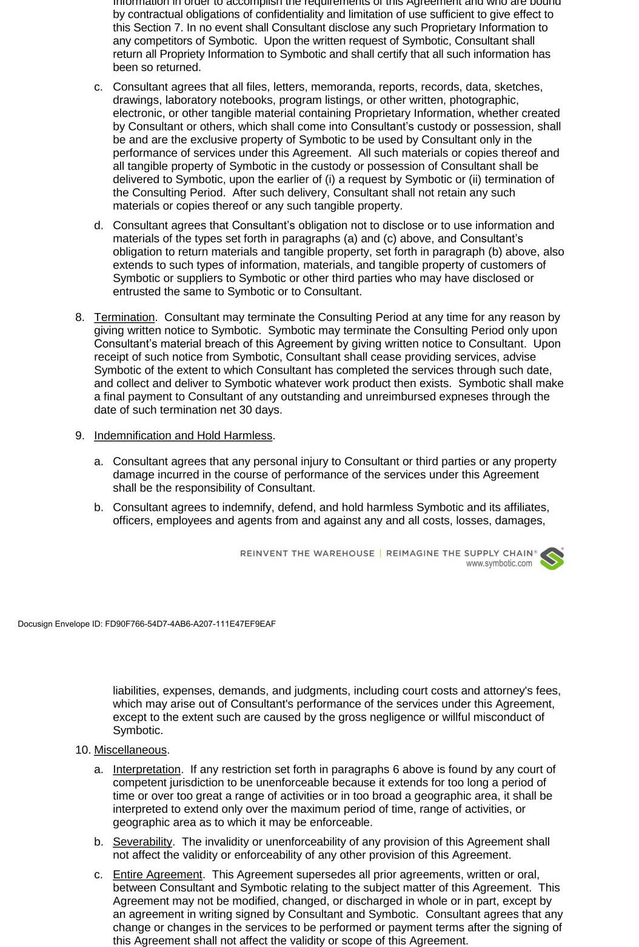

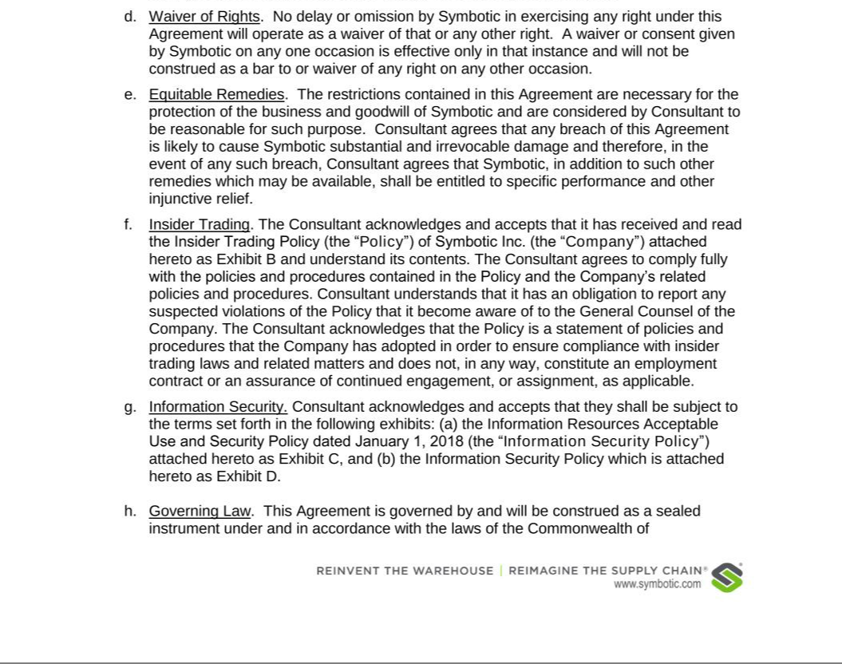

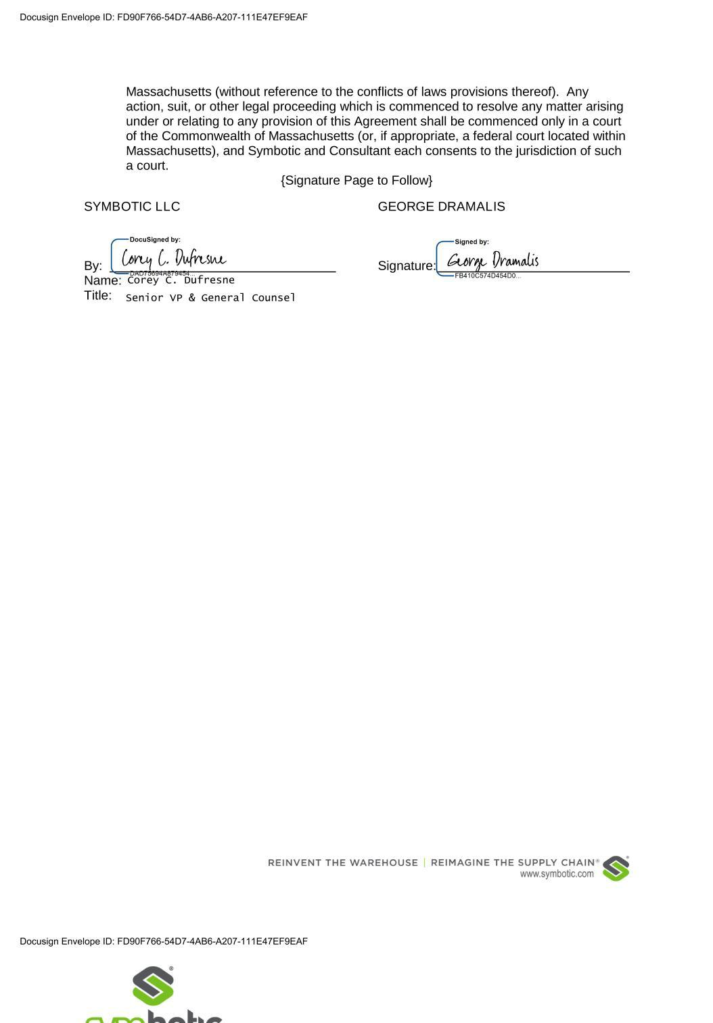

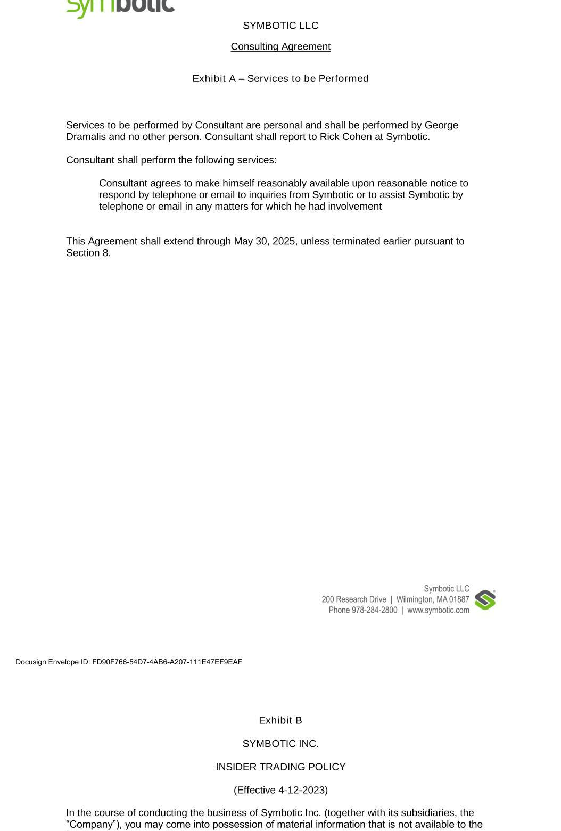

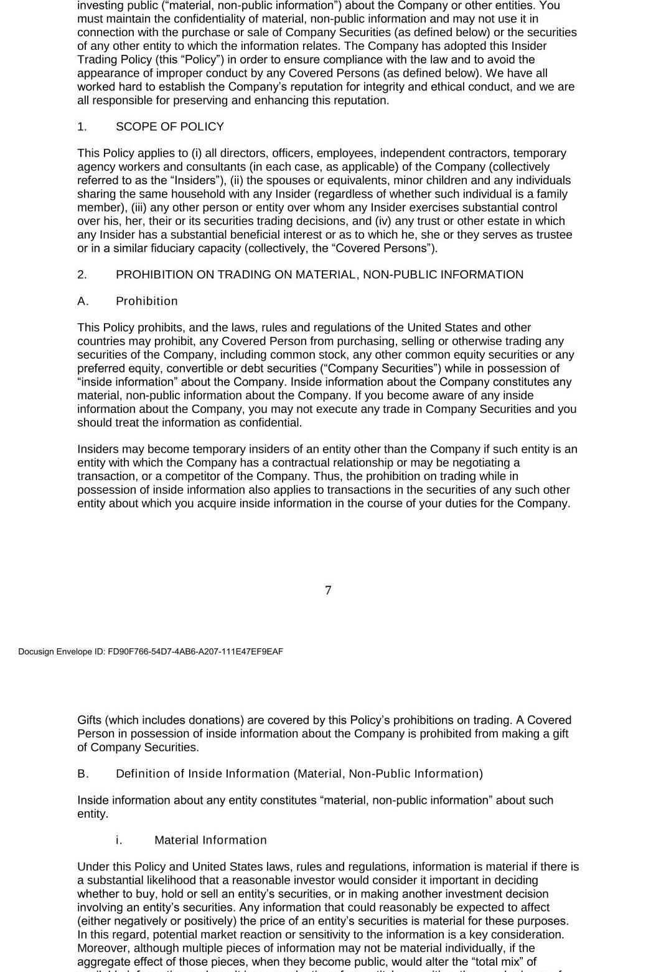

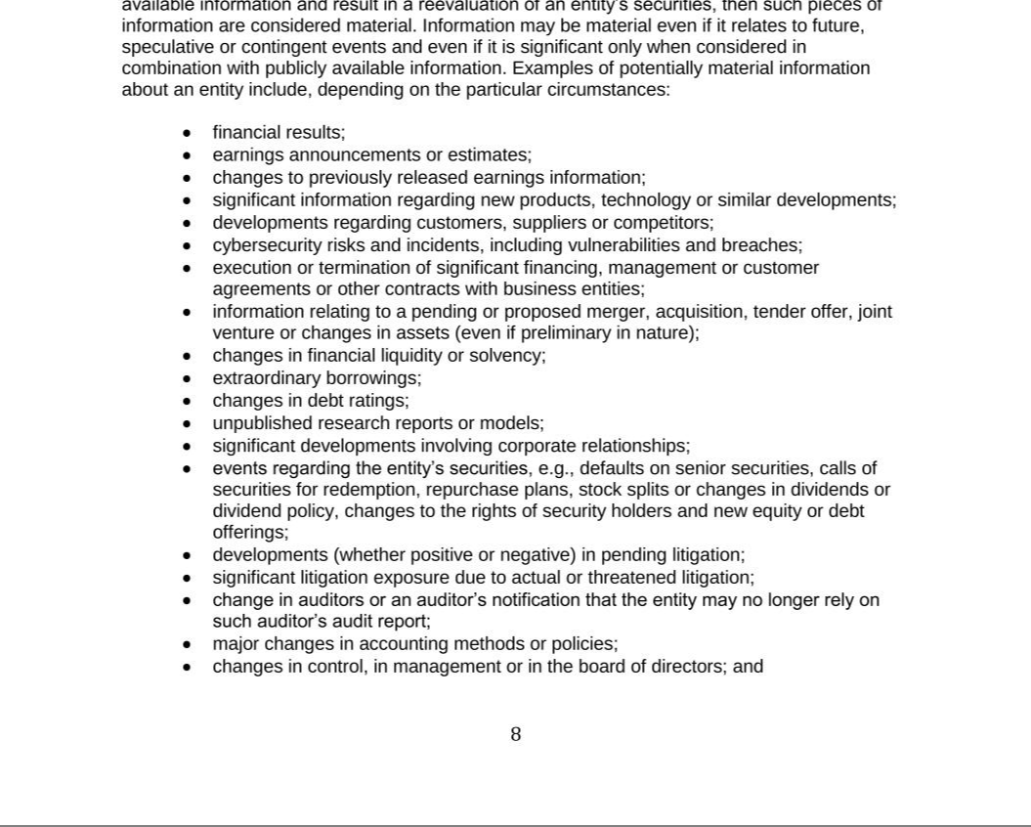

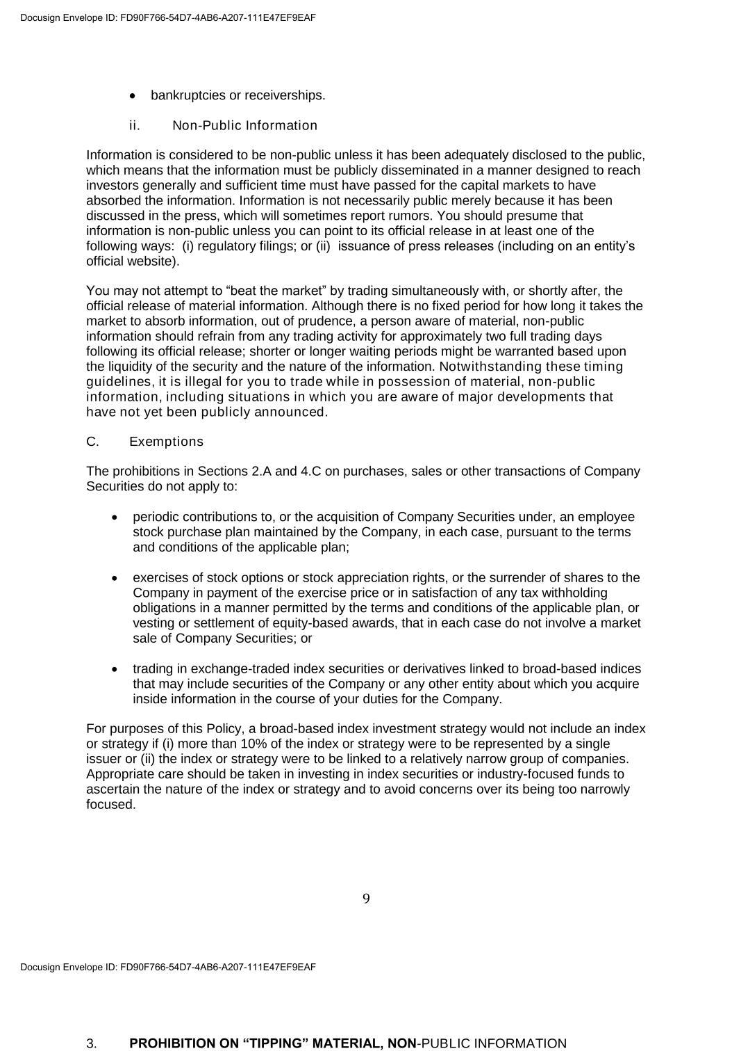

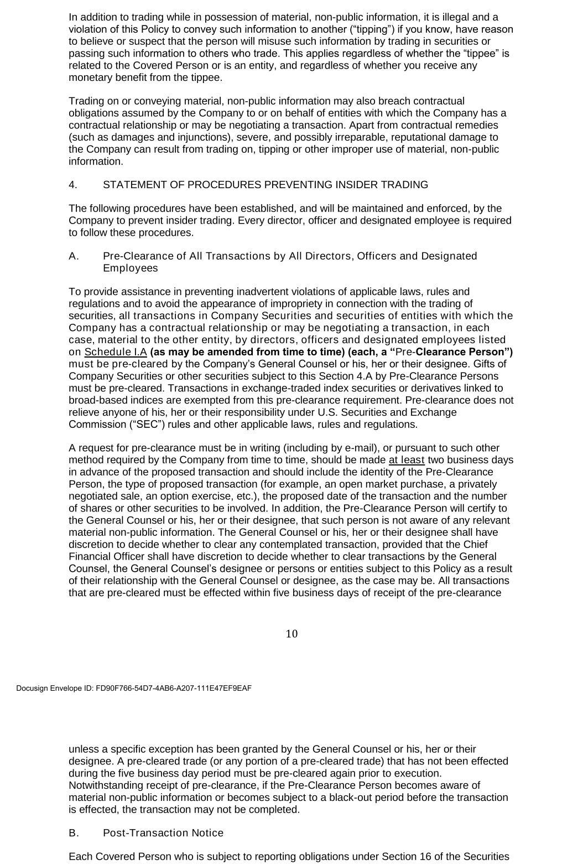

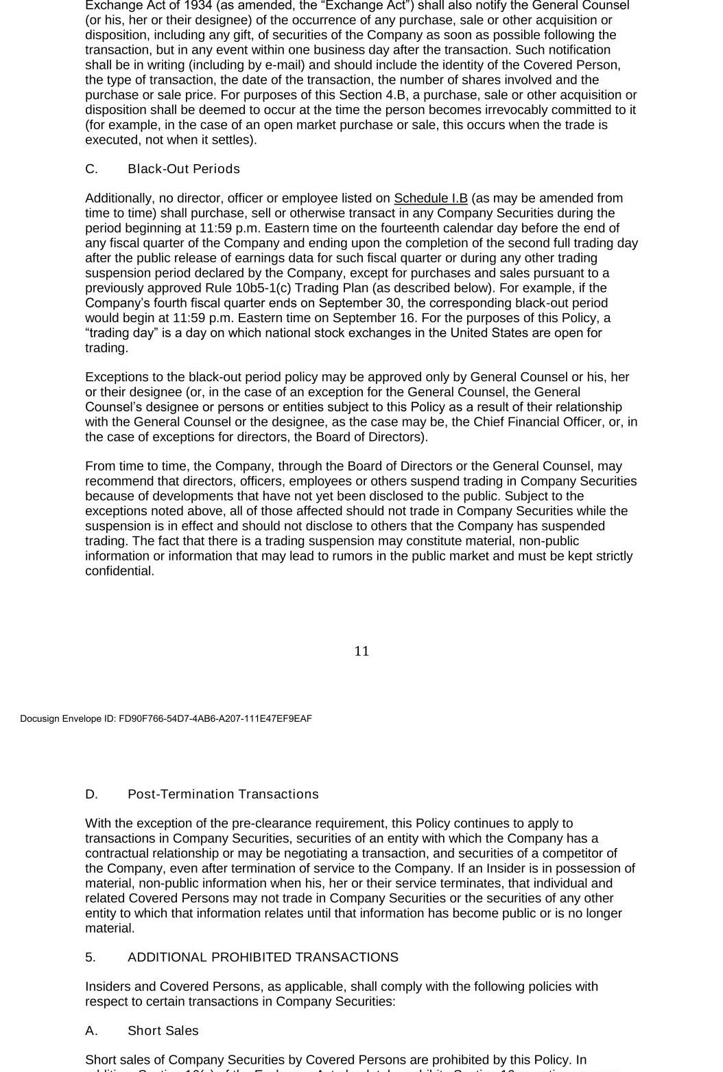

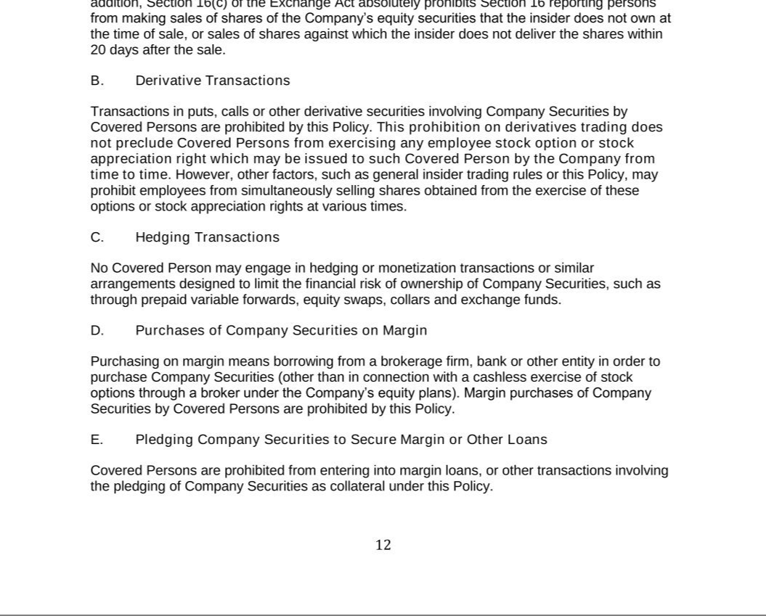

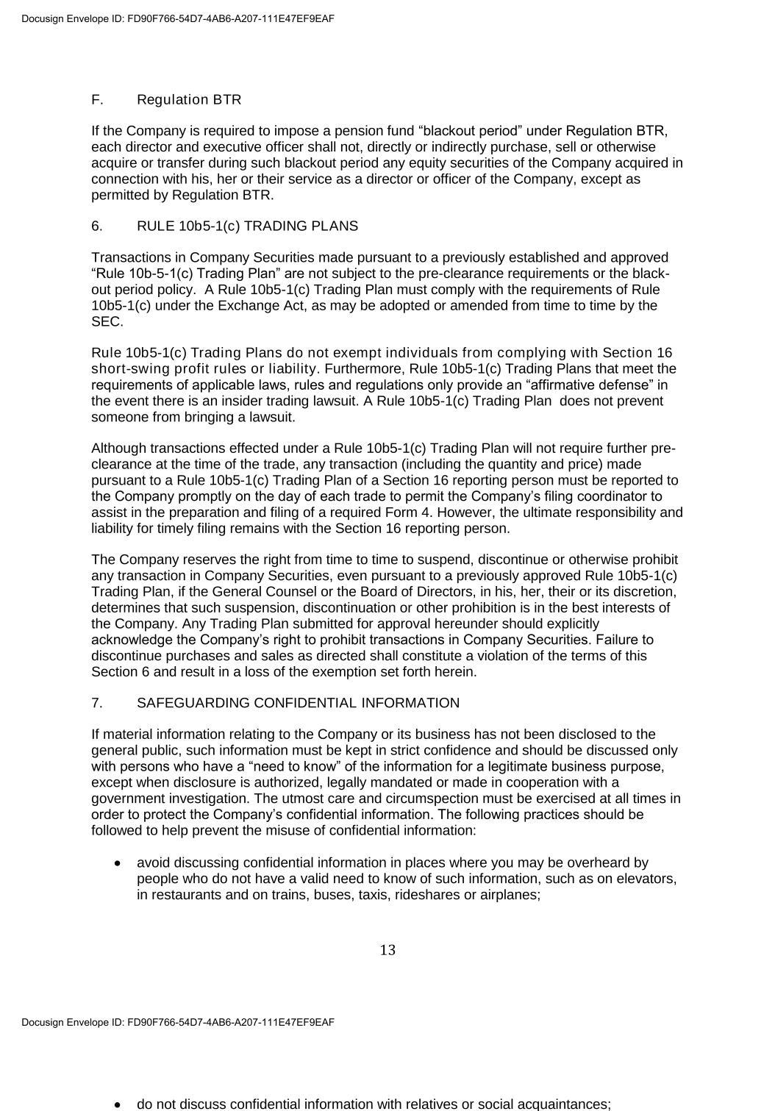

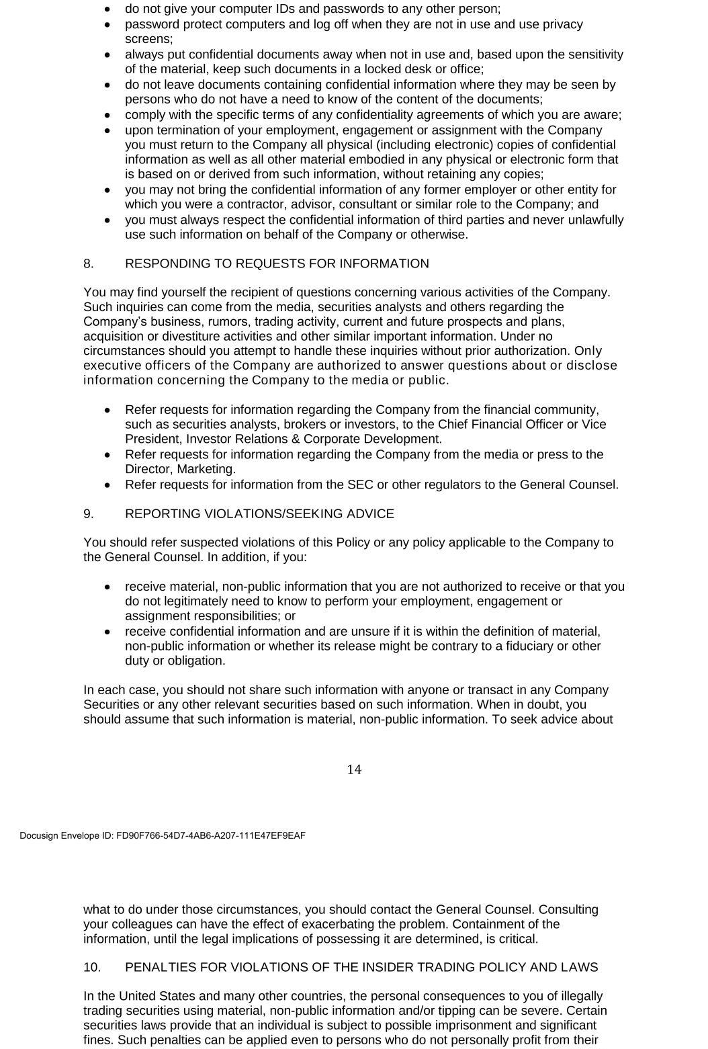

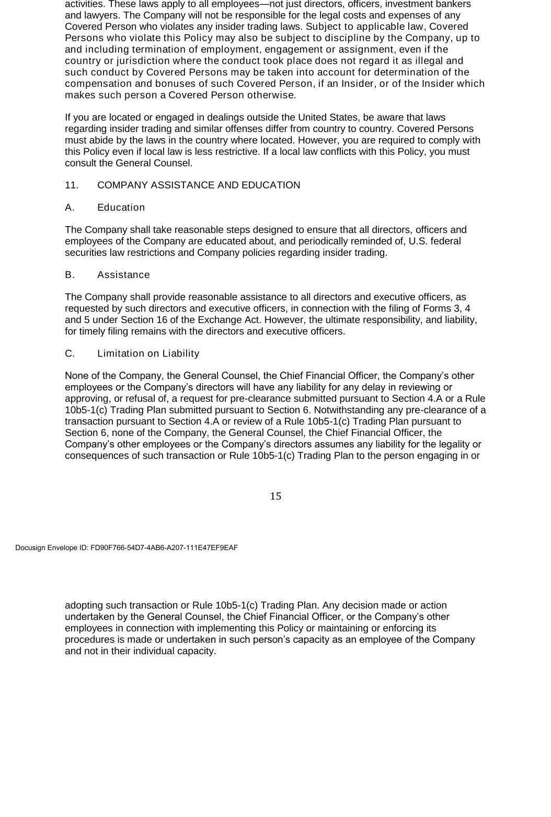

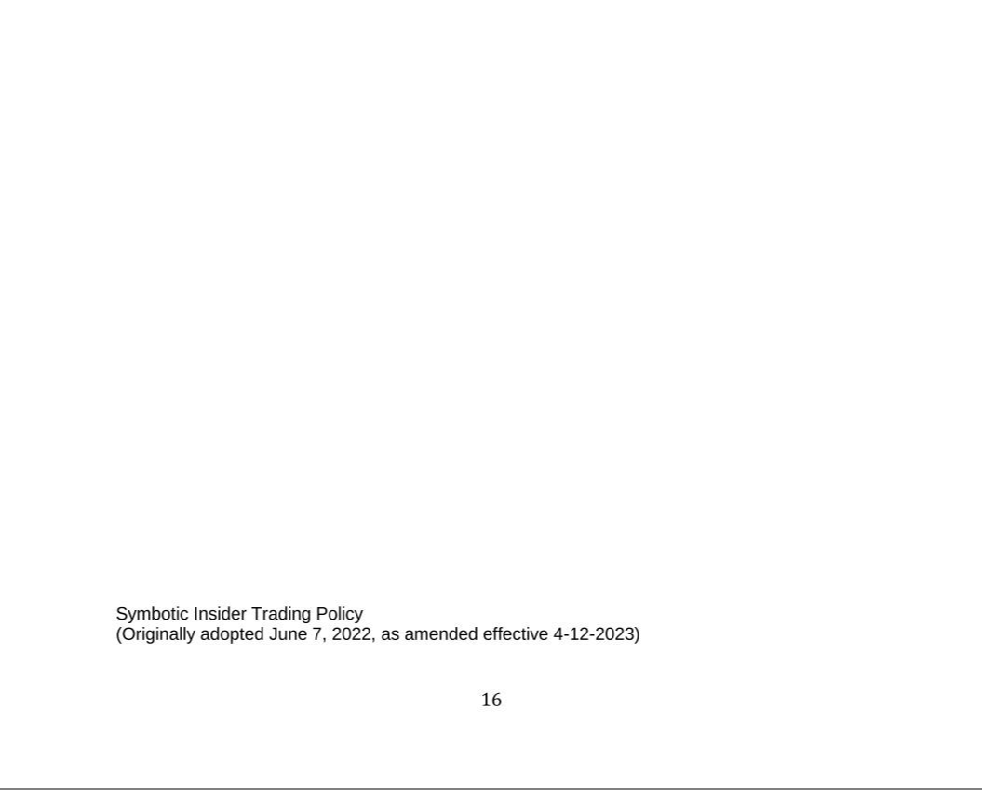

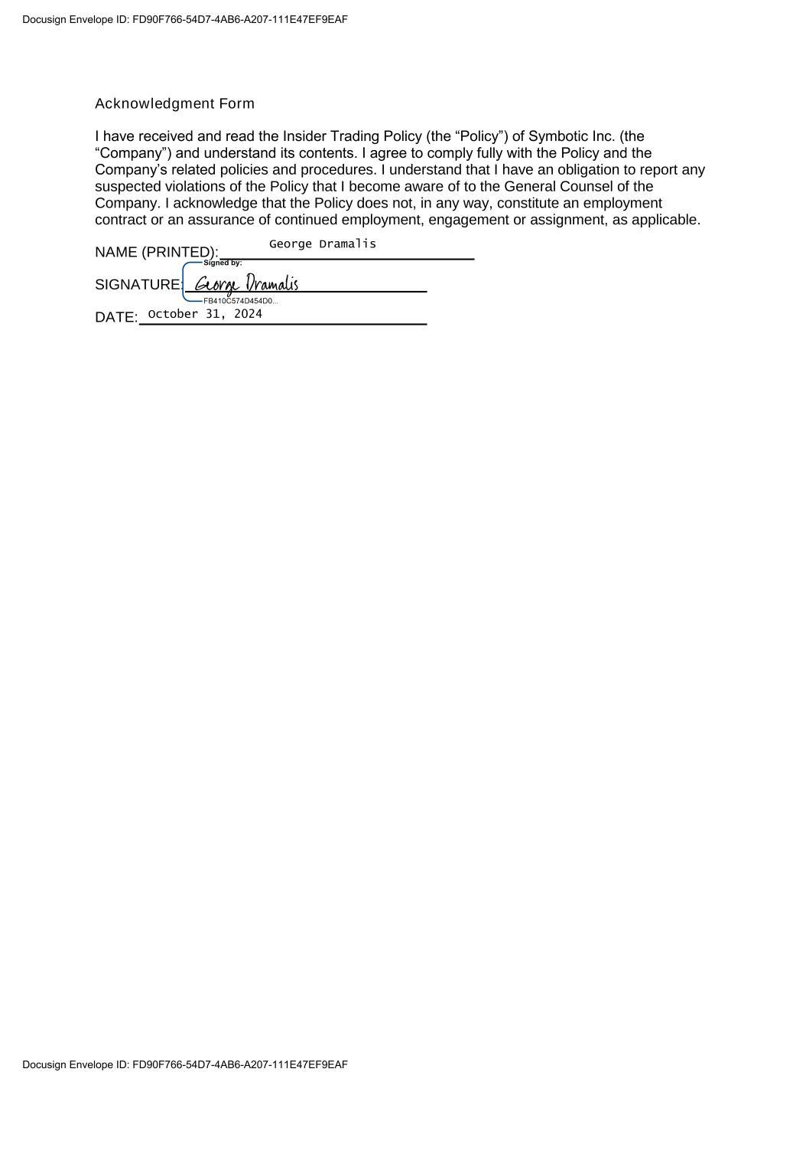

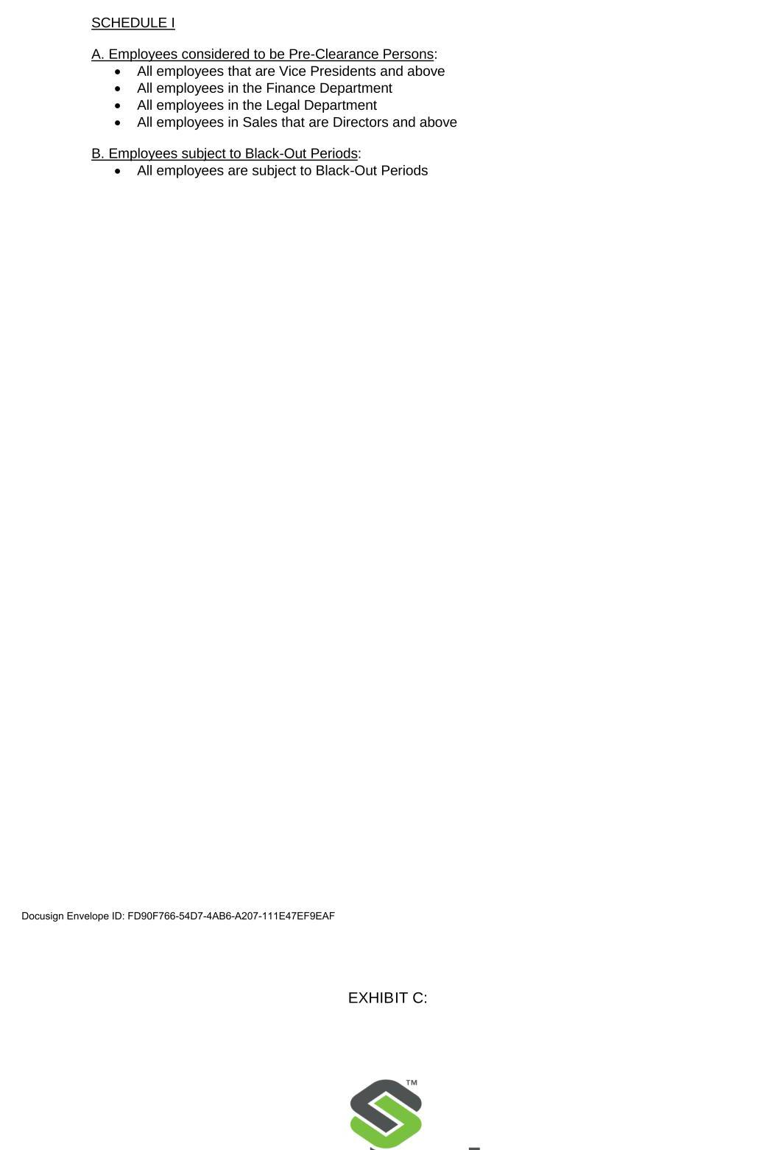

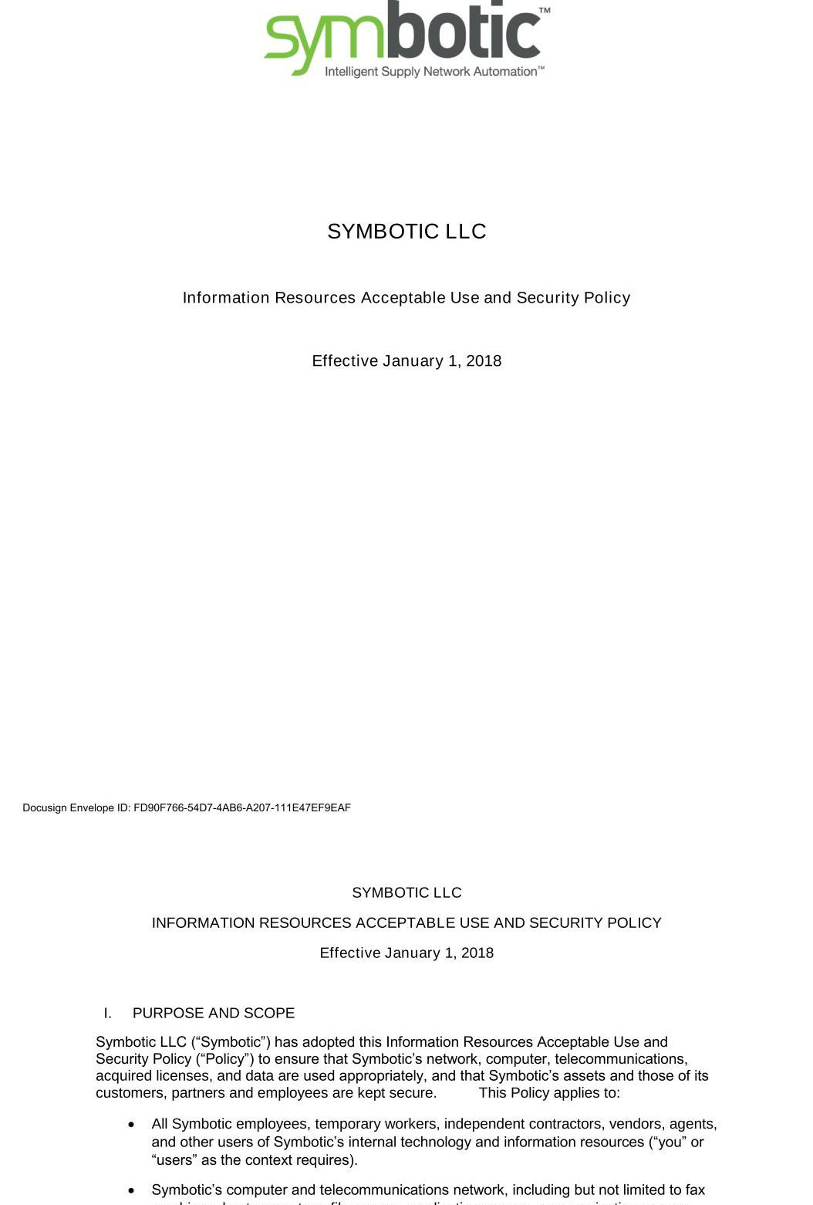

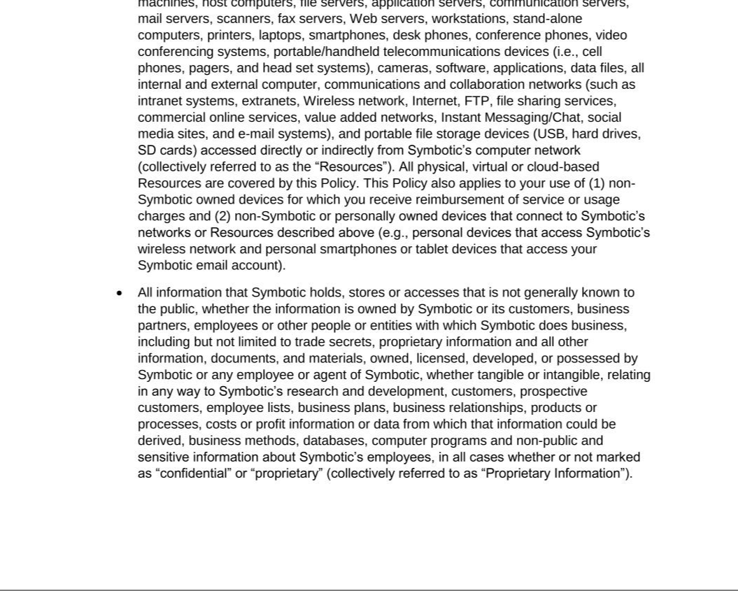

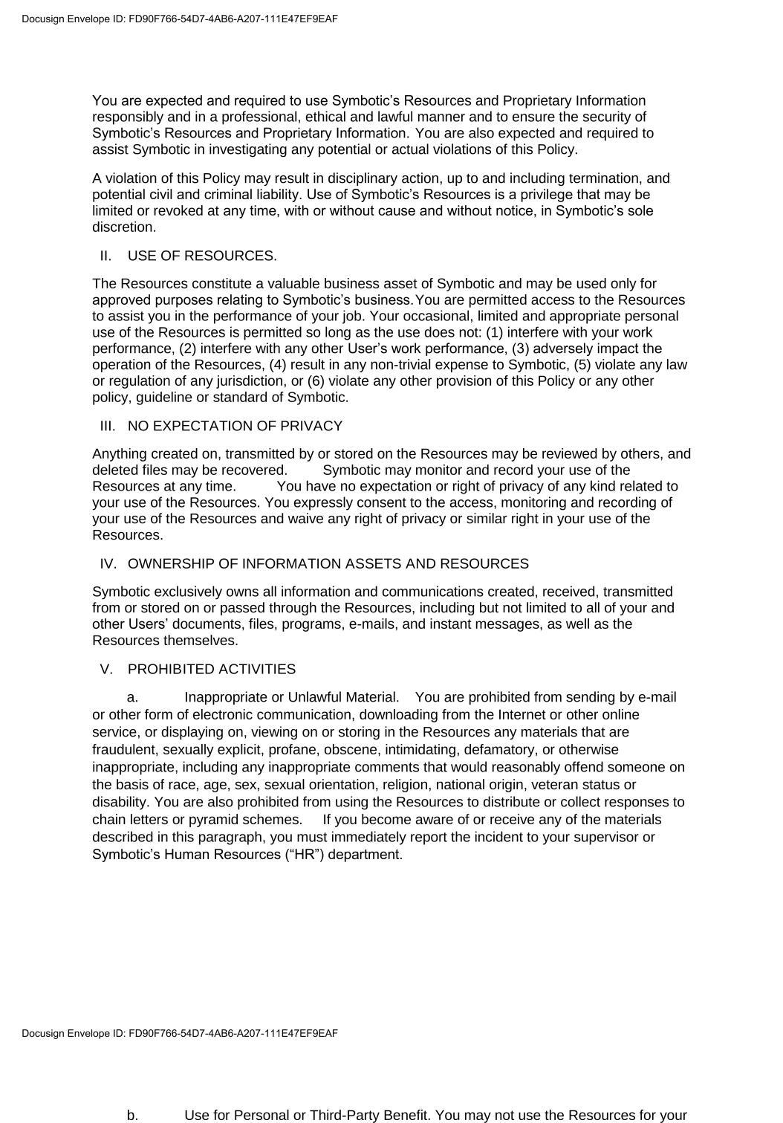

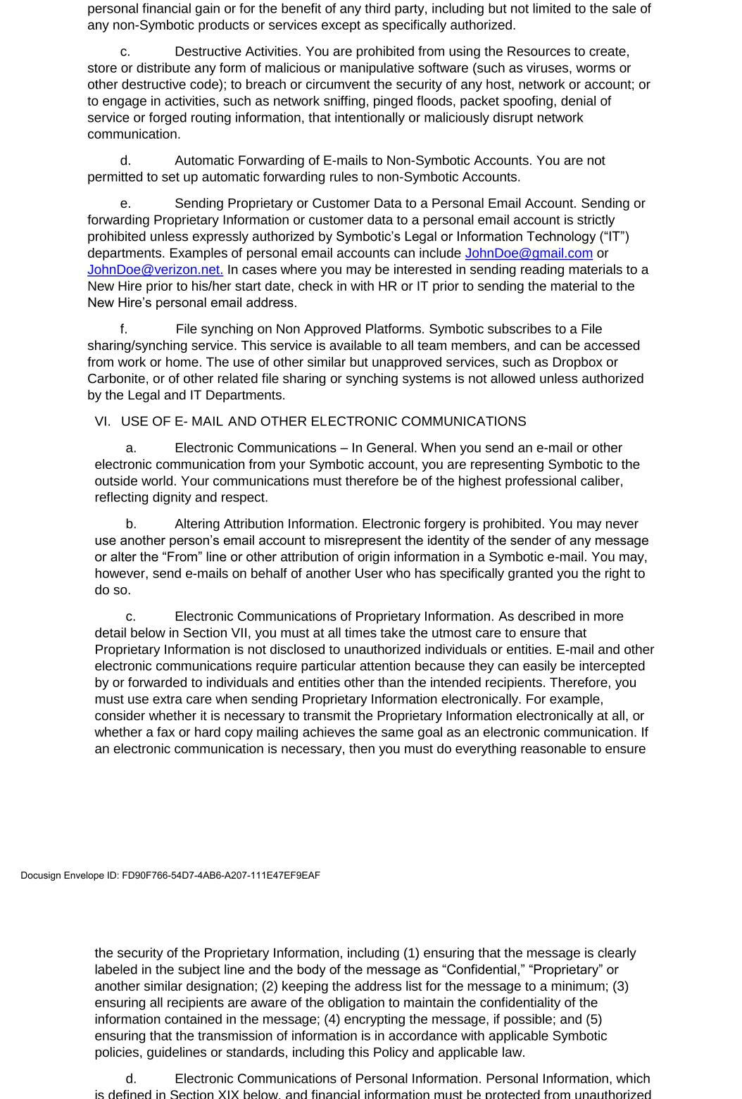

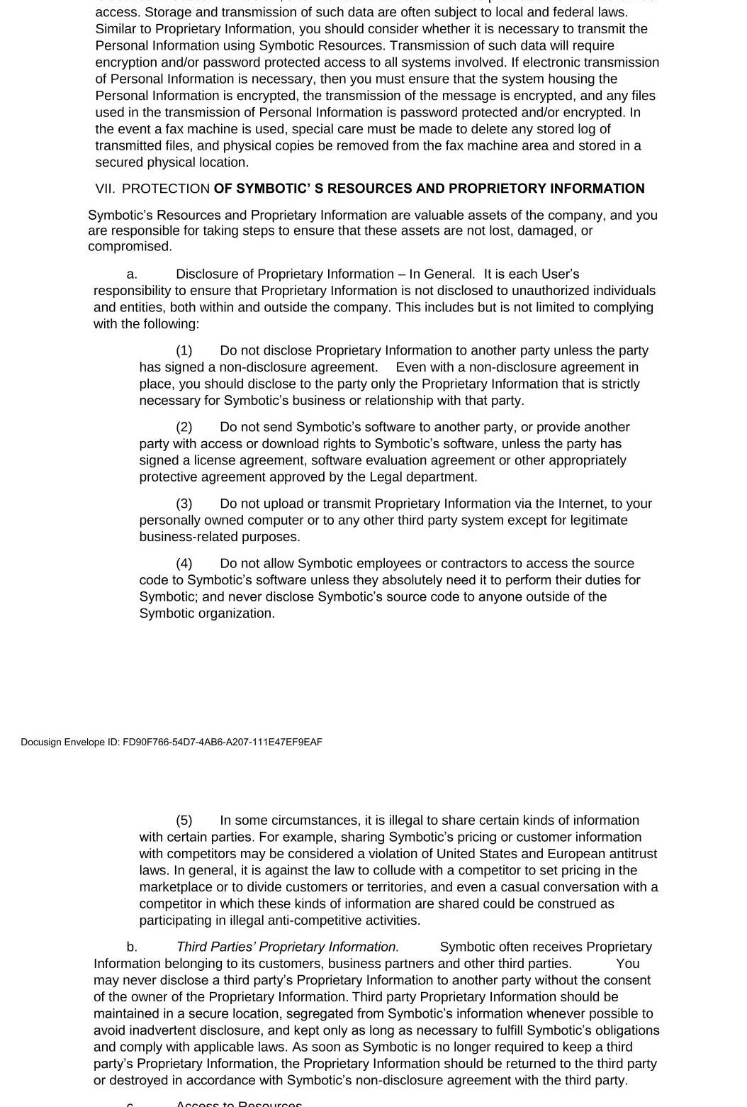

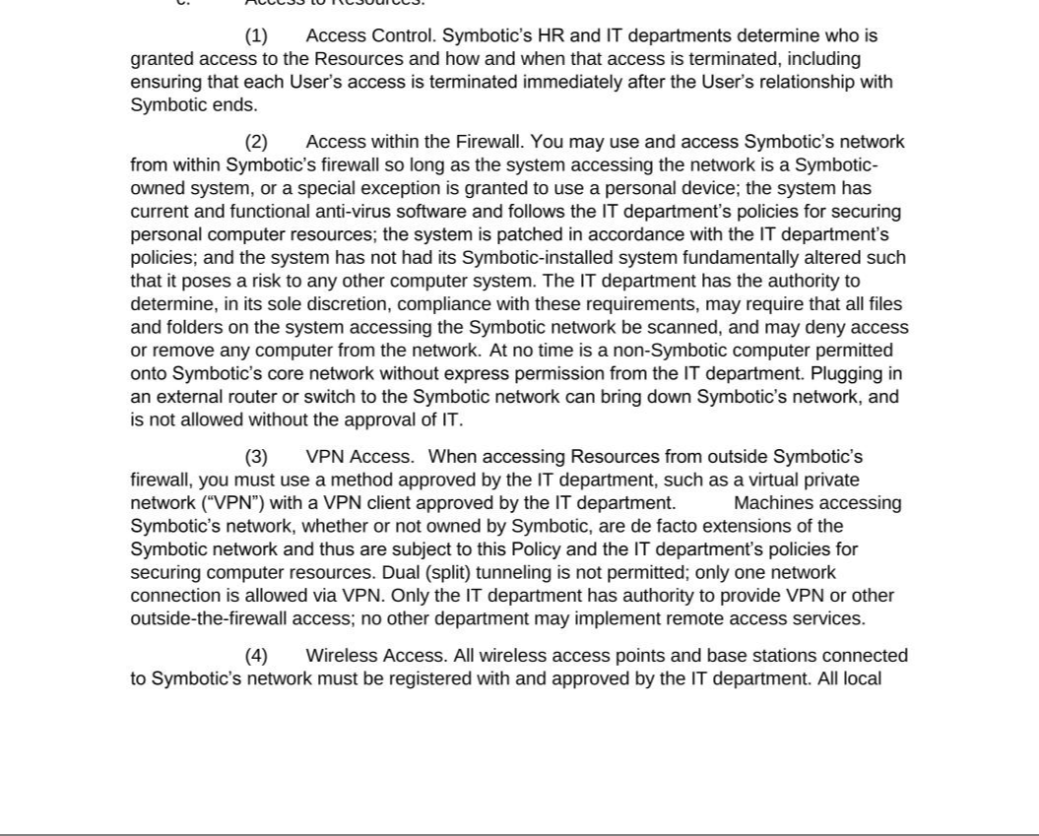

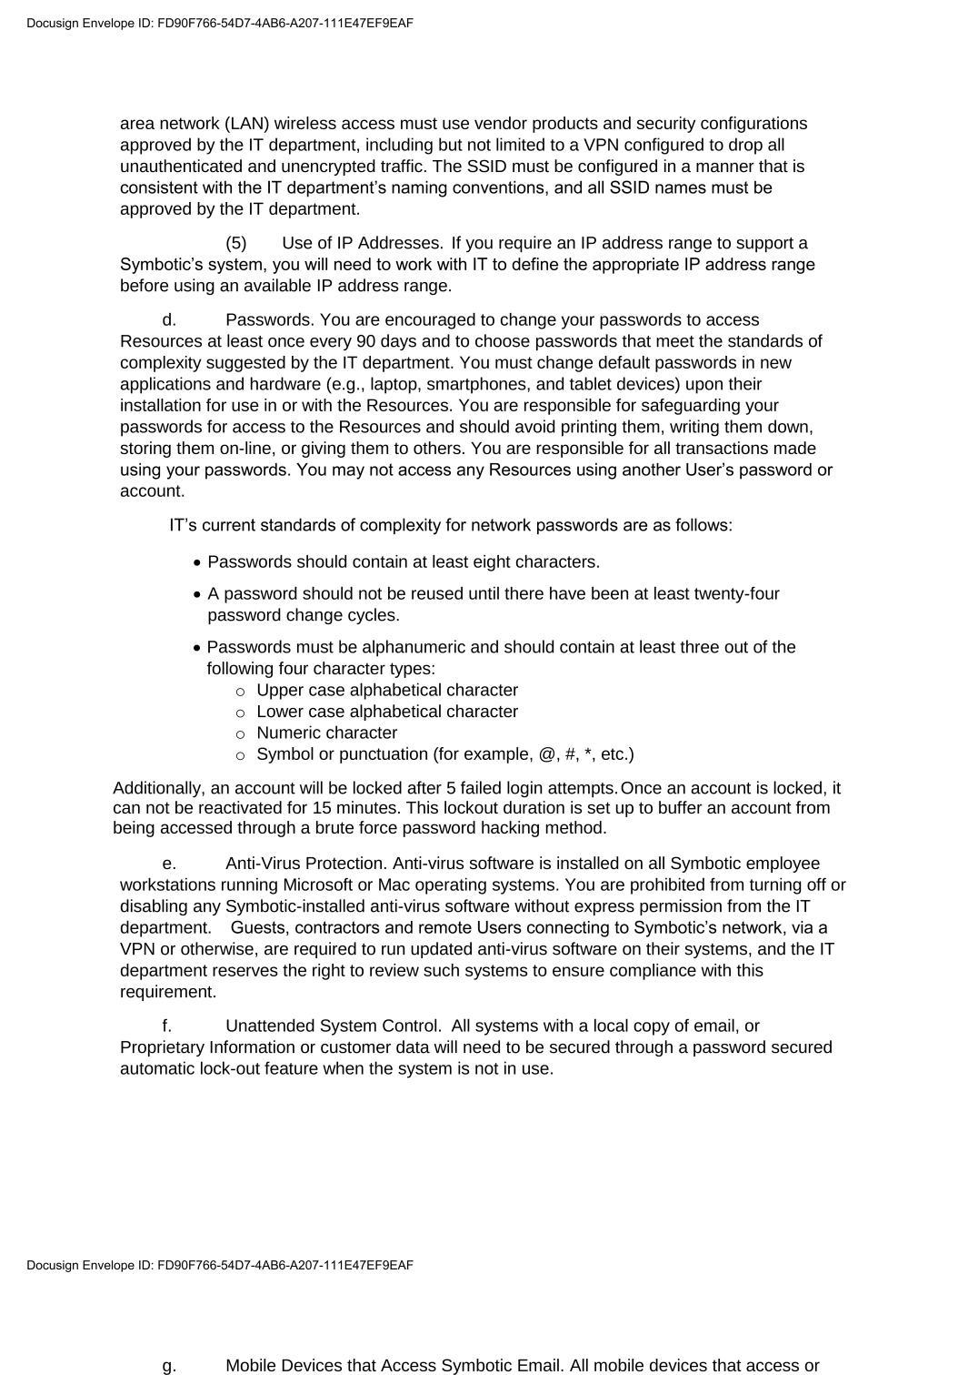

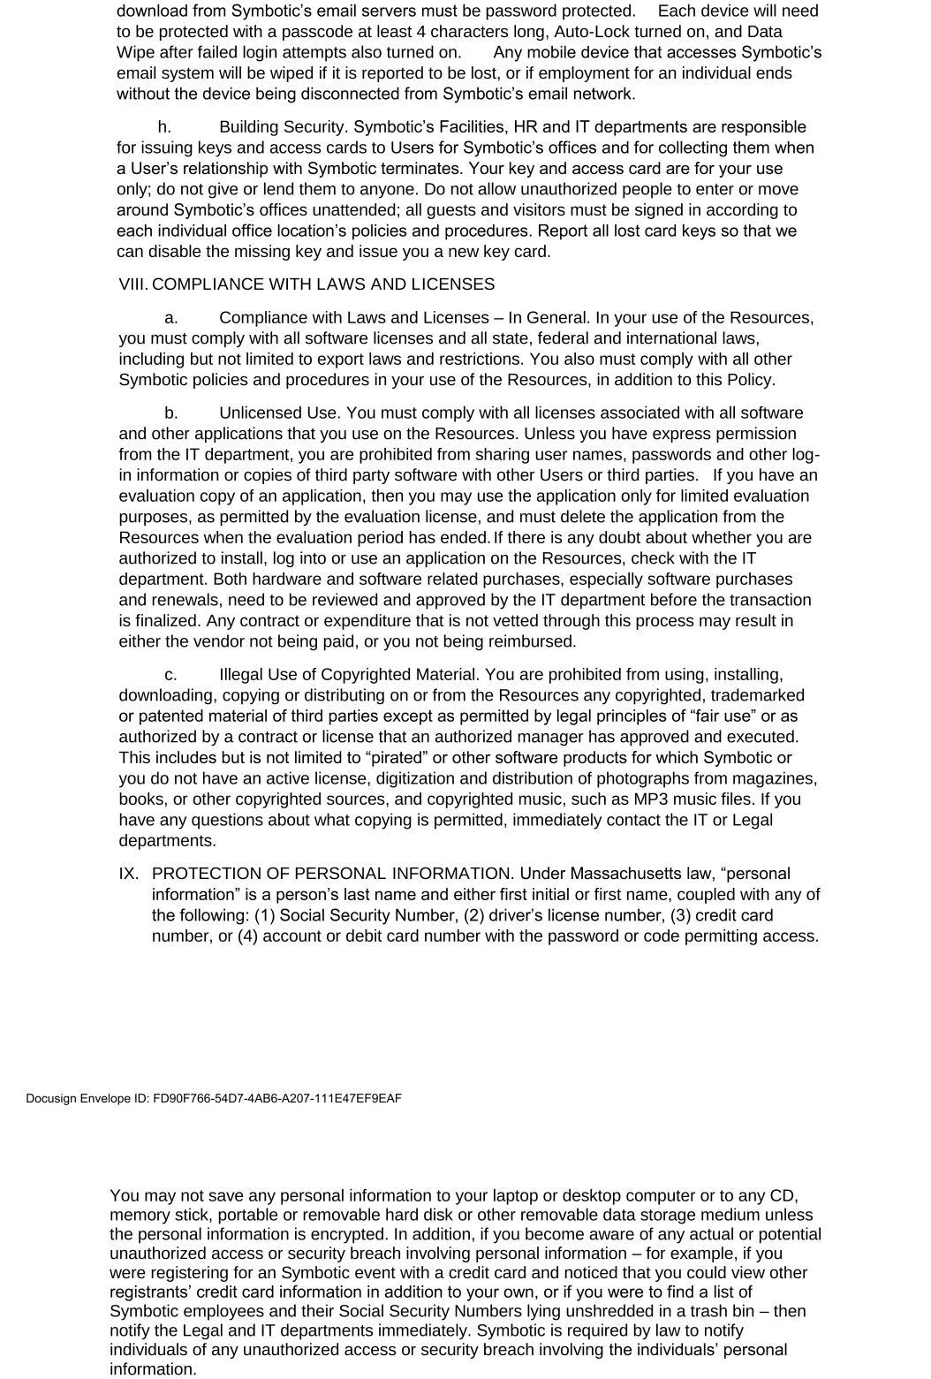

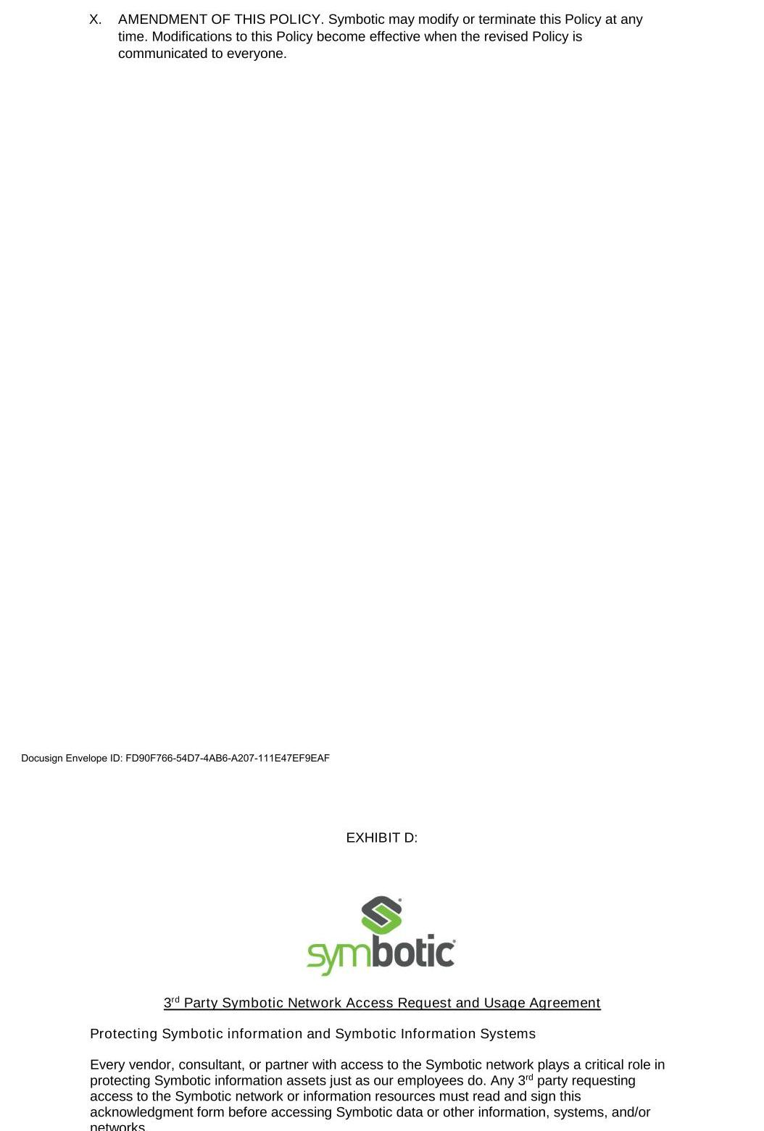

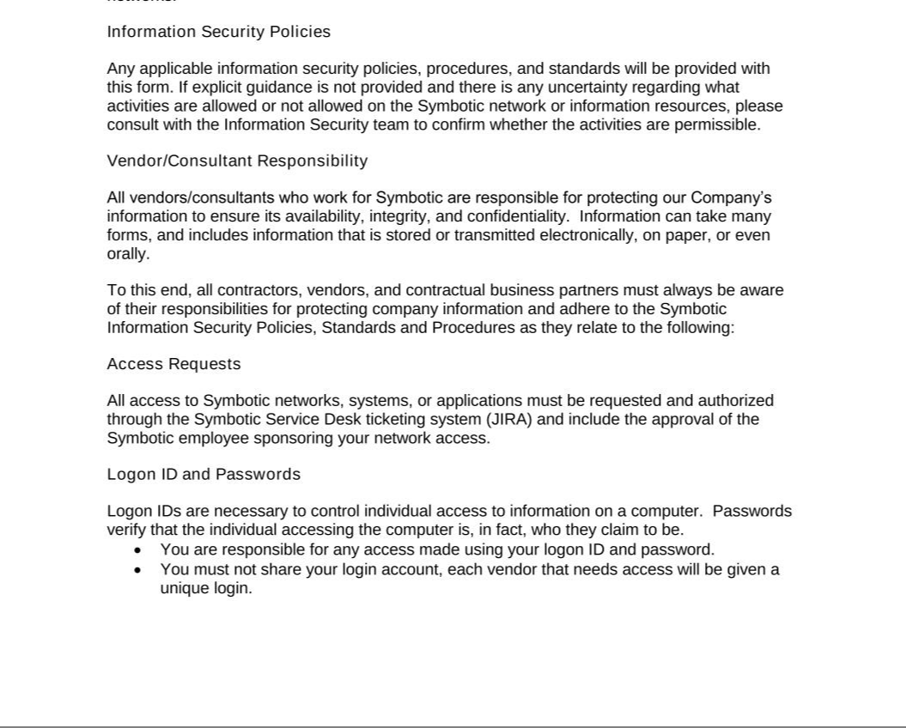

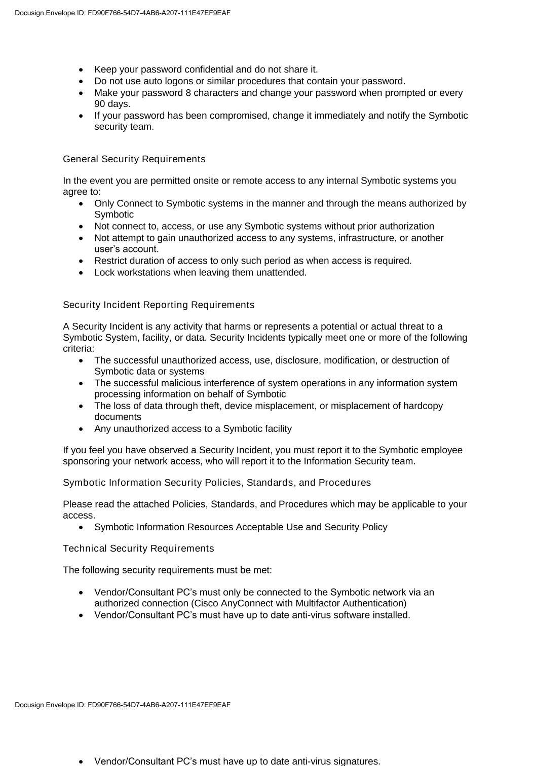

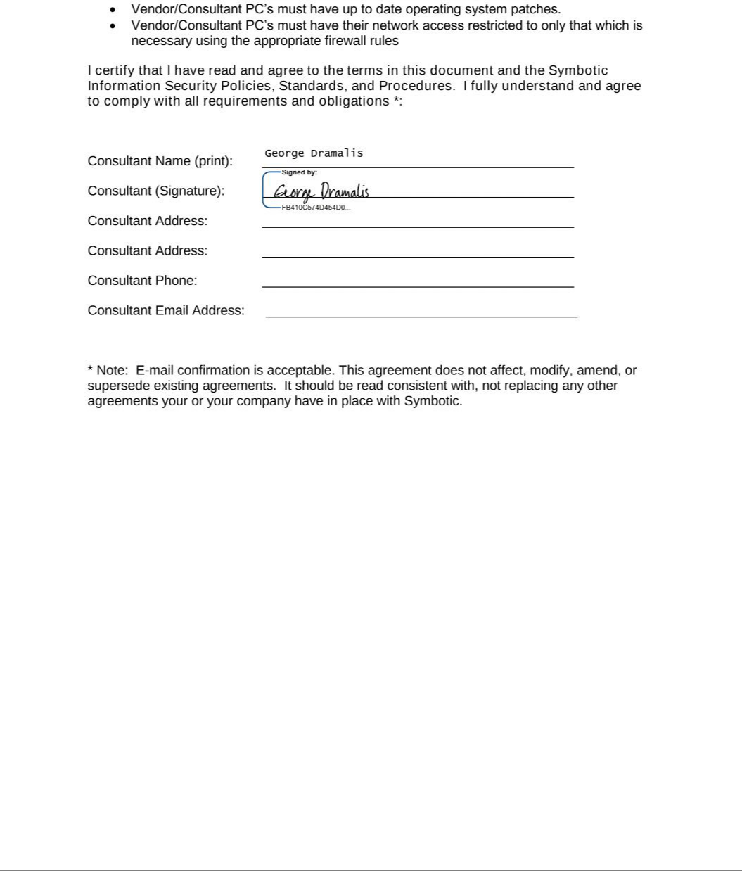

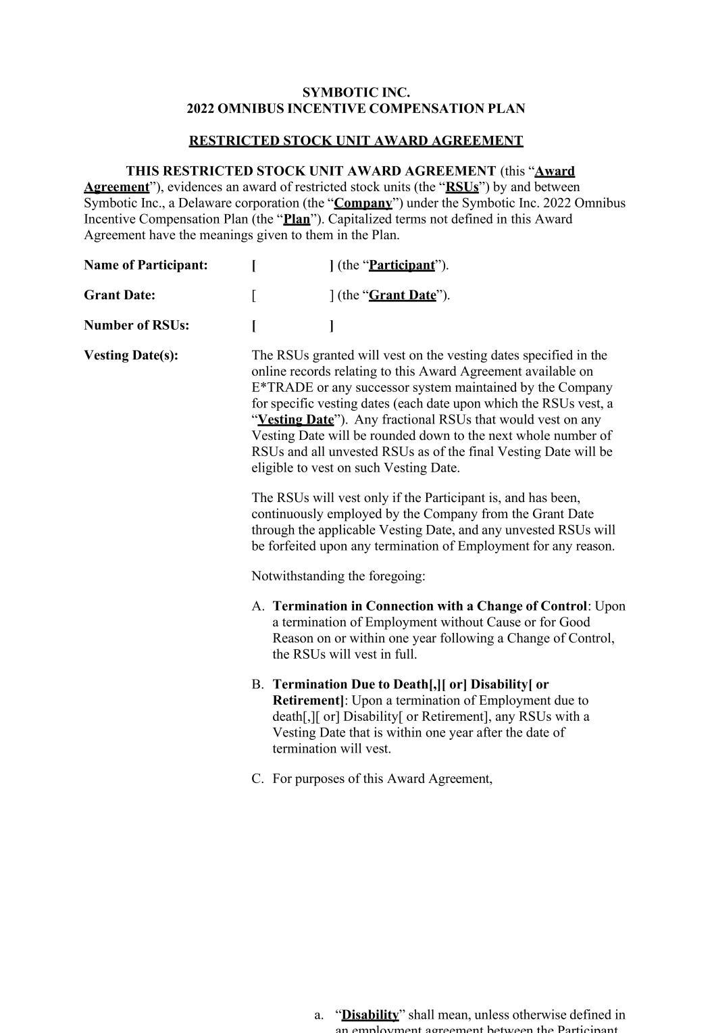

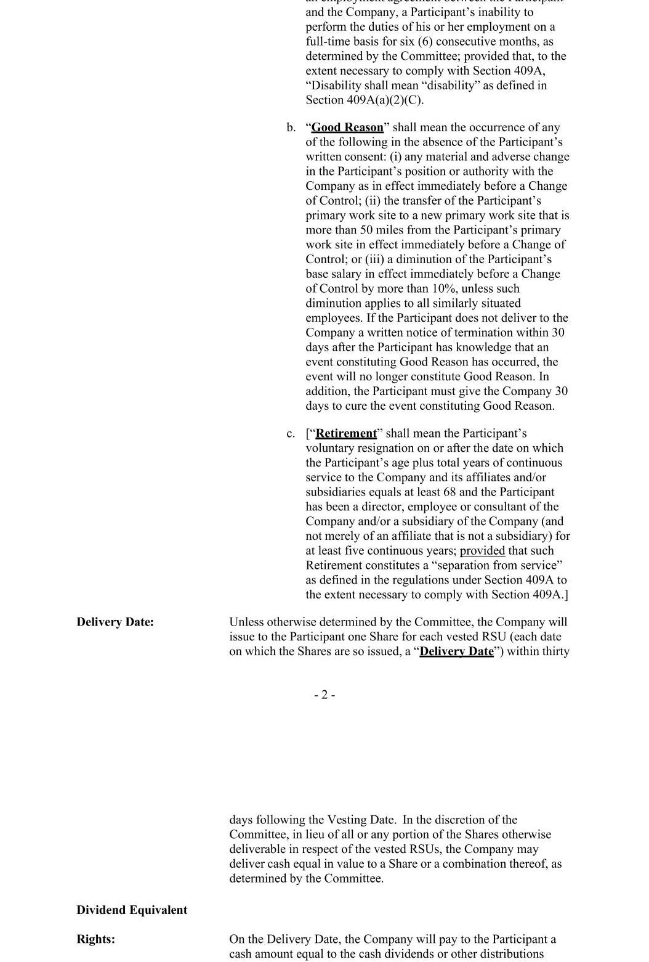

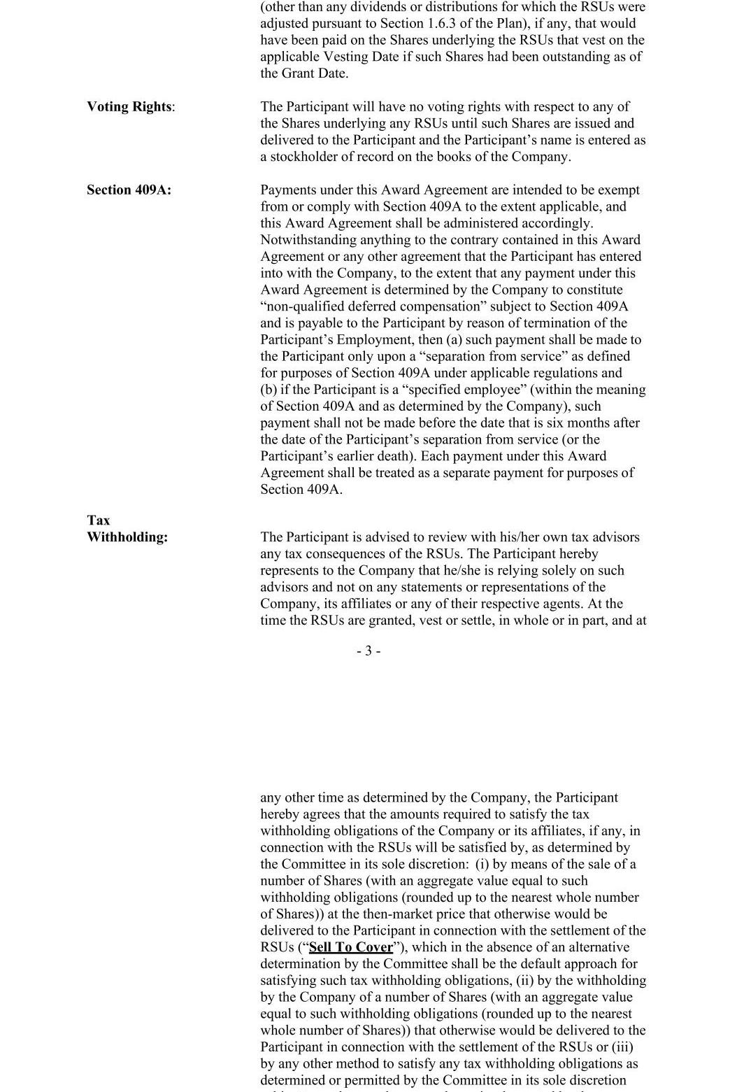

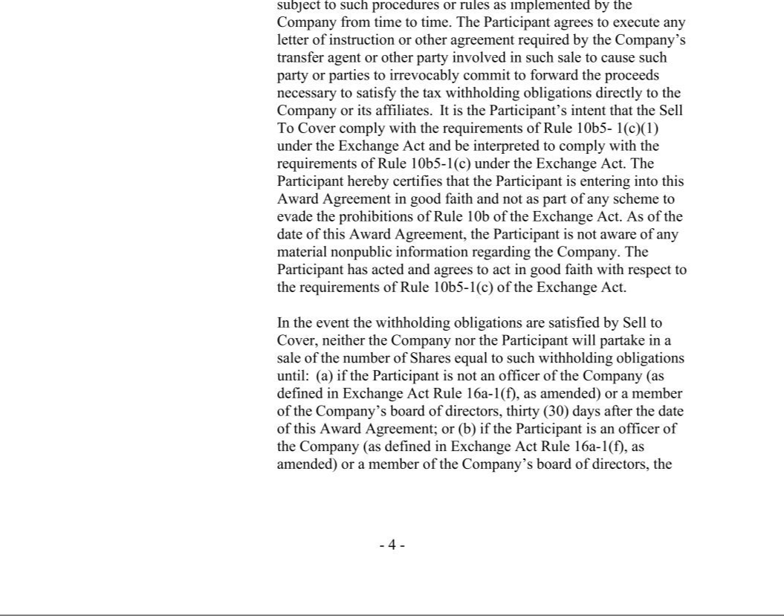

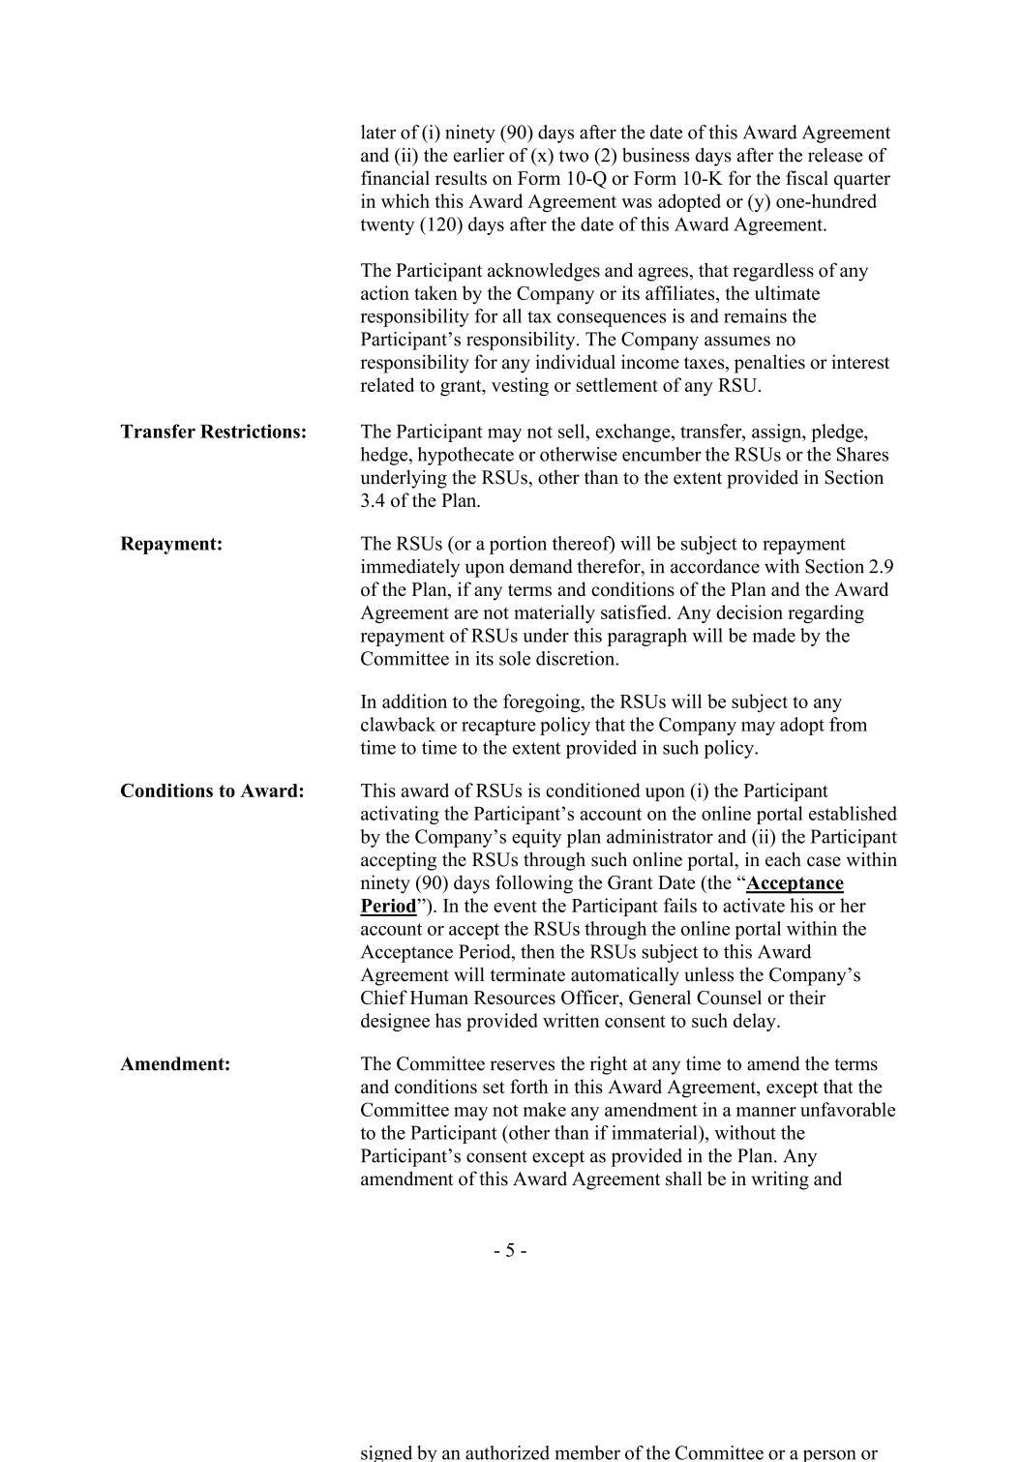

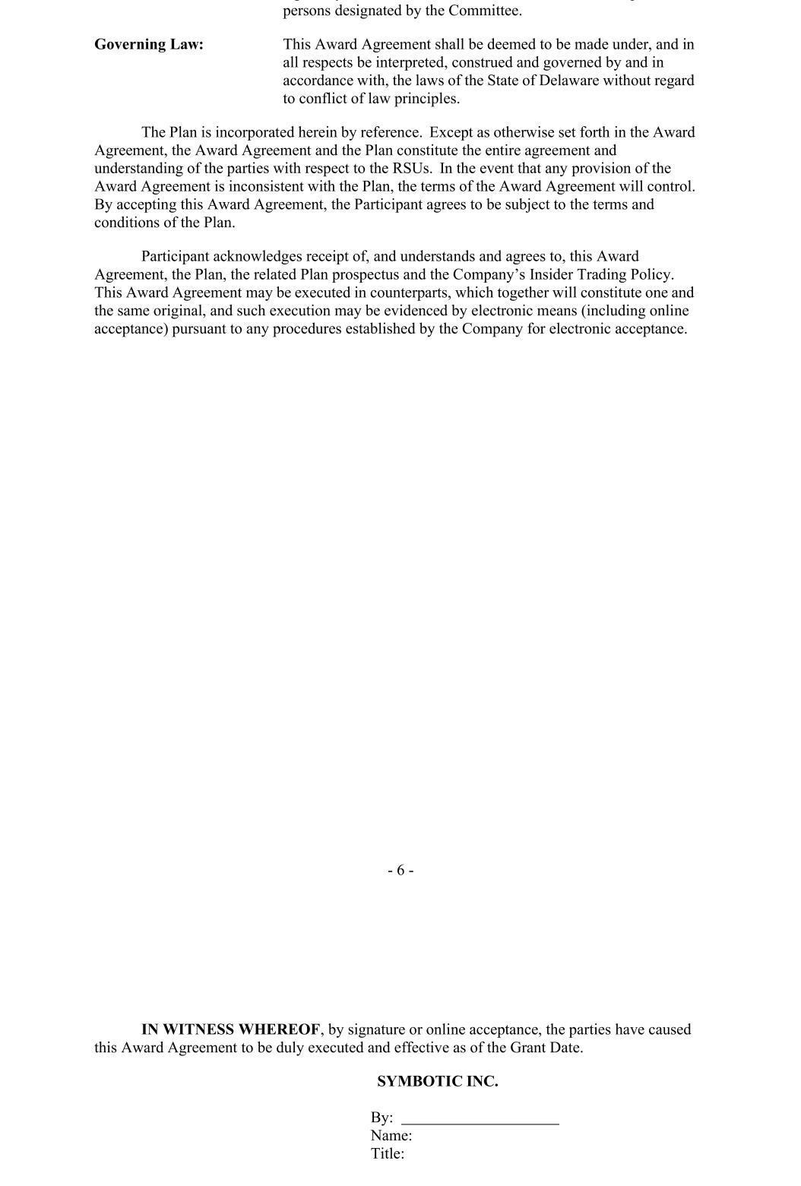



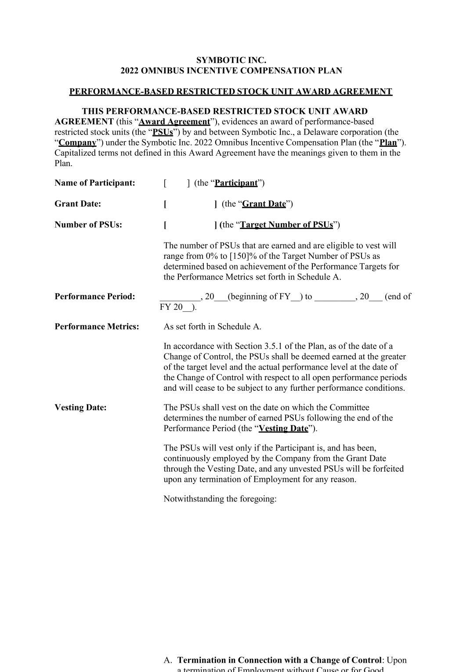

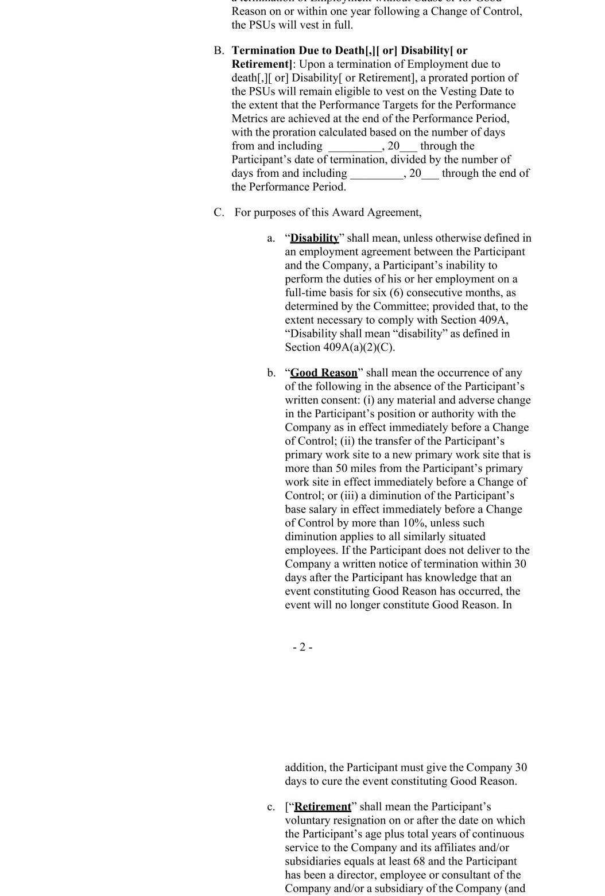

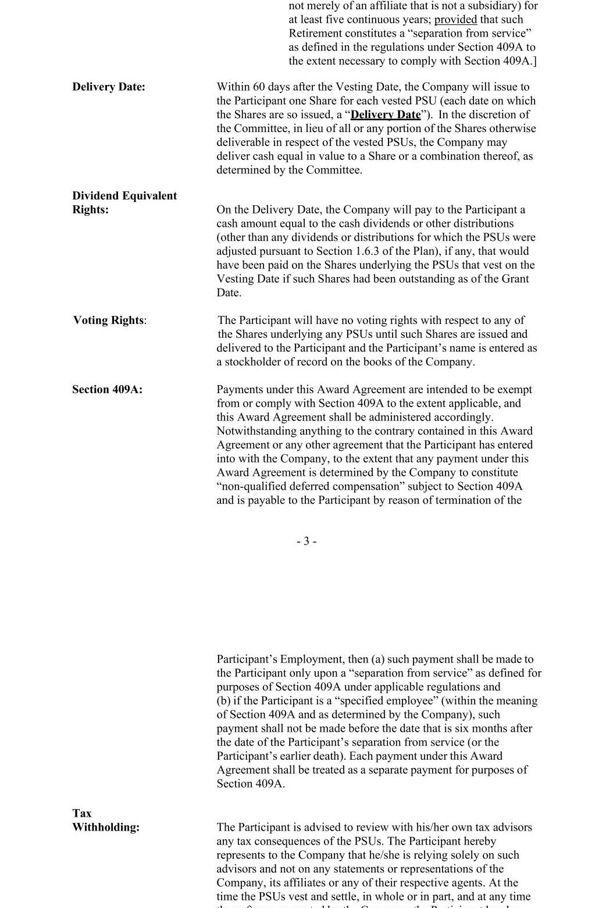

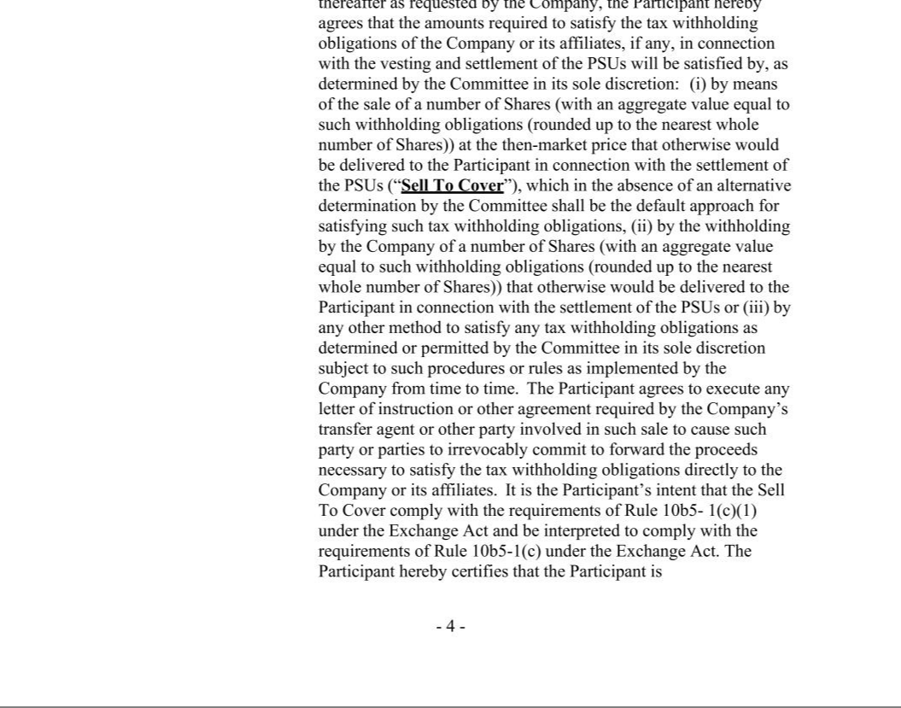

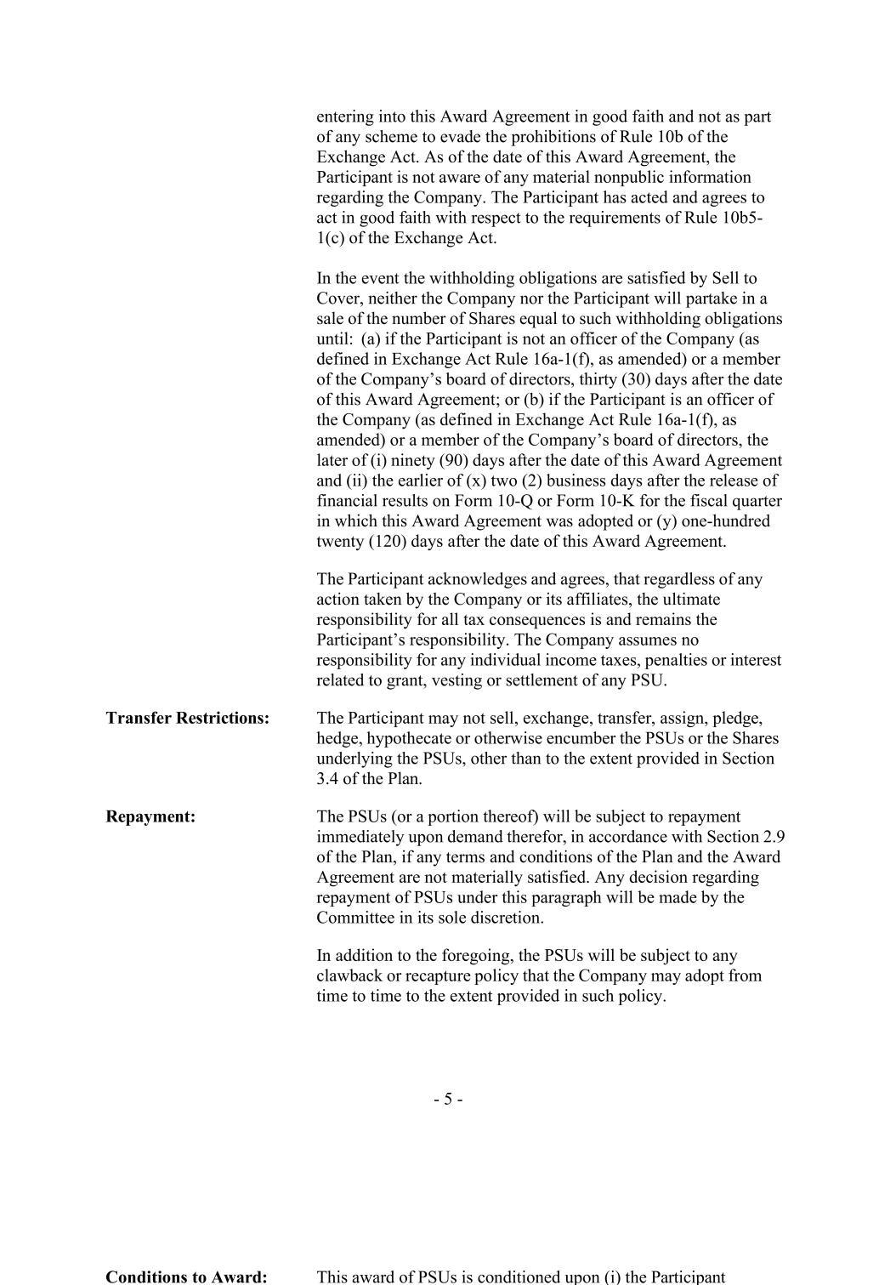

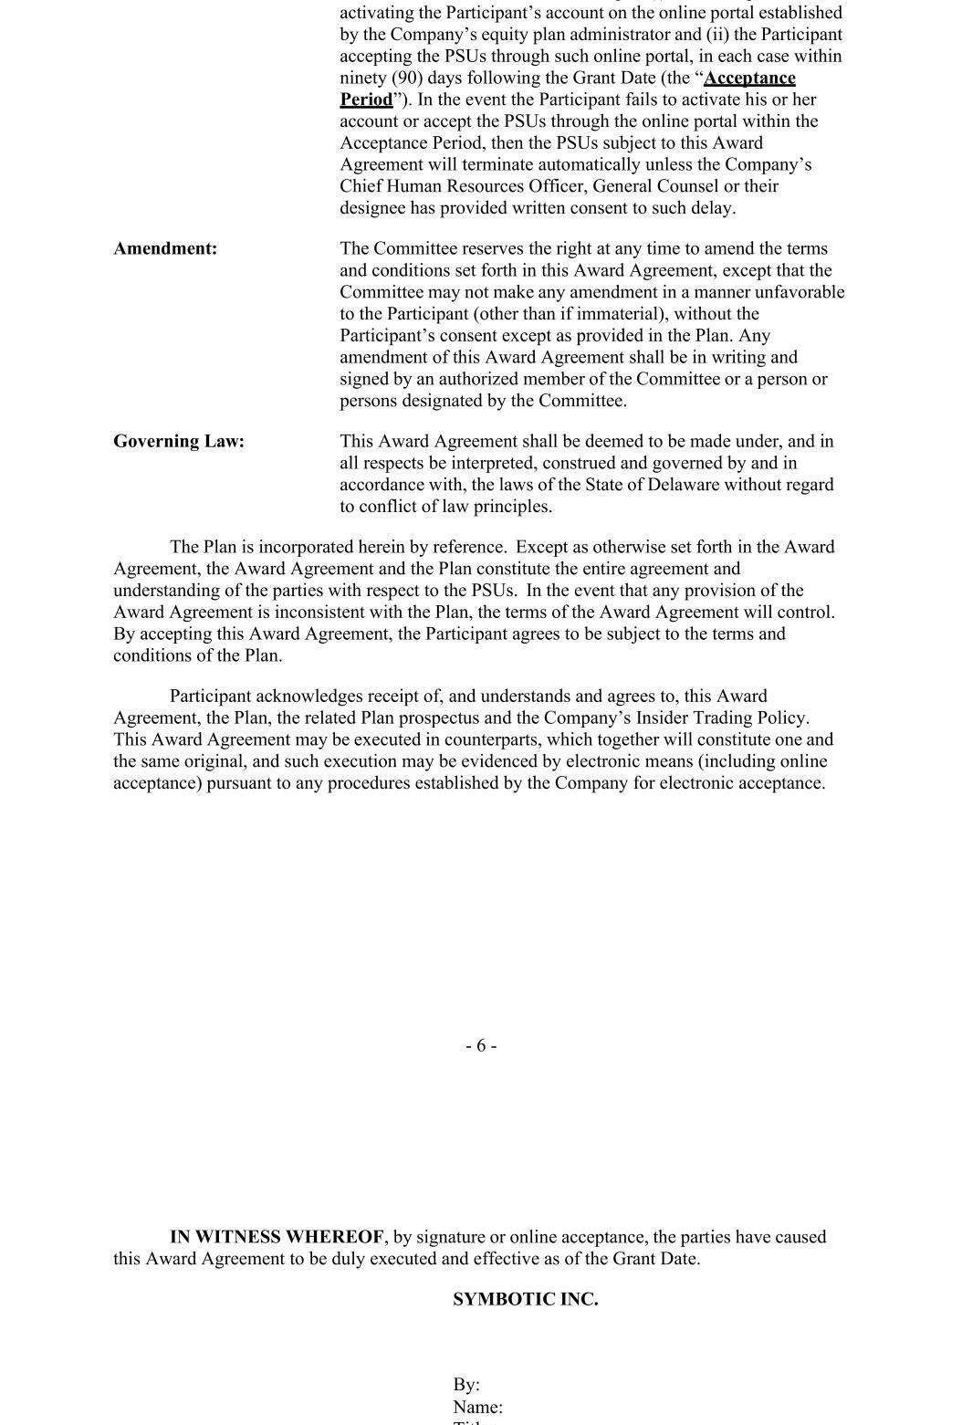

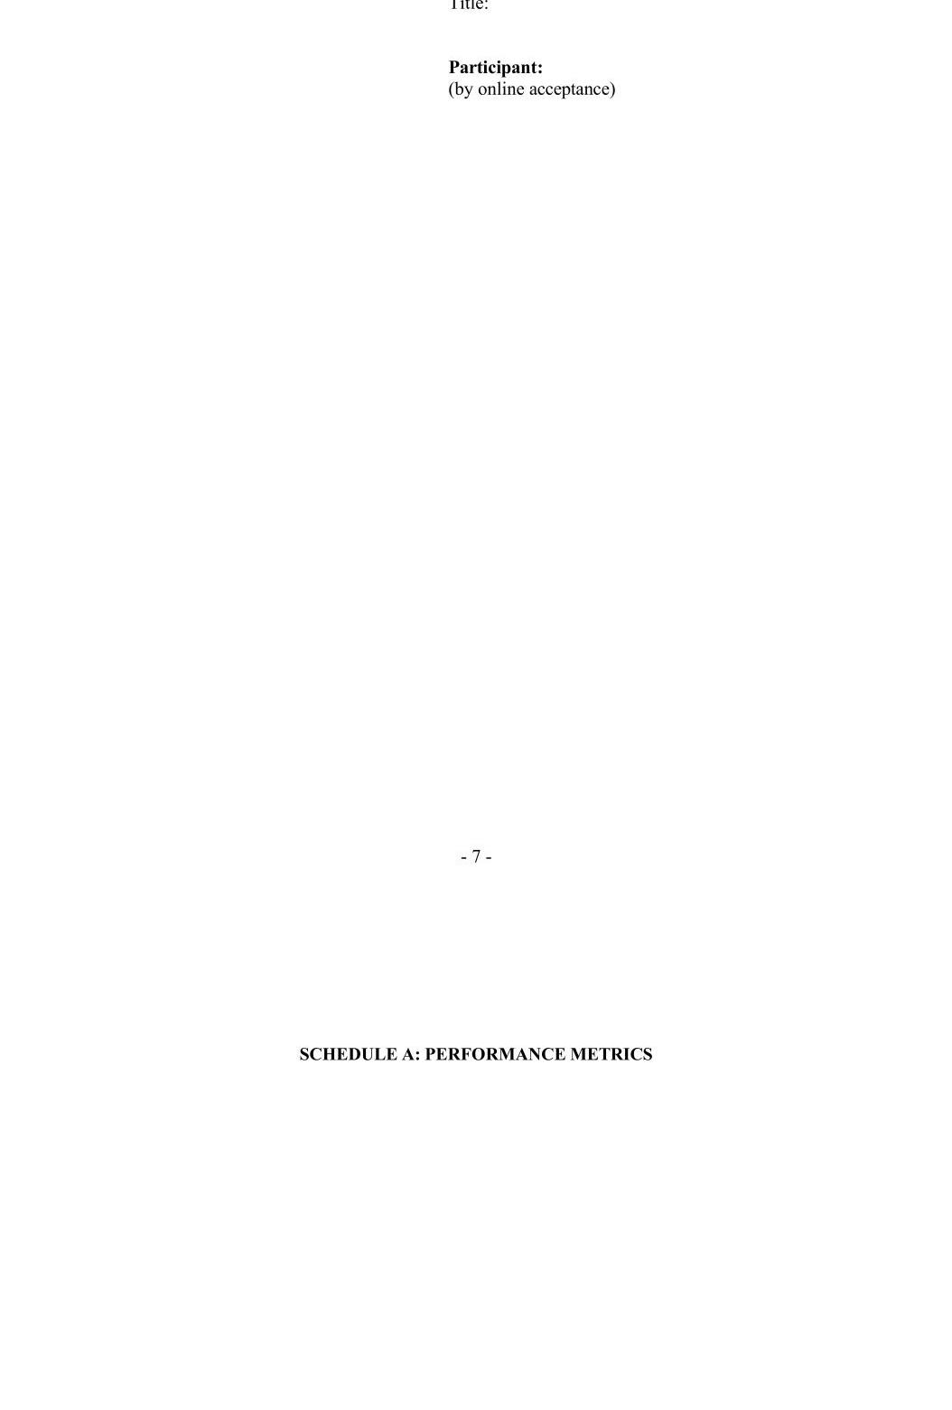





Exhibit 31.1

CERTIFICATION OF PRINCIPAL EXECUTIVE OFFICER PURSUANT TO

SECTION 302 OF THE SARBANES-OXLEY ACT OF 2002

I, Richard B. Cohen, certify that:

1. I have reviewed this Quarterly Report on Form 10-Q for the fiscal quarter ended December 28, 2024 of Symbotic Inc.;

2. Based on my knowledge, this report does not contain any untrue statement of a material fact or omit to state a material fact necessary to make the statements made, in light of the circumstances under which such statements were made, not misleading with respect to the period covered by this report;

3. Based on my knowledge, the financial statements, and other financial information included in this report, fairly present in all material respects the financial condition, results of operations and cash flows of the registrant as of, and for, the periods presented in this report;

4. The registrant’s other certifying officer and I are responsible for establishing and maintaining disclosure controls and procedures (as defined in Exchange Act Rules 13a-15(e) and 15d-15(e)) and internal control over financial reporting (as defined in Exchange Act Rules 13a-15(f) and 15d-15(f)) for the registrant and have:

- Designed such disclosure controls and procedures, or caused such disclosure controls and procedures to be designed under our supervision, to ensure that material information relating to the registrant, including its consolidated subsidiaries, is made known to us by others within those entities, particularly during the period in which this report is being prepared;

- Designed such internal control over financial reporting, or caused such internal control over financial reporting to be designed under our supervision, to provide reasonable assurance regarding the reliability of financial reporting and the preparation of financial statements for external purposes in accordance with generally accepted accounting principles;

- Evaluated the effectiveness of the registrant’s disclosure controls and procedures and presented in this report our conclusions about the effectiveness of the disclosure controls and procedures, as of the end of the period covered by this report based on such evaluation; and

- Disclosed in this report any change in the registrant’s internal control over financial reporting that occurred during the registrant’s most recent fiscal quarter (the registrant’s fourth fiscal quarter in the case of an annual report) that has materially affected, or is reasonably likely to materially affect, the registrant’s internal control over financial reporting; and

5. The registrant’s other certifying officer and I have disclosed, based on our most recent evaluation of internal control over financial reporting, to the registrant’s auditors and the audit committee of the registrant’s board of directors (or persons performing the equivalent functions):

- All significant deficiencies and material weaknesses in the design or operation of internal control over financial reporting which are reasonably likely to adversely affect the registrant’s ability to record, process, summarize and report financial information; and

- Any fraud, whether or not material, that involves management or other employees who have a significant role in the registrant’s internal control over financial reporting.

Date: February 5, 2025 | By: /s/ Richard B. Cohen
 |  | Richard B. Cohen
 |  | Chairman and Chief Executive Officer
 |  | (Principal Executive Officer)

Exhibit 31.2

CERTIFICATION OF PRINCIPAL FINANCIAL OFFICER PURSUANT TO

SECTION 302 OF THE SARBANES-OXLEY ACT OF 2002

I, Carol Hibbard, certify that:

1. I have reviewed this Quarterly Report on Form 10-Q for the fiscal quarter ended December 28, 2024 of Symbotic Inc.;

2. Based on my knowledge, this report does not contain any untrue statement of a material fact or omit to state a material fact necessary to make the statements made, in light of the circumstances under which such statements were made, not misleading with respect to the period covered by this report;

3. Based on my knowledge, the financial statements, and other financial information included in this report, fairly present in all material respects the financial condition, results of operations and cash flows of the registrant as of, and for, the periods presented in this report;

4. The registrant’s other certifying officer and I are responsible for establishing and maintaining disclosure controls and procedures (as defined in Exchange Act Rules 13a-15(e) and 15d-15(e)) and internal control over financial reporting (as defined in Exchange Act Rules 13a-15(f) and 15d-15(f)) for the registrant and have:

- Designed such disclosure controls and procedures, or caused such disclosure controls and procedures to be designed under our supervision, to ensure that material information relating to the registrant, including its consolidated subsidiaries, is made known to us by others within those entities, particularly during the period in which this report is being prepared;

- Designed such internal control over financial reporting, or caused such internal control over financial reporting to be designed under our supervision, to provide reasonable assurance regarding the reliability of financial reporting and the preparation of financial statements for external purposes in accordance with generally accepted accounting principles;

- Evaluated the effectiveness of the registrant’s disclosure controls and procedures and presented in this report our conclusions about the effectiveness of the disclosure controls and procedures, as of the end of the period covered by this report based on such evaluation; and

- Disclosed in this report any change in the registrant’s internal control over financial reporting that occurred during the registrant’s most recent fiscal quarter (the registrant’s fourth fiscal quarter in the case of an annual report) that has materially affected, or is reasonably likely to materially affect, the registrant’s internal control over financial reporting; and

5. The registrant’s other certifying officer and I have disclosed, based on our most recent evaluation of internal control over financial reporting, to the registrant’s auditors and the audit committee of the registrant’s board of directors (or persons performing the equivalent functions):

- All significant deficiencies and material weaknesses in the design or operation of internal control over financial reporting which are reasonably likely to adversely affect the registrant’s ability to record, process, summarize and report financial information; and

- Any fraud, whether or not material, that involves management or other employees who have a significant role in the registrant’s internal control over financial reporting.

Date: February 5, 2025 | By: /s/ Carol Hibbard
 |  | Carol Hibbard
 |  | Chief Financial Officer and Treasurer
 |  | (Principal Financial Officer)

Exhibit 32.1

CERTIFICATION OF PRINCIPAL EXECUTIVE OFFICER PURSUANT TO

18 U.S.C. SECTION 1350, AS ADOPTED PURSUANT TO

SECTION 906 OF THE SARBANES-OXLEY ACT OF 2002

In connection with the Quarterly Report on Form 10-Q of Symbotic Inc. (the “Company”) for the fiscal quarter ended December 28, 2024, as filed with the Securities and Exchange Commission on the date hereof (the “Report”), I, Richard B. Cohen, Chairman and Chief Executive Officer of the Company, certify, pursuant to 18 U.S.C. Section 1350, as adopted pursuant to Section 906 of the Sarbanes-Oxley Act of 2002, that, to my knowledge:

(1) The Report fully complies with the requirements of Section 13(a) or 15(d) of the Securities Exchange Act of 1934; and

(2) The information contained in the Report fairly presents, in all material respects, the financial condition and results of operations of the Company.

Date: February 5, 2025 | By: /s/ Richard B. Cohen
 |  | Richard B. Cohen
 |  | Chairman and Chief Executive Officer
 |  | (Principal Executive Officer)

The foregoing certification is being furnished solely pursuant to 18 U.S.C. Section 1350 and is not being filed as part of the Report or as a separate disclosure document.

Exhibit 32.2

CERTIFICATION OF PRINCIPAL FINANCIAL OFFICER PURSUANT TO

18 U.S.C. SECTION 1350, AS ADOPTED PURSUANT TO

SECTION 906 OF THE SARBANES-OXLEY ACT OF 2002

In connection with the Quarterly Report on Form 10-Q of Symbotic Inc. (the “Company”) for the fiscal quarter ended December 28, 2024, as filed with the Securities and Exchange Commission on the date hereof (the “Report”), I, Carol Hibbard, Chief Financial Officer and Treasurer of the Company, certify, pursuant to 18 U.S.C. Section 1350, as adopted pursuant to Section 906 of the Sarbanes-Oxley Act of 2002, that, to my knowledge:

(1) The Report fully complies with the requirements of Section 13(a) or 15(d) of the Securities Exchange Act of 1934; and

(2) The information contained in the Report fairly presents, in all material respects, the financial condition and results of operations of the Company.

Date: February 5, 2025 | By: /s/ Carol Hibbard
 |  | Carol Hibbard
 |  | Chief Financial Officer and Treasurer
 |  | (Principal Financial Officer)

The foregoing certification is being furnished solely pursuant to 18 U.S.C. Section 1350 and is not being filed as part of the Report or as a separate disclosure document.

